**MXMM TRADING SERIES**

**OPEN HIGH LOW CLOSE(BEARISH) AND OPEN LOW HIGH CLOSE(BULLISH): POWER OF 3**

True day open: when algorithm begins working (00:00 NY - 00:00NY)

**5 candle formations described here**

Bullish

Bullish reversal

Bearish

Bearish reversal

Consolidation

**Bullish**

|  |  |
| --- | --- |
|  | 1. Open 2. Make low of the day(mostly during the london session for the bullish candle here). 3. Expand during the day(especially during the NY session) 4. Close out bullish eventually |

**Bullish reversal**

|  |  |
| --- | --- |
|  | Consists of selling during most of the day, low trying to take out a HTF sell side liquidity.  Reversal to buying always happens at around the NY(NY reversal) and market eventually closes.   1. Open 2. Low aims for sell side Liquidity of HTF(Much selling on the LTF) 3. Always** at around NY(NY reversal), there is retracement and market starts buying till reaching high. 4. Market closes as bullish |

**Bearish**

|  |  |
| --- | --- |
|  | 1. Open 2. Form high of the day(always** during the london session) 3. Retracement and continuation of retracement during the NY session -- NY reversal 4. Form low of the day **(mostly during the NY session) 5. Close the day bearish |

**Bearish reversal**

|  |  |
| --- | --- |
|  | 1. Open 2. Buying pressure makes high to aim for a HTF buy stop or HTF premium array. High of the day always** around the london session. 3. HTF buy stop or Premium array causes reversal at around NY session. 4. Continuation during the NY session causes the low of the day. 5. Close bearish |

**Consolidation(indecision candle)**

|  |  |
| --- | --- |
|  | Relative equal top wick and low wick. Looks like a DOJI candle |

**REVERSALS AROUND MIDNIGHT OPEN**

A **reversal around the midnight open** refers to a price action pattern where the market changes its direction (reverses) near the opening price of the day, which is typically set at **00:00 in the trading platform's server time**. Here's what it means and signifies:

### ****What Happens in a Midnight Reversal?****

### ****Initial Market Movement****: After the daily open, the market may initially move in one direction (either bullish or bearish). This move could be a "manipulation" or "false push" intended to create liquidity by triggering stops or enticing traders in the wrong direction.

### ****Reversal Around Midnight Open****: Shortly after the initial move, the market reverses and moves in the opposite direction, often towards the true direction of the day.

**Why It Happens**:

* **Liquidity Grab**: Market makers target stop-loss levels near the midnight open to generate liquidity for larger moves...e.g grabing a nearby sell stop before going bullish
* **Order Pairing**: Institutions may be pairing orders at key price levels set near the midnight open.
* **Daily Bias Setup**: The reversal often aligns with the daily directional bias (e.g., bullish or bearish trend for the day).

### ****What Does It Signify?****

### ****Liquidity Zones****: The midnight open price acts as a **liquidity magnet**, often marking an area where significant buy or sell orders cluster.

### ****Institutional Activity****: Reversals near the midnight open suggest institutional participation, as these players may use this time to manipulate price for optimal entry or exit.

### ****Directional Bias Confirmation****: The reversal direction can hint at the **daily bias**:If price reverses and moves higher: It suggests a bullish bias for the day OR If price reverses and moves lower: It suggests a bearish bias for the day.

### ****Entry Opportunities****:The reversal creates high-probability trading setups, allowing traders to enter positions aligned with the daily trend after the manipulation phase.

**Confluence with Other Tools**:Combine this concept with other tools like **order blocks**, **liquidity zones**, or **fair value gaps** to enhance accuracy.

**EXAMPLE ONE(BULLISH DAILY CANDLE)**

EUR/USD Daily chart

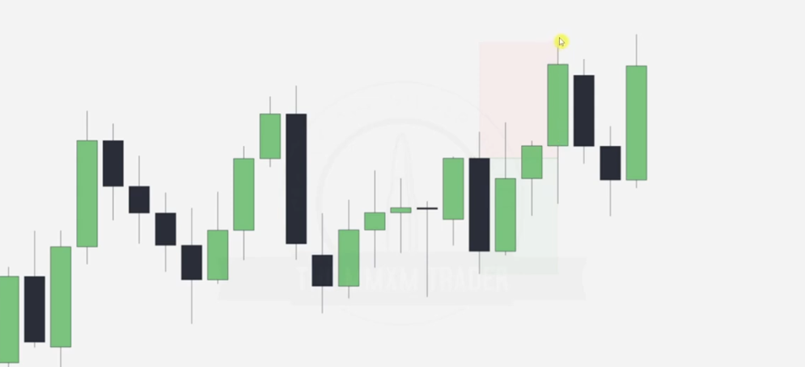

* Determine the highs and lows of the prem_disc chart and draw it
* Draw outline of the bullish OB and buy stops at the top.
* NB:After drawing out the rectangle of the Discount array(bullish OB) and the buy stop, we note that our target candle(last), taps into the Bullish OB and aims for the buy stops then closes out the day bullish.

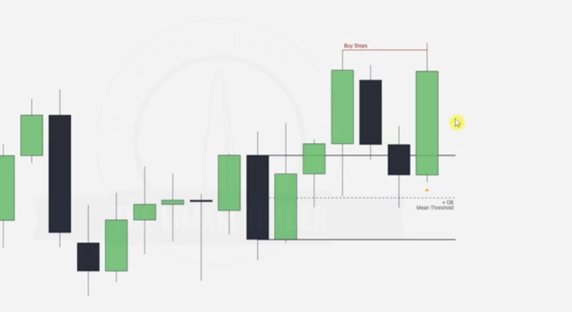

Go to 15mins time frame and draw the midnight open line.

Note that the low of the day will form below the midnight open mostly during the London session and when you see it after that session longing just know that it is heading for the buy stop drawn in the Daily HTF. Also note the NY continuation point in red. Buy stop is taken out.. high formed and day closes as bullish.

**EUR/USD 15min chart**

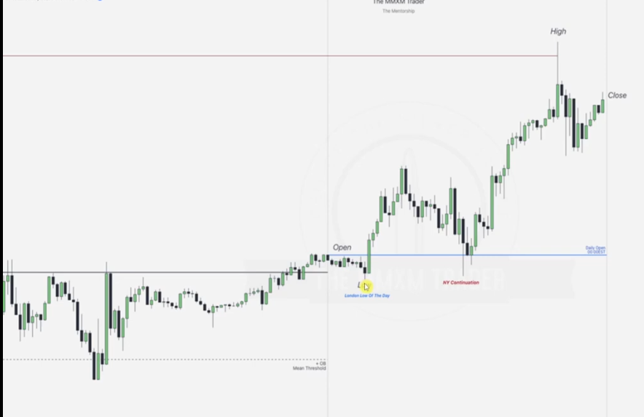

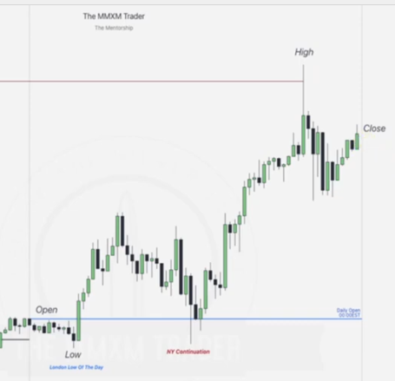

**EUR/USD Daily chart**

**EXAMPLE TWO(BULLISH REVERSAL CANDLE)**

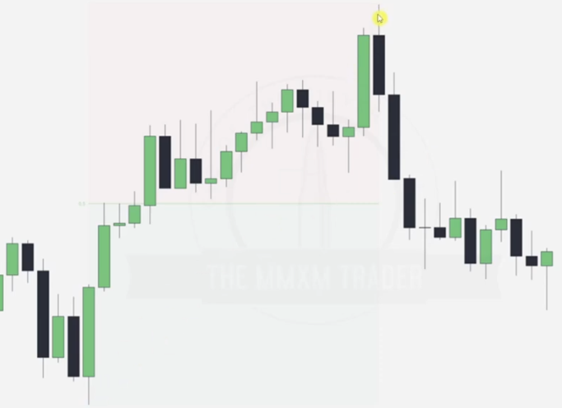

* Draw prem_disc chart from the dealing range.
* Candle will be aiming to tap the FVG as illustrated below hence the selling pressure.. selling foen to draw liquidity into the FVG

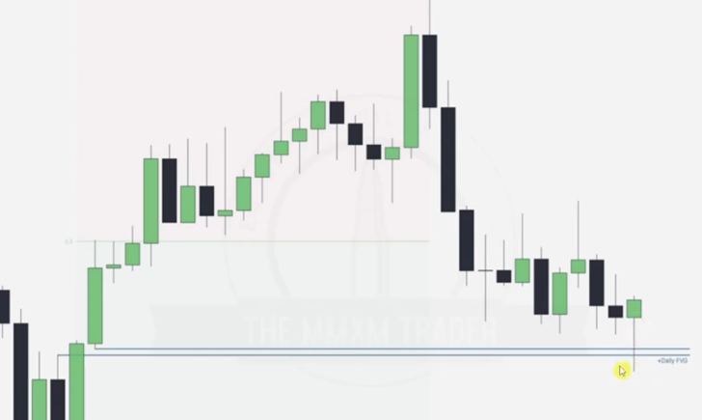

**EUR/USD 15 min chart**

Draw midnight open, note that there is consolidation during the London session and when the sell stops are sweeped at the FVG price now reverses at the NY reversal, continues until daily high is formed and day is closed

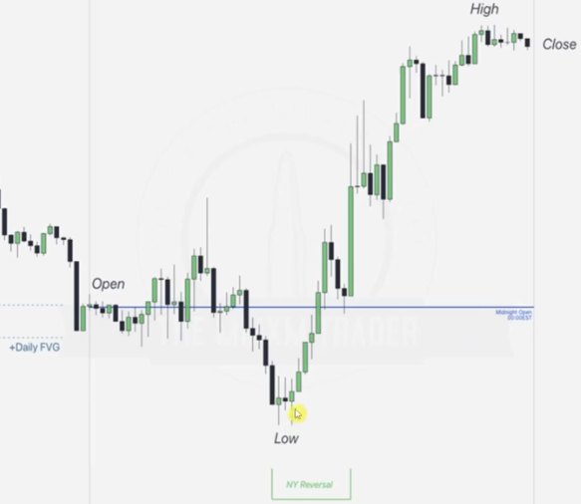

**EXAMPLE 3(BEARISH CANDLE)**

**EUR/USD Daily chart**

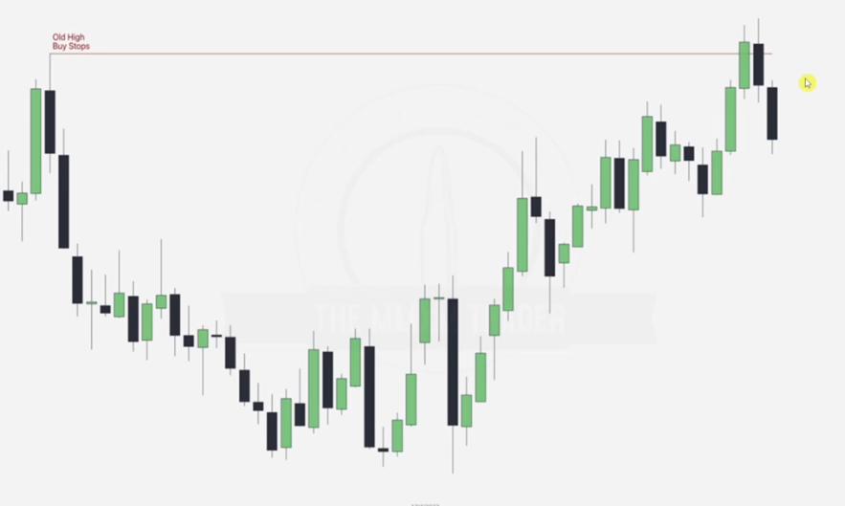

* Draw old high
* Note that the candles have ordered pairings at the buys tops(ERL) hence indicating a reversal , we now need to aim for the next IRL which is the FVG below

**EUR/USD 15 min chart**

* Draw midnight open
* Note that the high is formed during the lLondon session, at that time the market makers are clearing buy stops too, note that at NY session the continuation of shorting is there until low of the day is formed in that time, then day closes

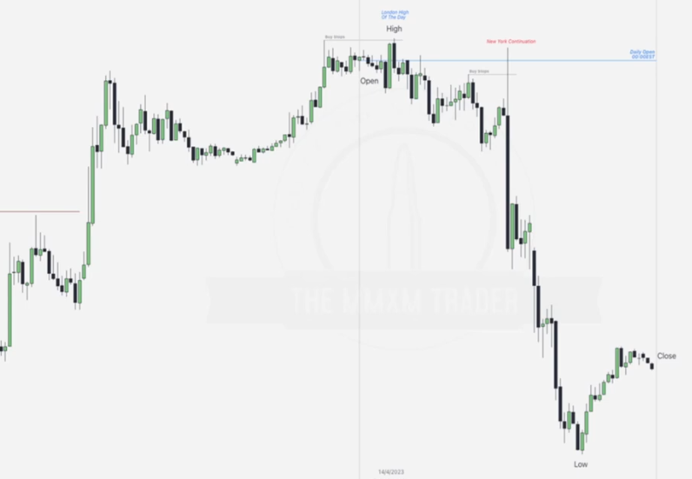

**EXAMPLE 4(BEARISH REVERSAL)**

**EUR/USD Daily chart**

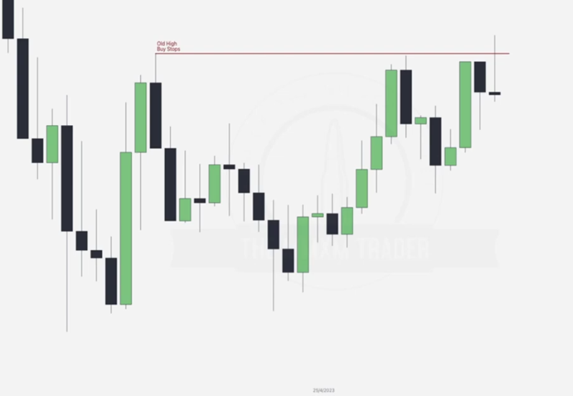

**EUR/USD 15 min chart**

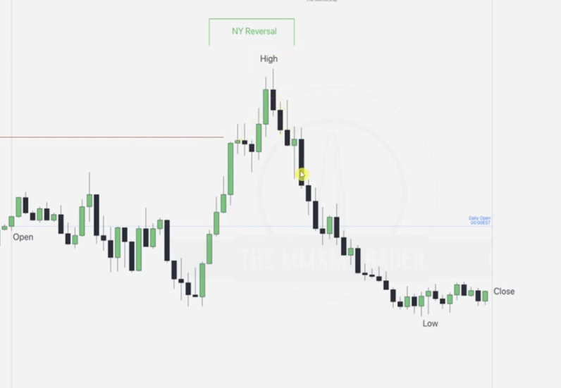

**EXAMPLE 5(INDECISION DAILY CANDLE)**

**EUR/USD Daily chart**

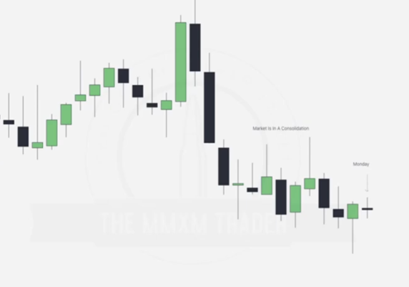

**EUR/USD 15 min chart**

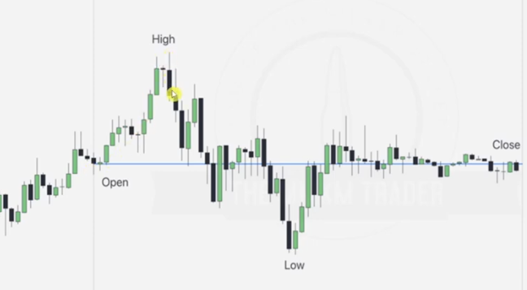

Just keeps hanging around the midnight open

**FAILURE SWINGS**

**LOW RESISTANCE LIQUIDITY**

We want to see this on the opposing side of our structure i.e

* **Bearish Failure swing**: High failing to take out previous high, we want to see this when we are bullish(or planning to go bullish).
* **Bullish Failure swing**: low failing to take out previous low

The market will always go through opposing failure swings with ease, like hot knife through butter

**HIGH RESISTANCE LIQUIDITY**

High resistance low: Low that ran a previous low and rejected.

High resistance high: High that ran a previous high and rejected.

**NB: We use this logic on all time frames**

**Bullish order flow(MMBM)**

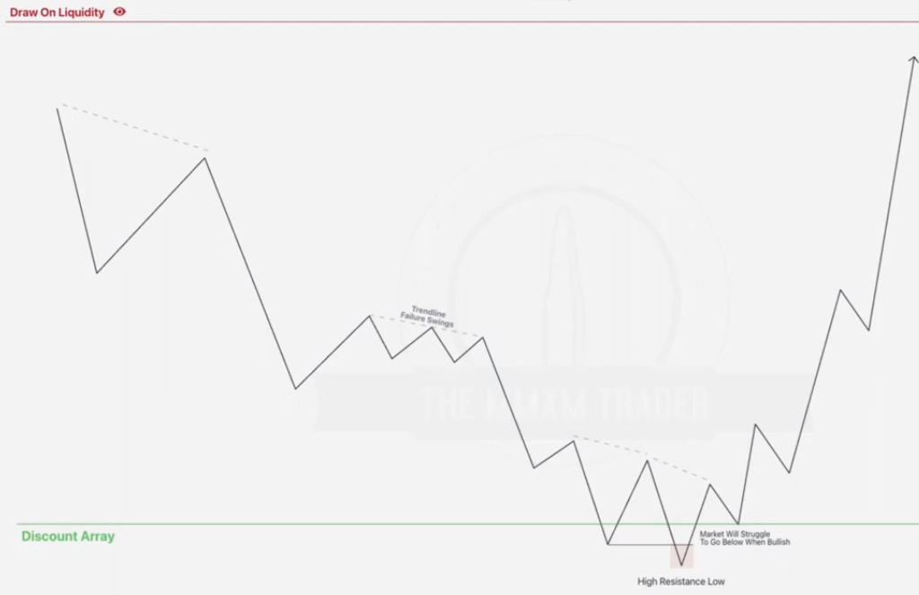

* Once we hit the discount array labeled and the low rejecting the previous low is formed(high resistance low).
* High resistance low is monitored to take out previous low and immediately reject it , starts moving up bullish.. now our next targets are the bearish low resistances OR mainly the draw on liquidity.. which can be the main target in case you trust and want to make more profits

**NB: In a case where the nearest bearish failure swing is still in discount(initially trading range prem_disc should be drawn), it is advisable to draw liquidity on failure swings in premium range.**

**Bearish order flow (MMSM)**

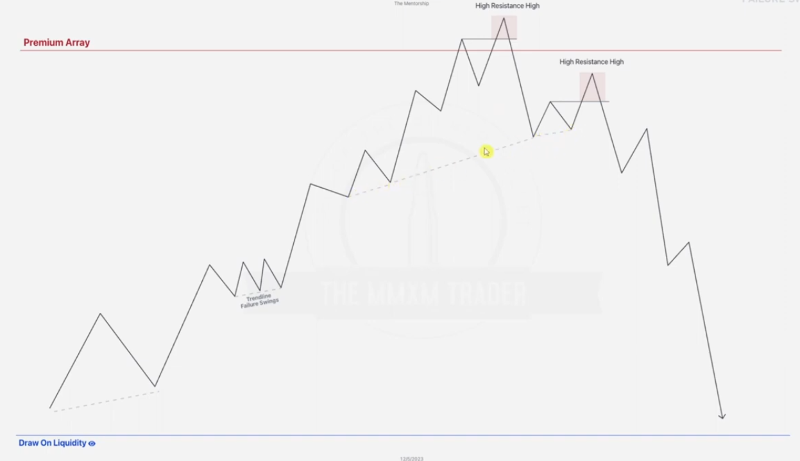

Once we hit the premium array labeled up and the high rejecting the previous high is formed(high resistance high). We also note a second high resistance high , market then starts shorting.. now our next targets are the bullish low resistances OR the draw on liquidity.

**NB: In a case where the nearest bullish failure swing is still in premium, it is advisable to draw liquidity on failure swings in discount range.**

**FAILURE SWINGS: EXAMPLE 1**

Given daily chart

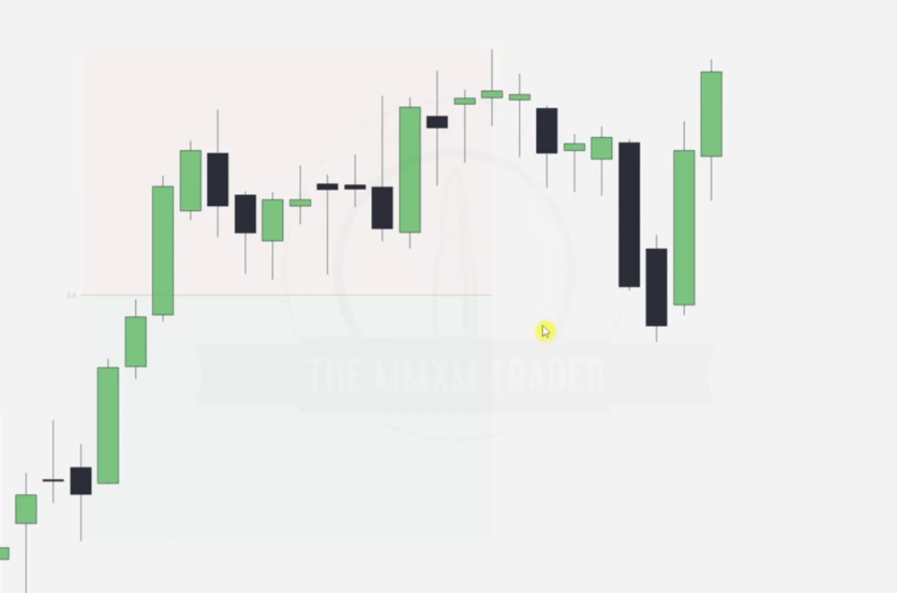

Draw the trading range.. prem_disc

Note the discount array to be tapped into, premium or discount and the failure swings.

### ****How to Identify MMSM(Sell) in Your Chart****

**Study the Structure**:

* Look for an **initial accumulation zone** (range-bound price action).
* Identify a sharp upward move (liquidity grab) followed by a rapid reversal.
* Confirm if the market trends downward with consistent **lower highs** and **lower lows** after the reversal.

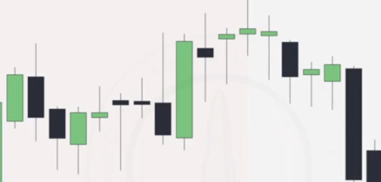

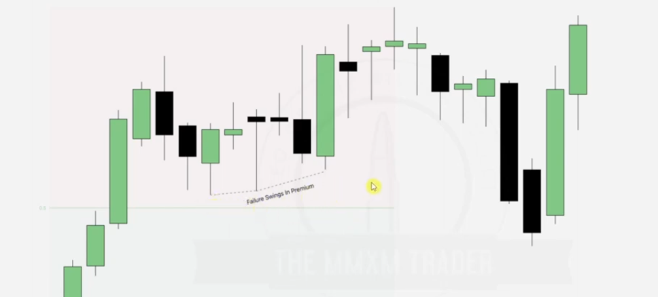

Label failure swings... note that if you try to take the MMBM you wont have failure swings in this chart you will have to go to a lower time frame like 15 minute chart to draw these failure swings hence choosing MMSM here.

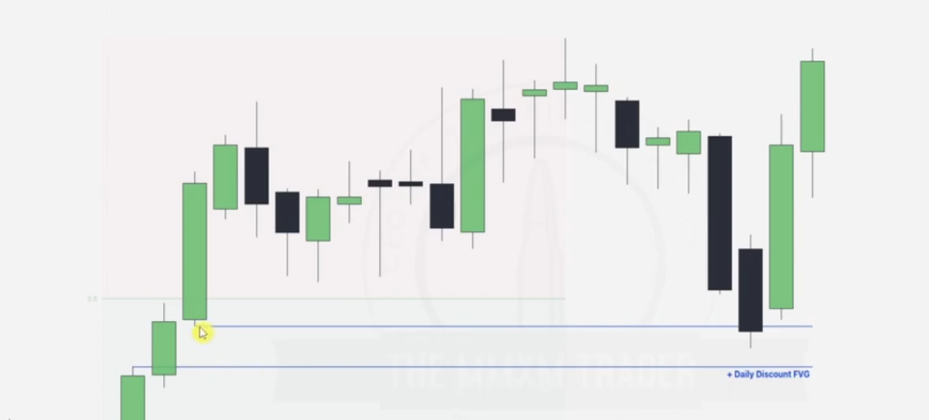

Now here we draw the daily discount FVG .. aiming to go to the MMBM in the 15 minute chart.

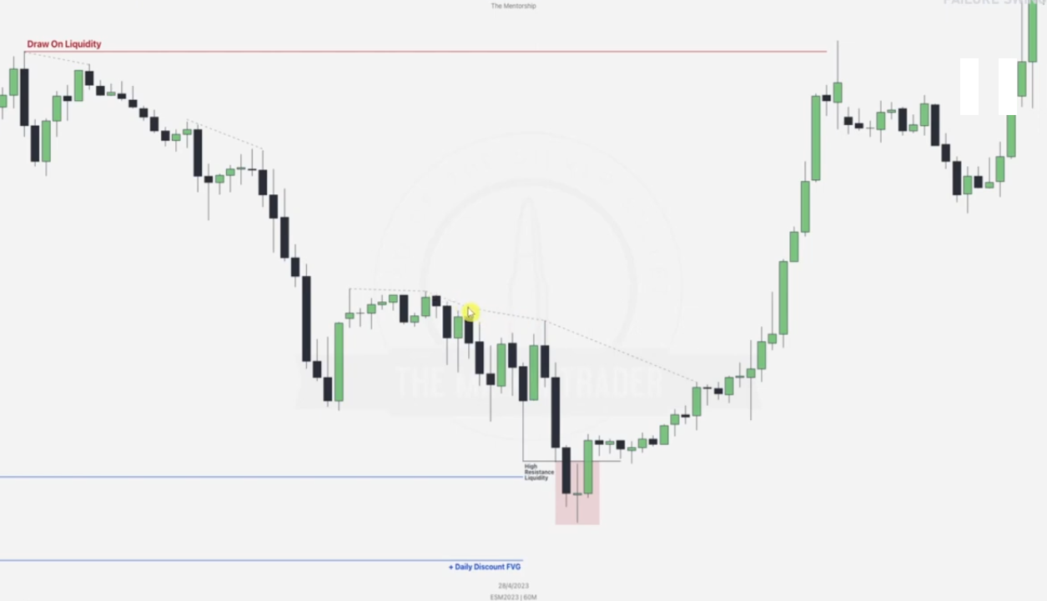

Draw the main draw on liquidity..Buy stop..higher ERL.. final boss after all the Failure swings.. buy stops too.

In this case where the highlighted bearish failure swing is still in discount, it is advisable to draw liquidity on failure swings in premium range.

Note the order pairing after tapping into the daily discount FVG. After this we wait for a break in structure which is already seen .. in case we tap into FVG.. here we tapped into a sell stop instead of the daily discount FVG... we could have had a better break in structure seen then.

**FAILURE SWINGS: EXAMPLE 2**

Given EUR/USD MONTHLY chart

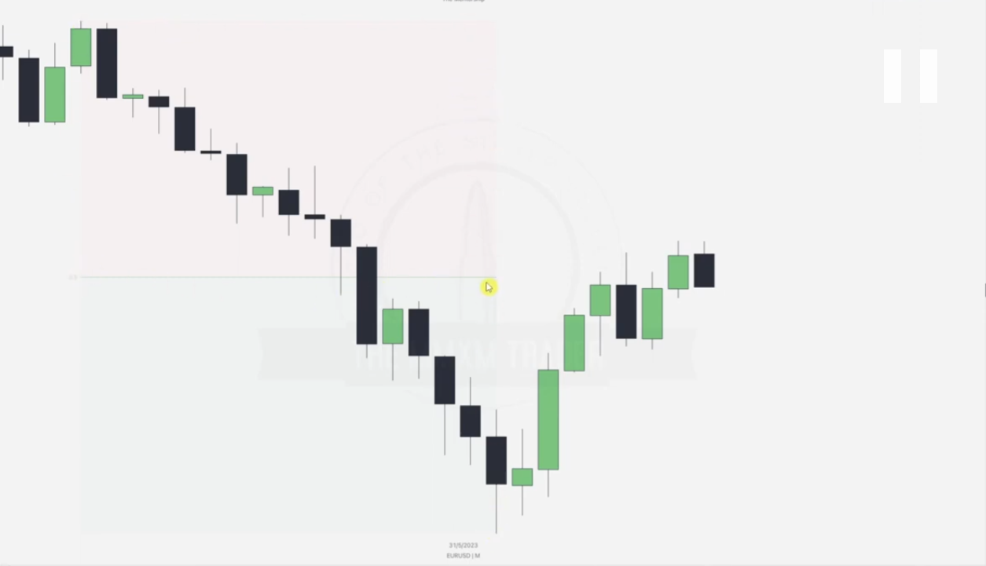

Note that here we have no discount FVG for order pairing for our MMBM.. hence we will label a possible stop hunt or PD array and go to a lower time frame to check for our MMXM with order pairing

Hence note that there are two FVGs around where the cursor is placed.. however FVG in discount is taken fully hence we resort to the FVG in the premium zone as labeled below.. this is a perfect place for rejection in the lower time frame

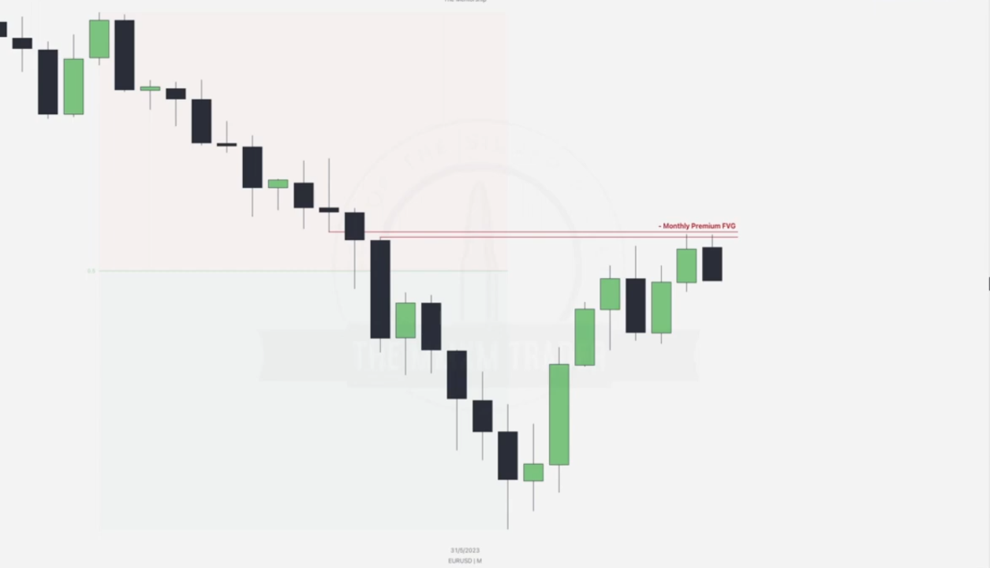

Going to the daily chart

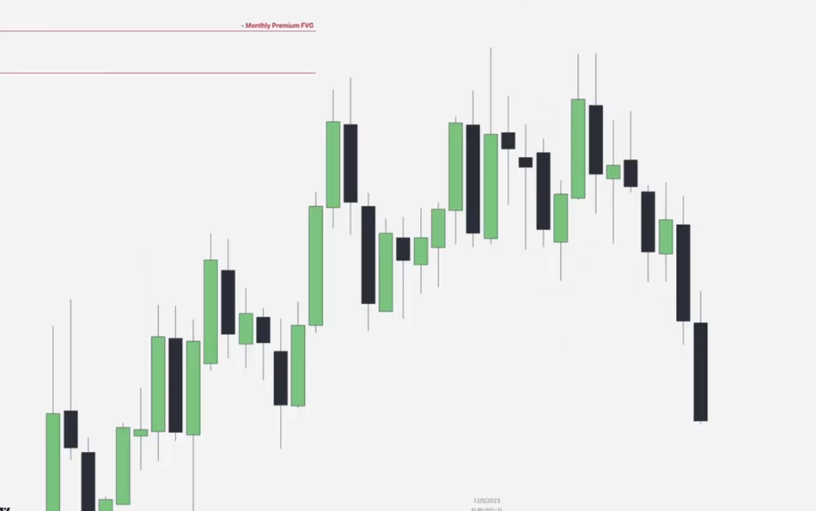

Note that we have a major high resistance high(MMSM).. which the second high also failed to take.. after noting our failure swings.. main question is .. where do we make a good entry to the shorting..Note that this is done at the PD array of the volume imbalance as labeled.

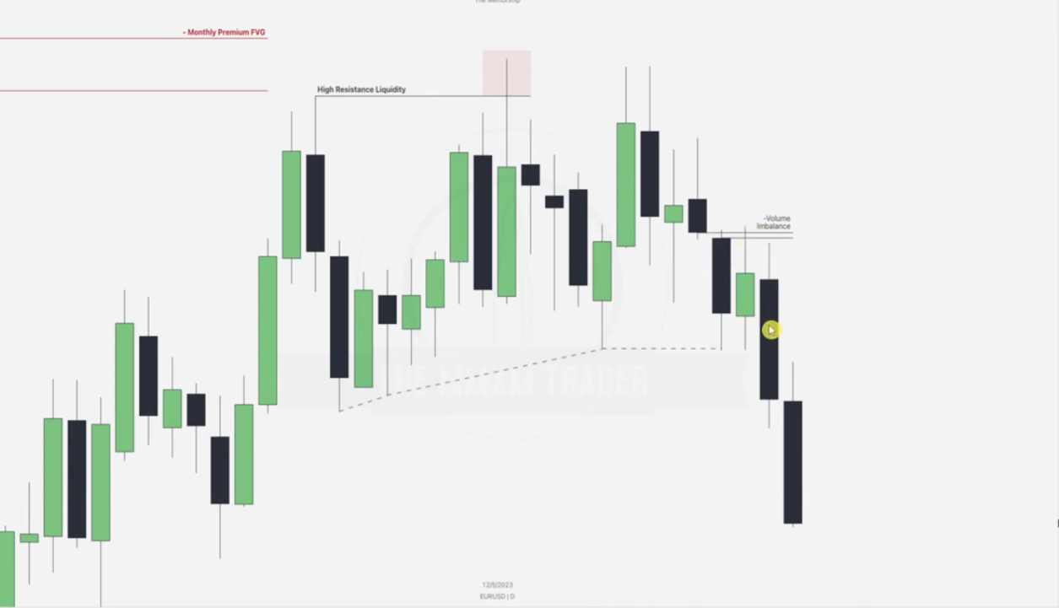

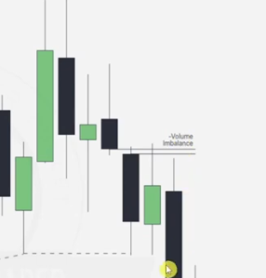

This **Volume Imbalance** was drawn by identifying an area where the body of one candle fails to overlap with the body or wicks of the adjacent candles, indicating inefficiency in price delivery. Let’s break it down step by step:

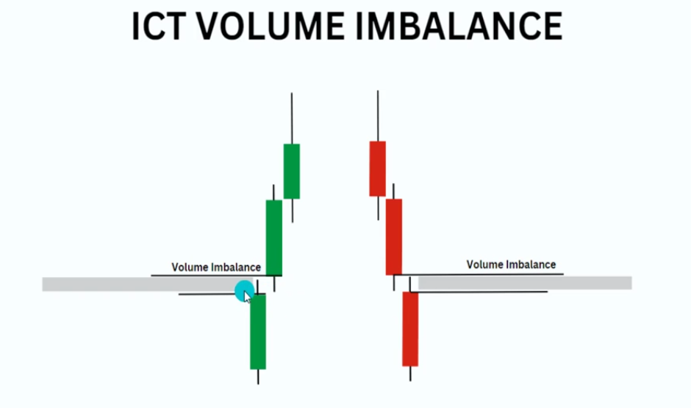

Price always comes back to tap into volume imbalances, it typically a PD array.

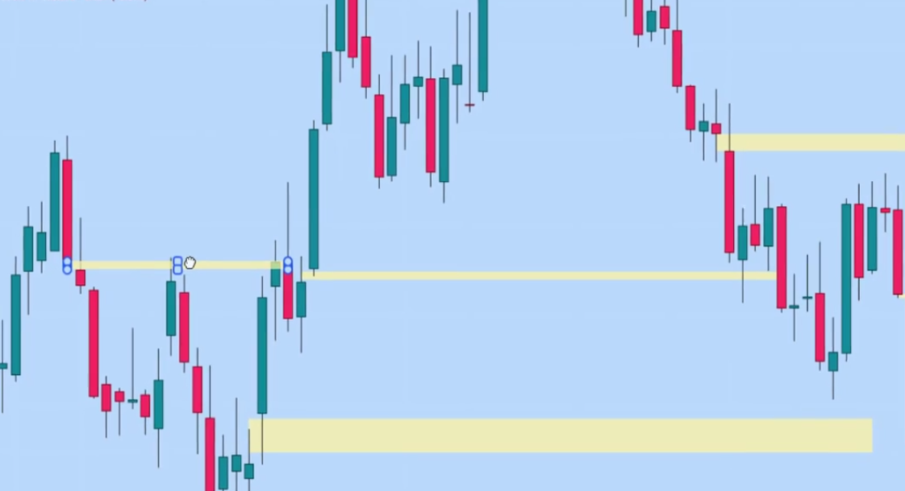

### ****Why Is It Significant?****:

### ****Market Re balancing****: Price often revisits these imbalanced zones to "fill in" the inefficiency, providing potential entry points for traders.

### ****Institutional Involvement****: These zones often indicate areas where institutions may have left unfilled orders, making them key levels of interest.

**PREVIOUS DAYS HIGHS AND LOWS**

Previous Days highs and lows are the easiest liquidity pools you can target and the easiest ‘draw on liquidity’ you have.

* In bullish order flow , market will seek buy-side liquidity above previous day highs.
* In bearish order flow, market will seek sell-side liquidity below previous day low.

Previous day highs and lows is one of the foundations to daily bias and the ‘draw on liquidity’. Its the easiest liquidity pool that the market will attack almost every single day.

**NB**:

* There is barely an inside bar(bar that doesn’t take previous day high or low). Daily candle is always seeking SSL or BSL.
* When the next candle takes out the previous high and low. This could indicate a reversal about to happen in favor of the last candle direction.

**PREVIOUS DAILY HIGH AND LOWS: EXAMPLE ONE**

Step one: Determining market bias e.g by determining using monthly/daily ERLs and IRLs if required

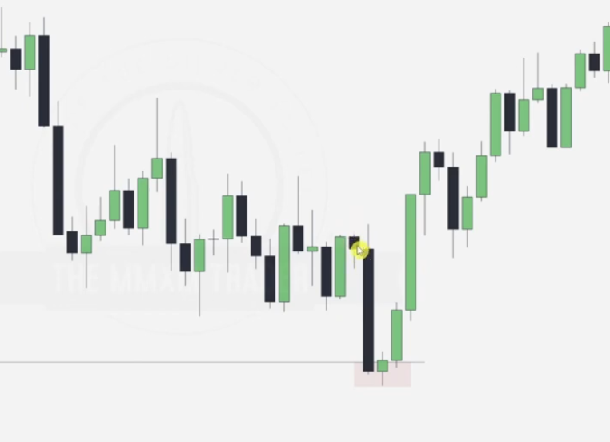

When the next candle takes out the previous high and low. This could indicate a reversal about to happen

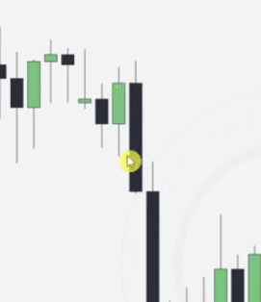

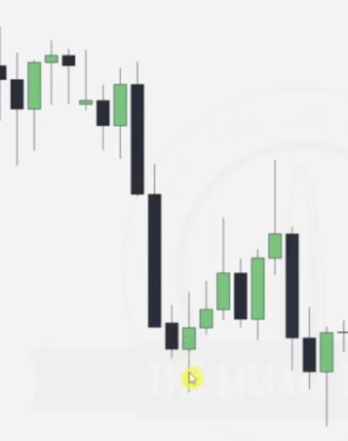

Using daily IRLs and ERLs to determine bias: We notice that the market has taken out an old high and there is a high resistance low hence order pairing and we expect reversal to a bullish order-flow, HENCE we draw the daily highs.

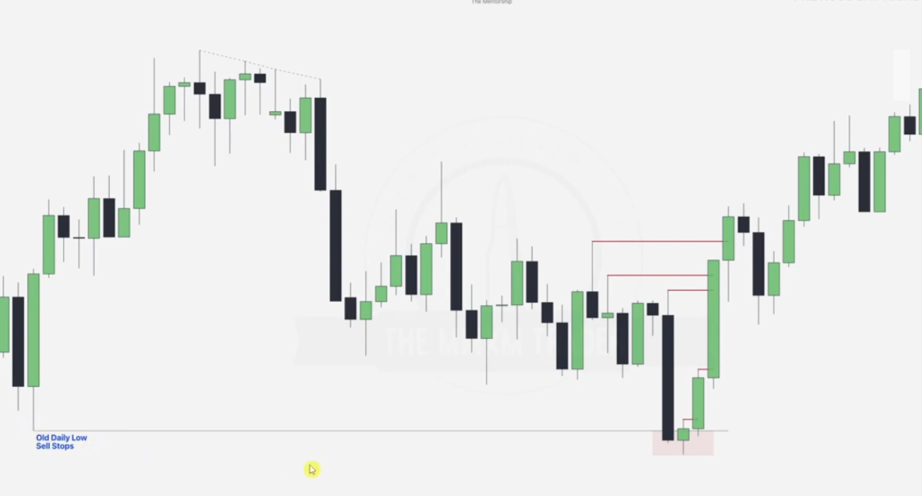

It is very important to note that the FVG causing the break of structure after order pairing here is very important, if we add to context that the long time daily low has been raided and some of the failure swings haven’t been touched. This shows that market is going bullish

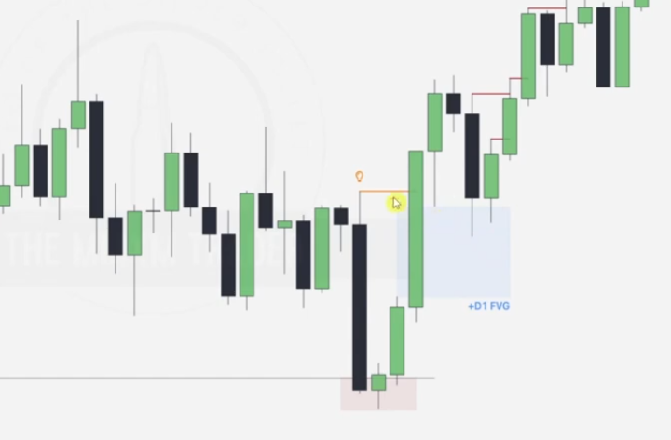

Going to the intra-day.. hourly chart

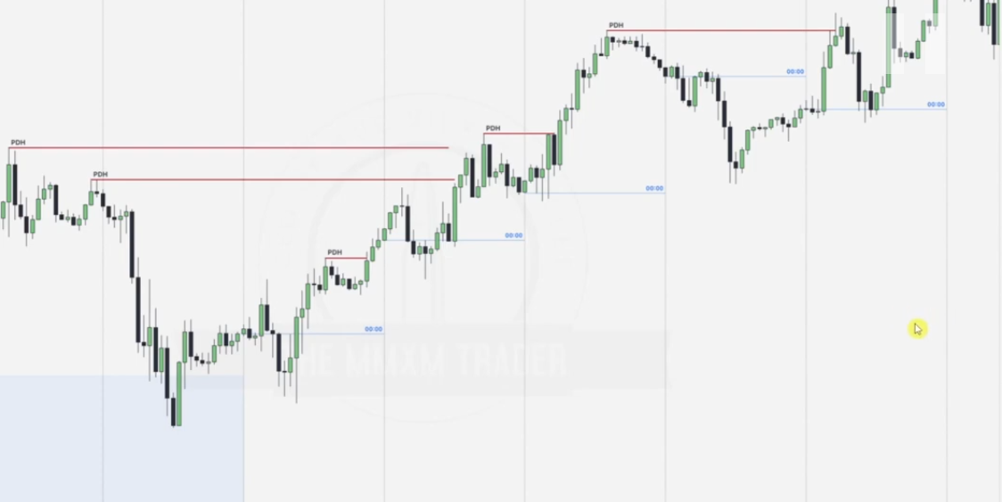

During the intra-day, we now refer to lesson one of bearish, bearish reversals, bullish, bullish reversals for daily ... draw midnight open.. determine the low/high of the day during the London session while for the reversals highs/lows anticipated during NY session..then use the various ERLs and IRLs to draw liquidity points, introduce the MMXM for order-flow confirmation .. based on the MMXM you can either go to lower time-frames to make entries or check possible ERLs and IRLs in the same time frame to make entries.

Note that whenever the midnight open is passed above(either in London or NY reversal), the market is going to be bullish for the rest of the day. RISK ATTACHED

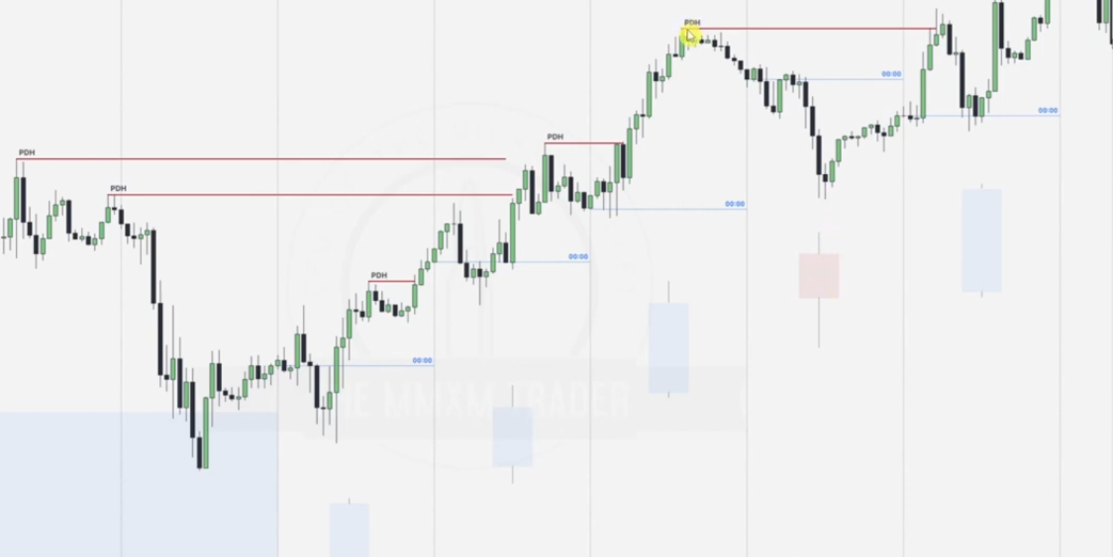

Note that there is a bearish daily candle but the order flow is still bullish. **Take note of the reversal around the midnight open too.**

**PREVIOUS DAILY HIGH AND LOWS: EXAMPLE ONE**

**Major steps**

* Draw major ERLs and IRLs
* Based on tapped ERLs / IRLs determine MMXM.. determine bias.
* Draw previous day high/ lows based on the bias predicted.

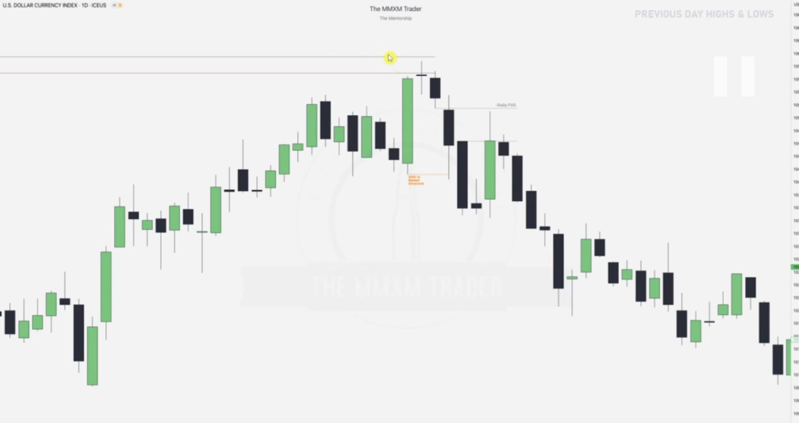

Note that the red Premium PD array is a FVG, this gets tapped by the doji candle.. order pairing.. now we wait for a break in structure to predict a reversal.

Break in structure comes with FVG formed, This shows that the market will be bearish coming days, hence get ready to draw the daily lows which will be hunted.

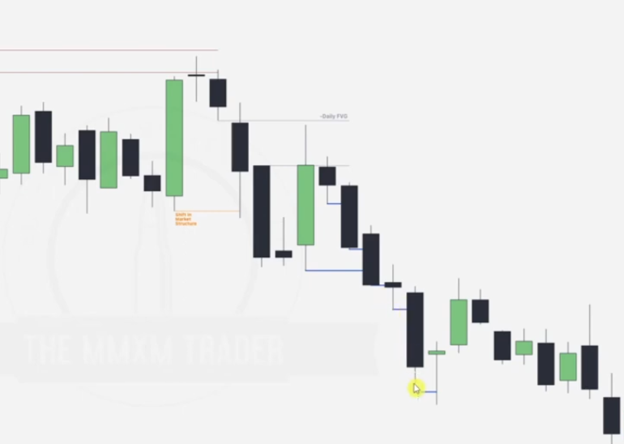

Going to the intraday chart

We notice that once price goes above the midnight open, there is a likely reversal after it has formed the daily high (london session or NY reversal). It is advisable to trade above the midnight open in asian session only

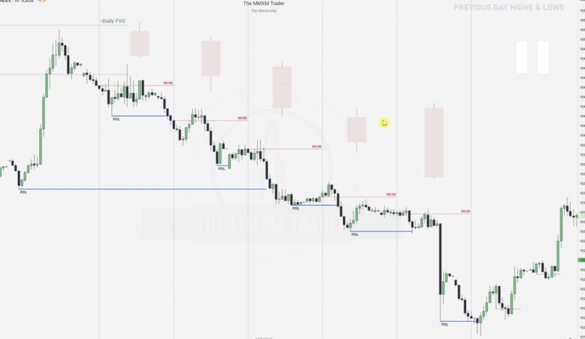

**DAILY SWING HIGHS AND LOWS**

Every turning point in the market forms a swing high or low

Now on a lower time frame , this is meaningless , however on a **Daily chart** if we see this at a KEY LEVEL and we have a draw on liquidity still present, this becomes crucial and we can frame an entire model behind this idea.

Below swings lows and swing highs are combination of 3 candles each

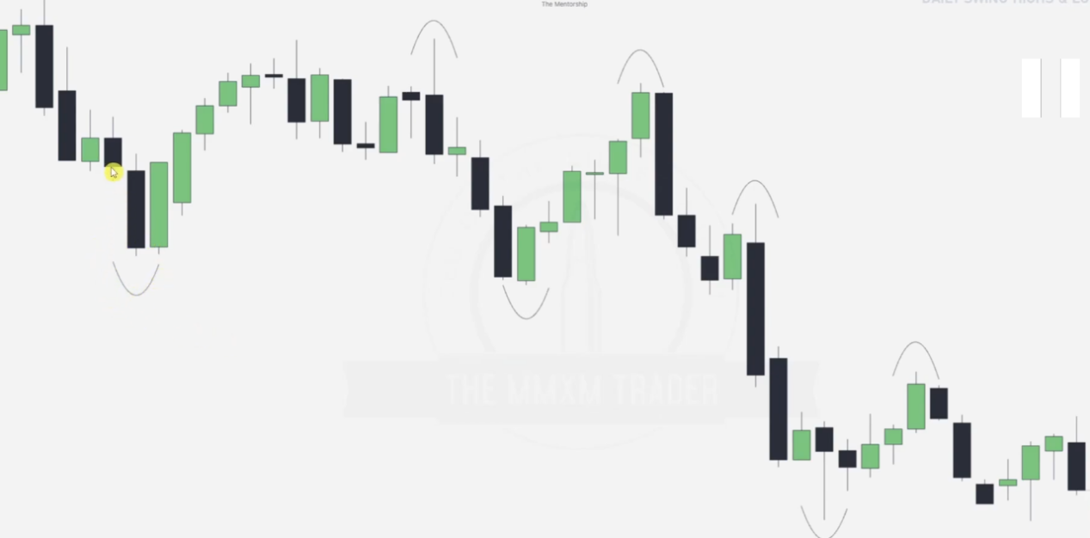

**Anticipating high probability price moves with swing highs and swing lows**

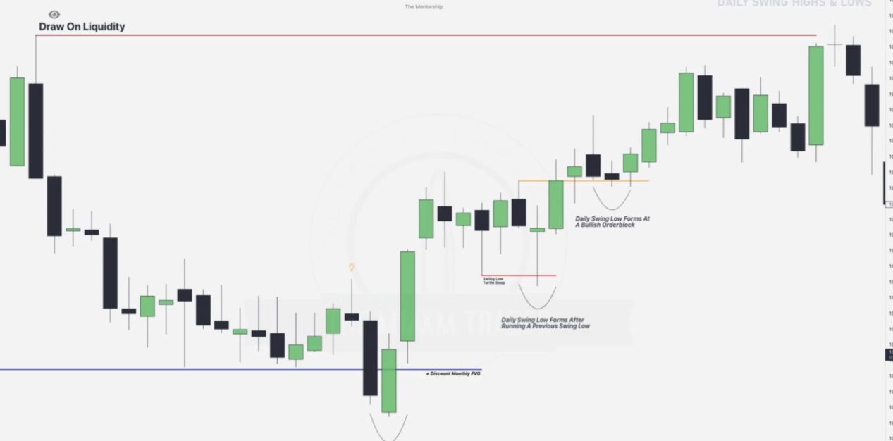

**Note: Just take the highest point on the disturbance and mark the two neighbors**

We need to see the swings form at a KEY LEVEL(key levels labeled in the chart above and their swings please take a closer look)

* If bullish we want to see swing lows form at discount arrays and / or after running another swing low ?

* If bearish we want to see swing highs form at premium arrays and or / after running another swing high.

#### ****BULLISH SCENARIO****

**1: Swing Lows Forming at Discount Arrays**

If price is in a **bullish trend**, it often retraces to a **discount area** (below the equilibrium of a range).At this level, we expect **buying pressure** to form a swing low, signaling the continuation of the upward move.

**Example Steps:**

* Identify the **discount area** (e.g., order block or fair value gap).
* Watch for price to retrace to this level and form a **swing low**.
* Look for signs of bullish intent (e.g., rejection from the discount area or bullish candlestick patterns).

**2: Swing Lows Forming After Running Another Swing Low**

Before continuing higher, price might dip below a **previous swing low** to grab **sell-side liquidity**. After the liquidity grab, price will reverse after forming a **higher low**, confirming bullish intent.

**Example Steps:**

* Identify a **previous swing low** as a liquidity pool.
* Watch for price to dip below it, clear liquidity, and then reverse.
* Enter on confirmation of the reversal (e.g., bullish engulfing or break of structure).

**BEARISH SCENARIO**

**Swing Highs Forming at Premium Arrays**

If price is in a **bearish trend**, it often retraces to a **premium area** (above the equilibrium of a range).At this level, we expect **selling pressure** to form a swing high, signaling the continuation of the downward move.

**Example Steps:**

* Identify the **premium area** (e.g., order block or fair value gap).
* Watch for price to retrace to this level and form a **swing high**.
* Look for signs of bearish intent (e.g., rejection from the premium area or bearish candlestick patterns).

**Swing Highs Forming After Running Another Swing High**

Before continuing lower, price might spike above a **previous swing high** to grab **buy-side liquidity**.After the liquidity grab, price will reverse and form a **lower high**, confirming bearish intent.

Taking out the swing high creates a new swing high. The **next high** in the sequence is the one that confirms the bearish trend by failing to surpass this level. This process reinforces the **lower-high, lower-low structure** of a bearish trend.

**Example Steps:**

* Identify a **previous swing high** as a liquidity pool.
* Watch for price to break above it, clear liquidity, and then reverse.
* Enter on confirmation of the reversal (e.g., bearish engulfing or break of structure).

### ****Putting It All Together****

Here’s how you combine these principles into a **trading plan**:

* **Mark Key Levels**:Look for order blocks, fair value gaps, swing highs/lows, or equilibrium levels.
* **Define Bias**: Are you bullish or bearish? This will guide whether you focus on swing lows (bullish) or swing highs (bearish).
* **Watch for Liquidity Grabs**:Look for price to spike beyond a swing high/low to grab liquidity, then reverse.
* **Validate at Key Levels**: Ensure that the swing high/low is forming at a **premium/discount area** or after clearing liquidity.
* **Confirm Direction**:Use candlestick patterns, a break of structure, or other tools to confirm the direction of the move.

**Best model** is to look at the day after the 3-day swing has formed, day 4 , we can also focus on day 5.

| **3rd Day** | **4th Day Action** | **Implication** | **5th Day Target** | **Bias** |
| --- | --- | --- | --- | --- |

|  |  |  |  |  |
| --- | --- | --- | --- | --- |
| Bullish | Takes out 3rd day’s high | Continuation to take out **4th day’s high** (trend higher) | High of 4th day | Bullish |

|  |  |  |  |  |
| --- | --- | --- | --- | --- |
| Bullish | Takes out 3rd day’s low | **Liquidity grab** on sell-side, followed by reversal higher | High of 4th day | Bullish |

|  |  |  |  |  |
| --- | --- | --- | --- | --- |
| Bearish | Takes out 3rd day’s low | Continuation to take out **4th day’s low** (trend lower) | Low of 4th day | Bearish |

|  |  |  |  |  |
| --- | --- | --- | --- | --- |
| Bearish | Takes out 3rd day’s high | **Liquidity grab** on buy-side, followed by reversal lower | Low of 4th day | Bearish |

Complete table

| **3rd Day Candle** | **4th Day Action** | **Implication** | **4th Day Likely Bias OHLC.** | **5th Day Target** | **5th Day Likely Bias OHLC** | **Current Bias (Order Flow)** |
| --- | --- | --- | --- | --- | --- | --- |

|  |  |  |  |  |  |  |
| --- | --- | --- | --- | --- | --- | --- |
| Bullish | Takes out 3rd day's high | Continuation to take out 4th day’s high (trend higher) | Bullish | High of 4th day | Bullish | Bullish |

|  |  |  |  |  |  |  |
| --- | --- | --- | --- | --- | --- | --- |
| Bullish | Takes out 3rd day's low | Liquidity grab on sell-side, followed by reversal higher | Bullish Reversal | High of 4th day | Bullish | Bullish |

|  |  |  |  |  |  |  |
| --- | --- | --- | --- | --- | --- | --- |
| Bearish | Takes out 3rd day's low | Continuation to take out 4th day’s low (trend lower) | Bearish | Low of 4th day | Bearish | Bearish |

|  |  |  |  |  |  |  |
| --- | --- | --- | --- | --- | --- | --- |
| Bearish | Takes out 3rd day's high | Liquidity grab on buy-side, followed by reversal lower | Bearish Reversal | Low of 4th day | Bearish | Bearish |

|  |  |  |  |  |  |  |
| --- | --- | --- | --- | --- | --- | --- |
| Bullish | Consolidates (no significant move) | Indecision or resting phase, likely a continuation higher | Neutral or Bullish | High of 4th day | Bullish | Bullish |

|  |  |  |  |  |  |  |
| --- | --- | --- | --- | --- | --- | --- |
| Bearish | Consolidates (no significant move) | Indecision or resting phase, likely a continuation lower | Neutral or Bearish | Low of 4th day | Bearish | Bearish |

|  |  |  |  |  |  |  |
| --- | --- | --- | --- | --- | --- | --- |
| Bullish | Takes out both high and low of 3rd day | Stop-hunt or fakeout; reversal depends on key levels hit | Mixed (likely Bullish Reversal if at discount) | Depends on direction | Mixed (likely Bullish) | Neutral |

|  |  |  |  |  |  |  |
| --- | --- | --- | --- | --- | --- | --- |
| Bearish | Takes out both high and low of 3rd day | Stop-hunt or fakeout; reversal depends on key levels hit | Mixed (likely Bearish Reversal if at premium) | Depends on direction | Mixed (likely Bearish) | Neutral |

We can confluence this with the OHLC /OLHC lesson one(Prem_dic chart array, midnight open, london/NY reversal etc)

**DAILY SWING HIGHS AND SWING LOWS: EXAMPLE ONE**

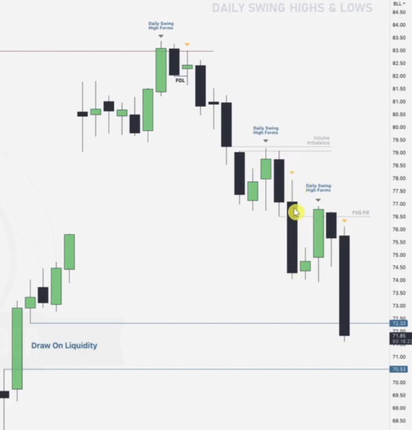

* **Determine the bias**: note the BSL(red) in daily or HTF and the FVG.. draw on liquidity(blue) anticipating that after order pairing at the BSL .. will aim for the FVG draw on liquidity(blue).. hence expected bias is bearish..
* **Mark the possible key levels**: in the bearish movements where the retracements to form swings are likely to be in... volume imbalance and FVG labeled on the bearish movement.Note that swings are formed while trying to tap into these two key levels.
* A swing is also noted to form at the BSL at top, then also would possibly form after tapping the blue draw on liquidity at the bottom..
* **Apply best model table to swing monitored at key level**: Once the swing is monitored.. apply best model concept .. we aim for the 4th or 5th day based on risks.. more below..

### ****When to Aim for the 5th Day Only****

* **You Want Confirmation:** Waiting for the 5th day reduces risk since the market direction becomes clearer after the 4th day's action aligns with the framework. E.g., if the 4th day takes out the 3rd day's low in a bullish trend, the 5th day often confirms the reversal by aiming for the 4th day's high.
* **You Trade with a Conservative Approach:** If you're risk-averse or prefer high-probability trades.

### ****When to Trade Earlier (4th Day or Both Days)****

* **4th Day Liquidity Grab Opportunities:** On the 4th day, when price takes out the 3rd day's liquidity (high/low), it often provides **early reversal entries**: Bullish grab (takes out the 3rd day’s low): Enter near the low after rejection OR Bearish grab (takes out the 3rd day’s high): Enter near the high after rejection. These setups allow you to **capture the reversal** earlier before the 5th day’s target is reached.
* **Confidence in the Market Bias:** If you’re confident in your analysis.
* **Scalping or Intraday Opportunities:** The 4th day often provides high-quality **intraday setups** after the liquidity grab, which you can trade if you’re not looking to hold positions for the 5th day.

### ****Ideal Approach: Combine Both****

* **4th Day Entry:** Enter on the 4th day after liquidity grabs for a reversal (confirmation from key levels).
* **Hold to the 5th Day:** Keep part of your position open to ride the move into the 5th day target.

Enter 4th day and ride or die till 5th day....Maximizing your profit potential.

* **Go intraday.. best 1hr using the OLHC..OHLC aiming for entries in either 4th or 5th day.. best model table will help you determine the daily candle stick patterns (bullish/bearish..reversals)**: Next step after confirming which day to enter in..Use the OHLC..OLHC concepts e.g highs/lows in London session or NY reversals **in addition** with core concepts.. PD arrays.. ERL IRL.. order pairing .. failure swings.. MMXM .. OB.. Mitigation.. breaker.. Equal Highs.. volume imbalances etc.

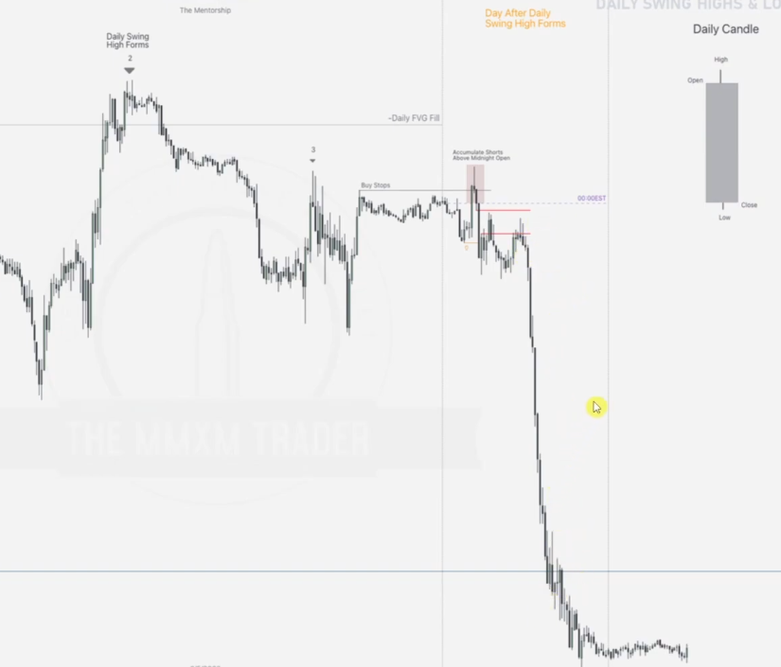

We note accumulation of shorts in London session to form high of the day above the midnight open, formation of an FVG(hourly) which is tapped back, then reversal and continued distribution during the NY. 5th day should be the continuation.

EXAMPLE 2

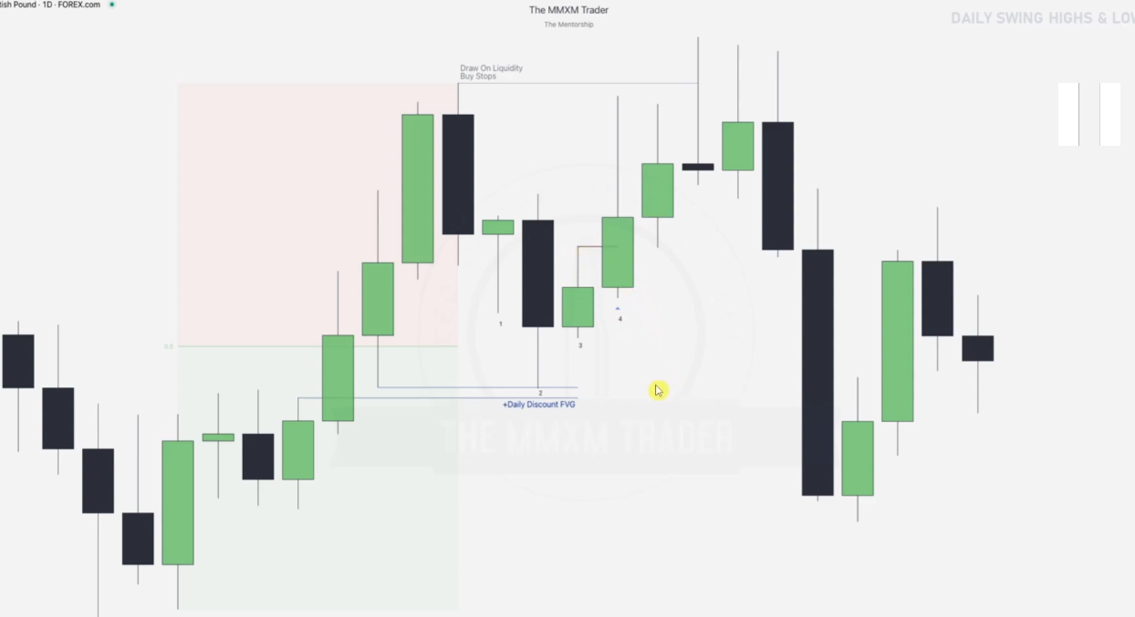

* **Determine the bias and mark key levels**: prem_disc drawn and key levels drawn.. ERL and the discount FVG.
* Use best model when key level tapped: When a swing touches the discount FVG.. key level pick up the **best model** and note that 3rd candle is bullish whose high is taken hence 5th candle aims for high of the 4th candle.
* **Go intra-day** to see if you can enter at 4th or 5th:

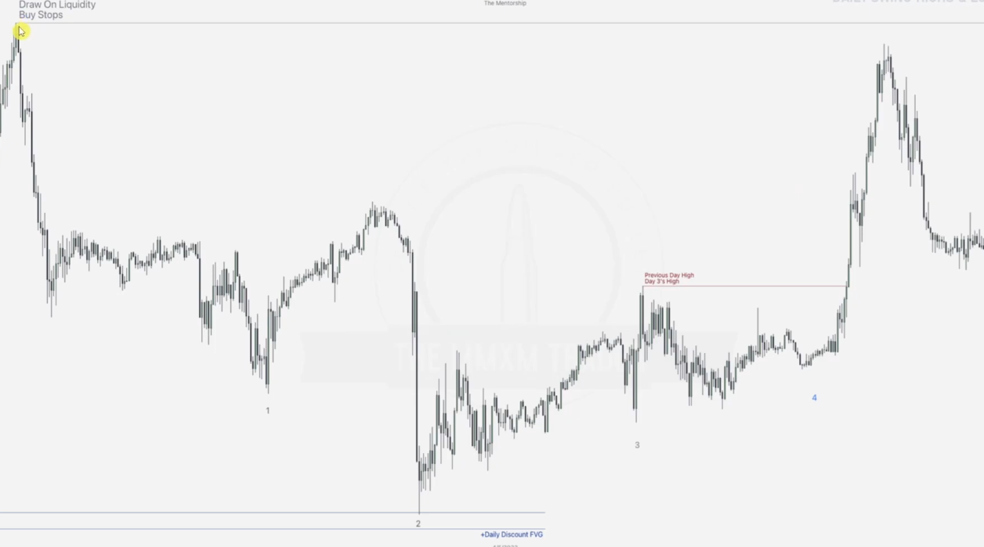

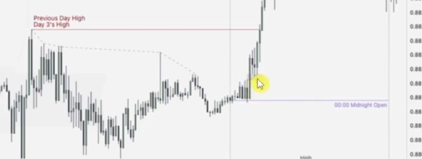

**FVG here on 4th day**

* Draw Failure swings on day 3 and note that the high resistance low appears as we enter into day 4 , from where there is a break FVG showing that we can go higher(entry) and we aim for the low resistance swings or the PDH of day 3(red) in general. This is going up above the midnight open.

**DAILY SWING HIGHS AND SWING LOWS: EXAMPLE TWO**

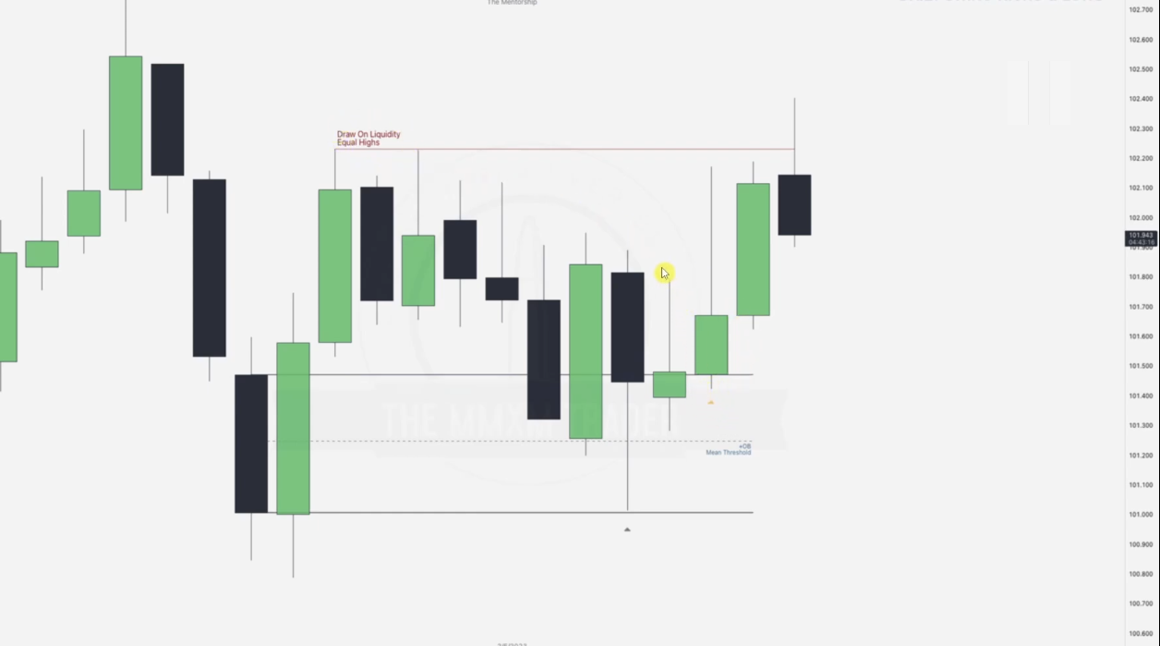

* We draw order-block-OB and its mean distance, the swing low touches this point, cursor is at the 3rd candle.
* Going intra-day

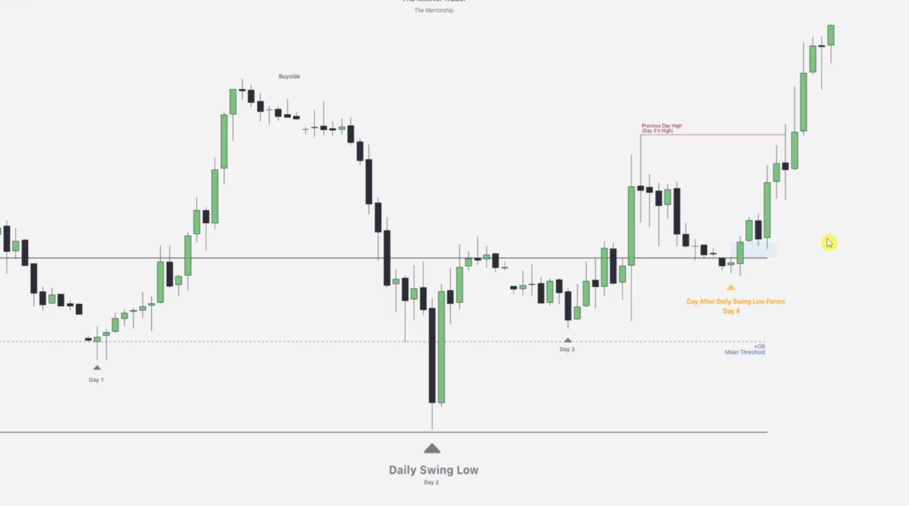

* We draw our failure swings on day 1 entering into day 2, day 2 provides us with the high resistance low---way below the mean distance of the OB, hence day 3 is on the longing rise and its high is formed.
* Picking up from day 3.. where our trading begins, if we decide to enter on day 4. looking at the OB which hasn’t yet been engulfed.. we still use it as IRL.. hence ERL buy stops are drawn up... now we will aim for order pairing at a point in day 4.. aligning with the cursor.. from where we go high to take out the PDH of day 3.. we continue to day 5...

**INTERNAL & EXTERNAL RANGE LIQUIDITY: THE RELATIONSHIP**

This is the lesson that makes bias prediction easy

**TIME FRAME ALIGNMENT**

While using ERL VS IRL use the following time frame alignment

* Monthly > Daily
* Weekly > 4h
* Daily > 1h

**RELATIONSHIP BETWEEN INTERNAL & EXTERNAL LIQUIDITY**

This relationship is key in understanding where market is likely to draw to.

**DEFINING INTERNAL & EXTERNAL LIQUIDITY**

* **Internal Range Liquidity is defined by FVG or other PD arrays**
* **External Range Liquidity is defined by highs or lows**
* **When ERL is taken, IRL becomes the next draw**
* **When IRL is tagged, ERL becomes the next draw**

**Illustration 1(Taking out low ERL and heading back to an FVG and vice-versa )**

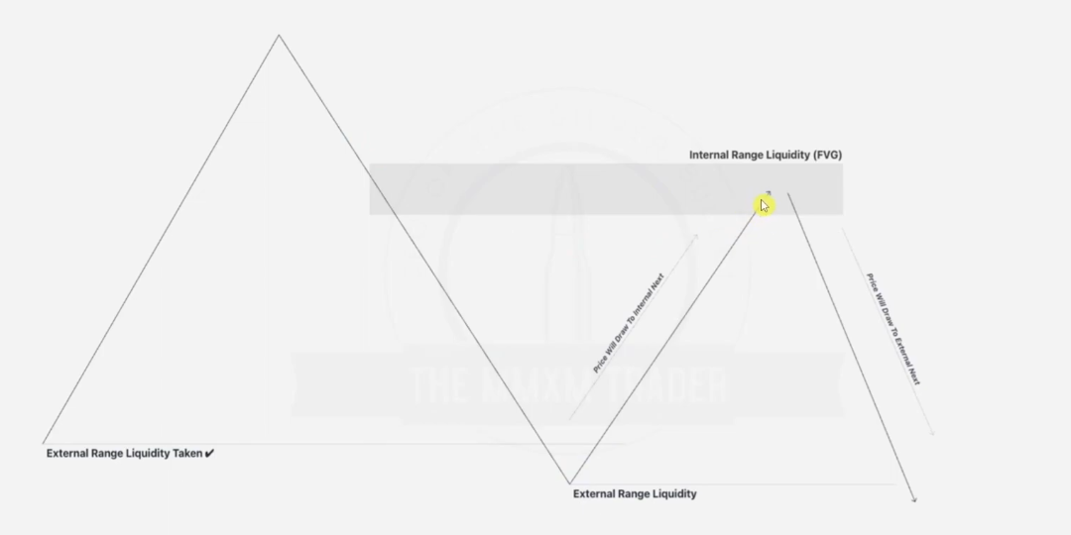

During the process of the price coming back to take the low, there is an imbalance formed-- FVG hence as a result, after taking it, that FVG is the next target.

Same happens in example below but here we were hunting BSL ERL

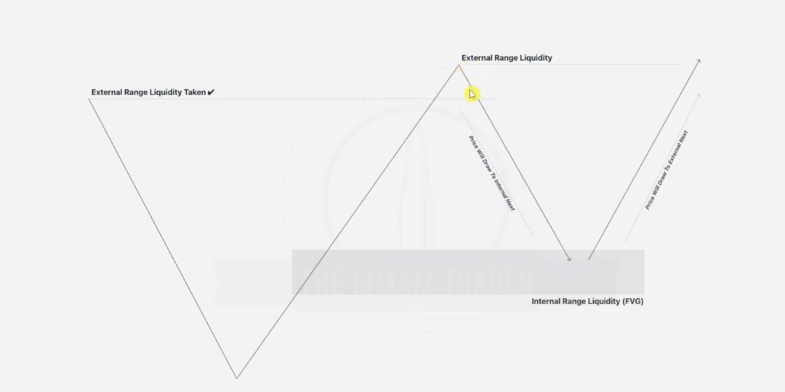

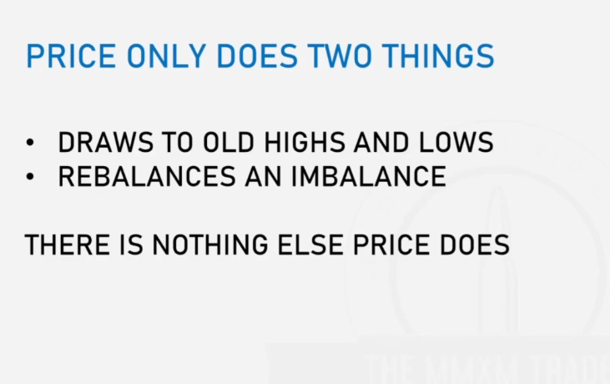

**Idea**: So for example we are in a bullish order flow and an old low has been taken, we should look forward to buy into the FVG created as a result of the hunting of the old low, any of the many FVGs formed in the hunt.

**NOTE:**

When trading from the **monthly higher time frame (HTF)** to the **daily time frame(LTF)**, it's essential to focus on how liquidity concepts (external and internal) translate between these time frames. Here's how you can approach the scenario:

### Identifying HTF ERL helps you anticipate where price is likely to seek liquidity beyond the current range e.g seek for monthly ERL while on daily chart.Identifying IRL helps pinpoint reaction zones where price could pause, reverse, or consolidate within the current range.

### ****Practical Approach****

* **Label Monthly Liquidity Levels:**Clearly mark ERL and IRL on your Monthly chart for reference.
* **Add New Daily Liquidity Levels Only When Necessary:**Focus on daily highs/lows, order blocks, or gaps that align with your **monthly narrative**. Avoid overloading your chart with unnecessary levels that don't align with HTF liquidity concepts.
* **Check Alignment With HTF Bias:** If price is in a **monthly bullish external range**, identify daily liquidity levels that align with a bullish continuation (e.g., bullish order blocks or internal daily liquidity pools).If price is seeking **monthly internal liquidity**, focus on daily levels within that range that support retracements or consolidation.

### ****Key Considerations****

### **Confluence Is Key**: Daily liquidity levels should align with the monthly structure and narrative.

### **Execution Focus**: Use daily liquidity to pinpoint precise entries and stops while letting monthly liquidity guide the overall direction... BIAS

### **Dynamic Adjustments**: Be prepared to re-evaluate daily liquidity points if price breaks key HTF levels or shifts in structure occur.

### ****Steps for Efficient Range Labeling****

### ****Identify the Range Boundaries****:Mark the **highest high** and **lowest low** of the time-frame you're analyzing. These represent the **external range liquidity** (where liquidity lies outside the range).Example: In a consolidation, the upper and lower extremes are the external liquidity zones.

### ****Focus on the Midpoint (Equilibrium)****: Calculate the midpoint (50% of the range) to divide the range into **premium** and **discount** zones. **Premium Zone** (above 50%): Look for potential **sell-side liquidity grabs** or **resistance zones**. **Discount Zone** (below 50%): Look for potential **buy-side liquidity grabs** or **support zones**.

### ****Prioritize Key Swing Points****: Within the range, focus only on **significant swing highs/lows** that are likely to attract liquidity. Ignore minor fluctuations unless they align with major liquidity pools.

**Use Context to Determine Focus**: In a **bullish context**, give more weight to lows (discount arrays or internal range liquidity). In a **bearish context**, give more weight to highs (premium arrays or internal range liquidity).

**Mark Without Overloading**: Instead of marking every liquidity point, simply highlight:

* External Range High
* External Range Low
* Key Swing Highs/Lows near the **midpoint** for internal liquidity..order pairing.

POSSIBLE SCENARIOS FOR INTERACTIONS BTN IRLS AND ERLS

Here's a structured table summarizing all possible scenarios based on price interactions with **FVGs, IRLs, and ERLs**:

| **Scenario** | **Market Behavior** | **Target** | **Bias** |
| --- | --- | --- | --- |
| **1. Price taps an FVG and respects it** | Price reacts to the FVG and moves in the opposite direction | Opposite ERL | Temporary reversal until ERL is reached |
| **2. Price taps an FVG but does not respect it** | Price moves through the FVG without reacting | Nearest liquidity pool (ERL or IRL) in the same direction | Continuation |
| **3. Price sweeps an IRL and reverses** | Price moves below/above an IRL, takes liquidity, then reverses | ERL in the opposite direction | Reversal |
| **4. Price sweeps an IRL and continues** | Price moves through an IRL and keeps going | ERL in the same direction | Continuation |
| **5. Price sweeps an ERL and reverses** | Price reaches an ERL, takes liquidity, and reverses | IRL in the opposite direction | Reversal |
| **6. Price sweeps an ERL and continues** | Price reaches an ERL and keeps moving | Next liquidity level beyond the ERL | Strong continuation |

**ERL Vs IRL: EXAMPLE 1**

Given Monthly chart

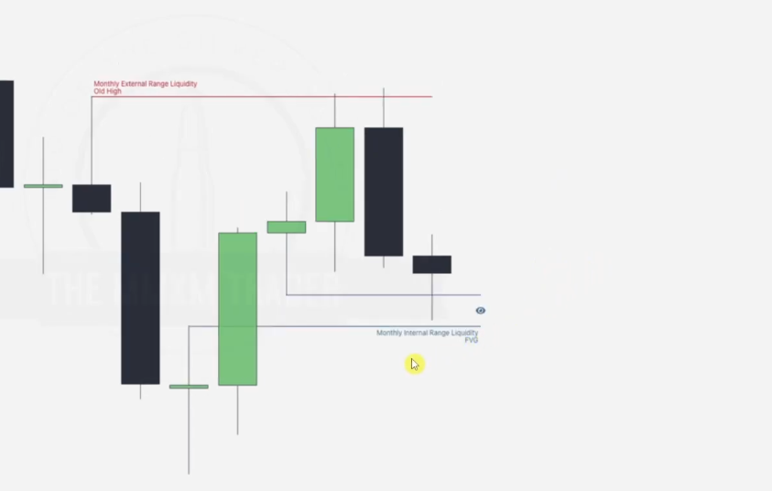

* We are in a bearish flow, we see a bullish struggle meaning, it is hunting for a high.. hence look for a swing and mark the high(red), in the process of the hunt, an FVG is formed which will be tapped into later.
* **Going to the daily chart now, for confirmation.**
* After marking the point of the ERL being taken, we need to confirm with a break of structure to reverse and go towards the IRL as illustrated using long bearish candle not the **doji** candle by the yellow cursor. 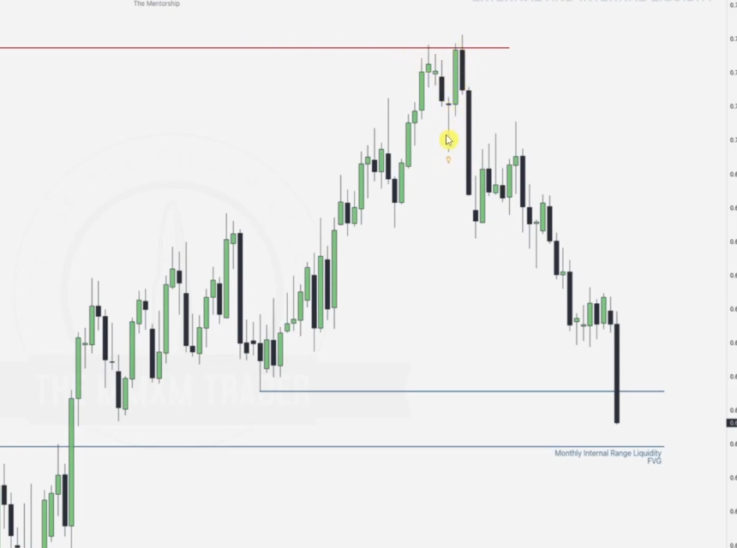

**ERL Vs IRL: EXAMPLE 2**

Given weekly chart

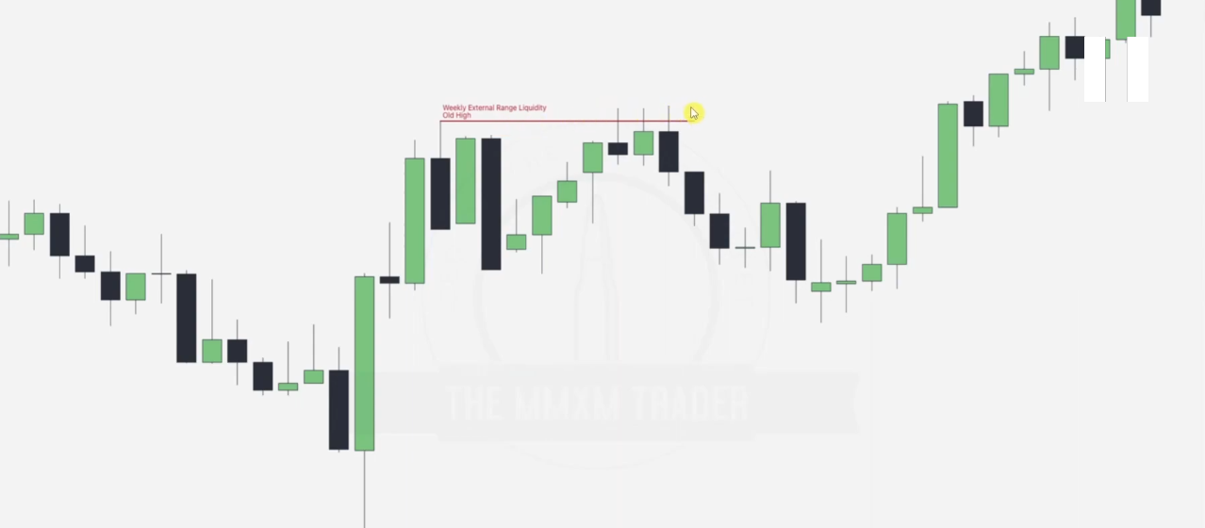

Where next does the market aim after taking the weekly high?

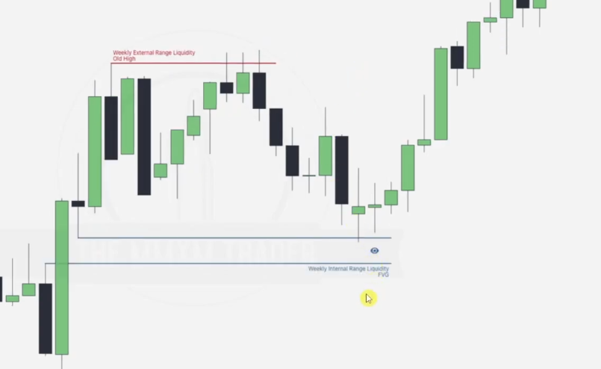

Now after this, where do we draw into next

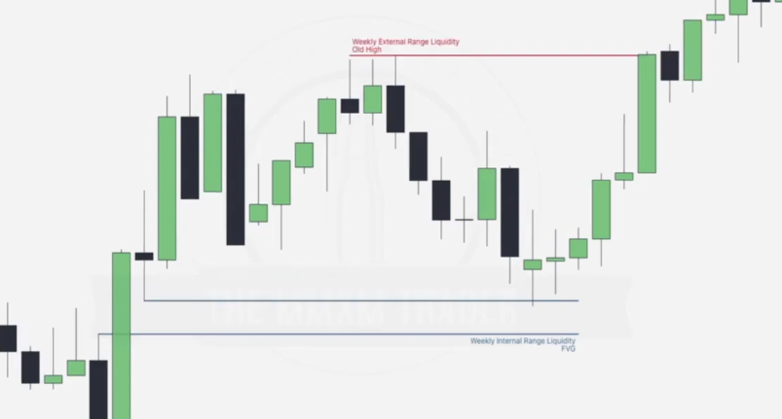

We note to take out the high that previously took out the original weekly old high.

Going to the daily chart. We will

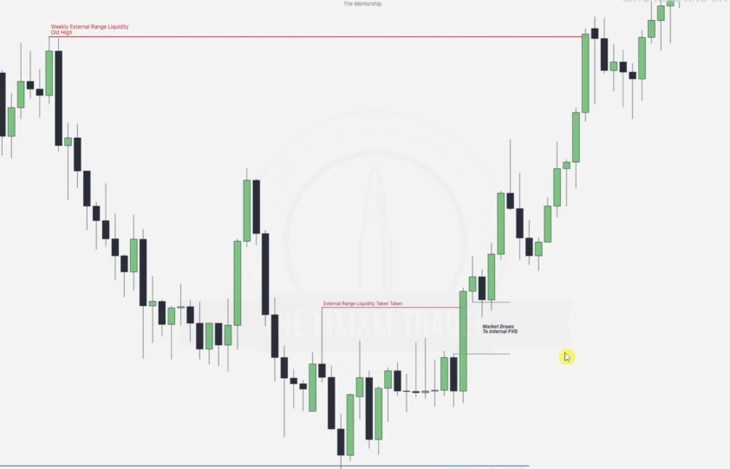

After hitting the Weekly IRL, price hunts the next ERL, Candle with long wick in the process an FVG is formed(near the cursor), we note that the next bearish candle immediately taps into the FVG formed so which ERL next?

NOTE: ERLS ARE FORMED AT **SWING HIGHS / LOWS**

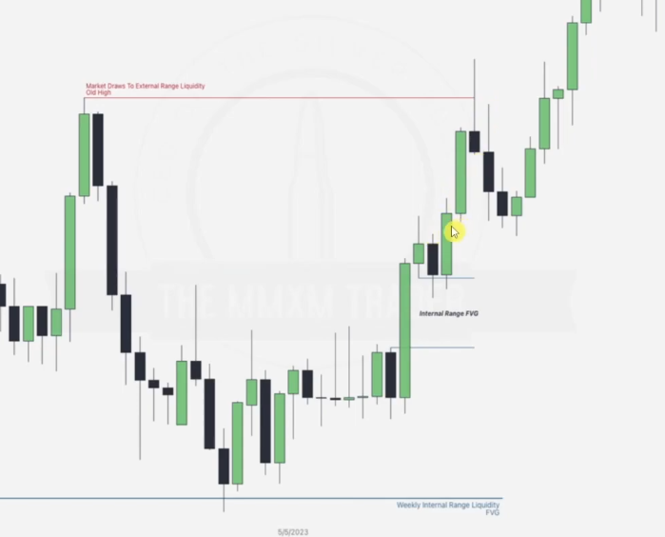

Next is the ERL at the swing high as illustrated, after it is taken we note that there are two FVG formed, hence next IRL lies there, but we will choose the lowest ERL since we are going in a bullish order flow, hence consider the FVG more deep in the discount zone.

This looks to be a repeating cycle, **so what next. But remember to avoid marking unnecessary points.**

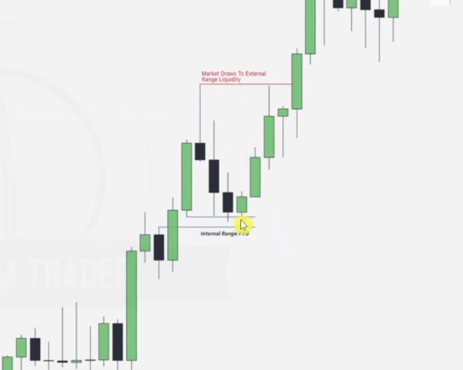

Note that from here, two FVGs are formed to take the next ERL, but they are not eaten back, HENCE we need to be cautious. **ACCORDING TO ME OR YOU CAN USE THE BPR TO HANDLE THIS.. EXCEPT THERE IS NO BPR HERE HENCE WE JUST HAVE TO TIME HOW WE MARK OUR ERLS AND IRLS.. I THINK YOU JUST NEED TO AIM FOR FVG IF YOU NOTICE AN OPPOSITE CANDLE FORMING UP NEAR THE FVG.**

HENCE Next will be something like this

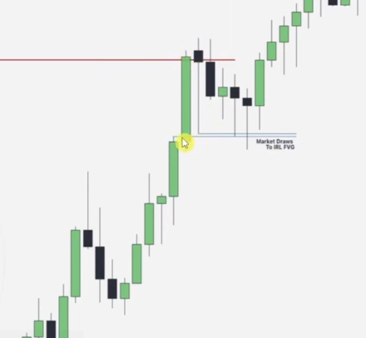

Drawing the final in the day to day

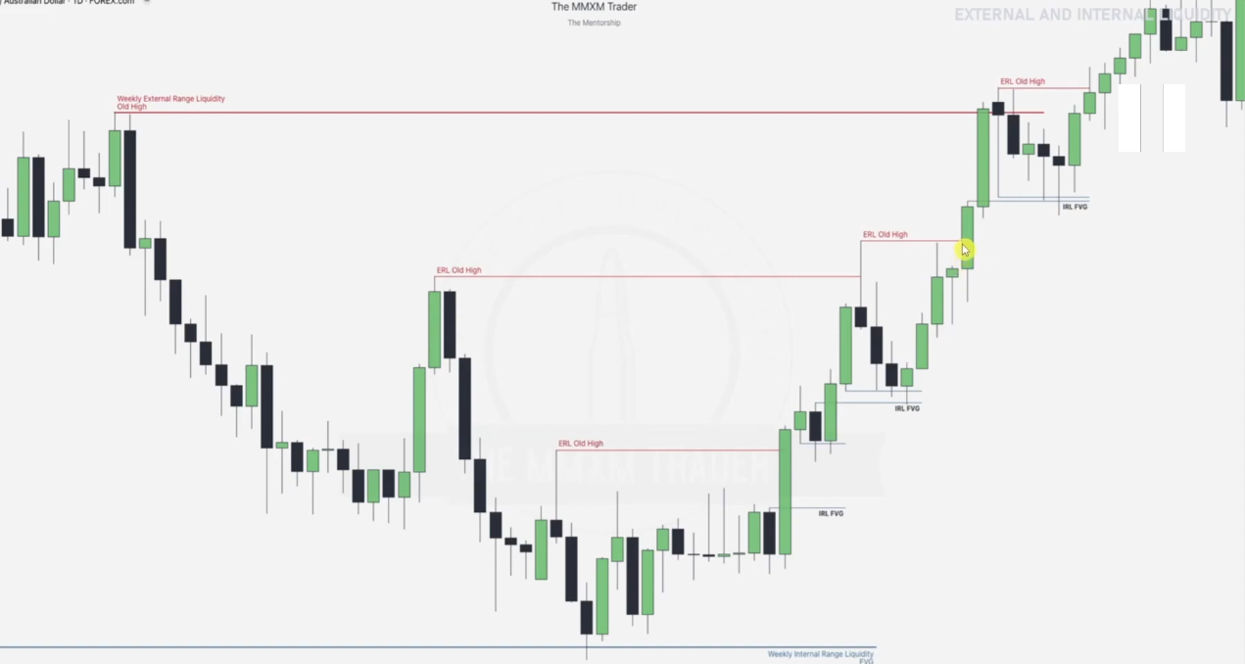

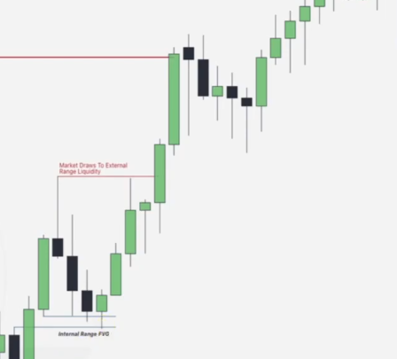

**ERL Vs IRL: EXAMPLE 3**

Note the Failure swings and note the SSLs.. and we are in a MMSM

Using the SSL(taking out SSLs) in daily bias video

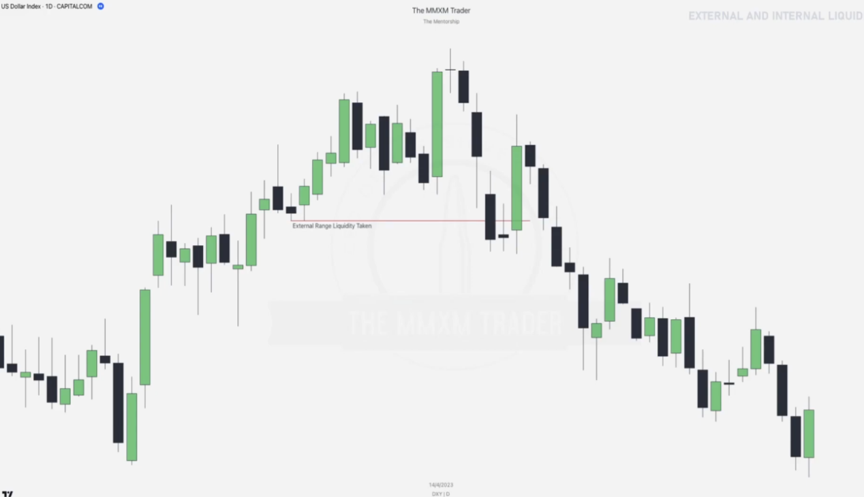

This is our next draw here

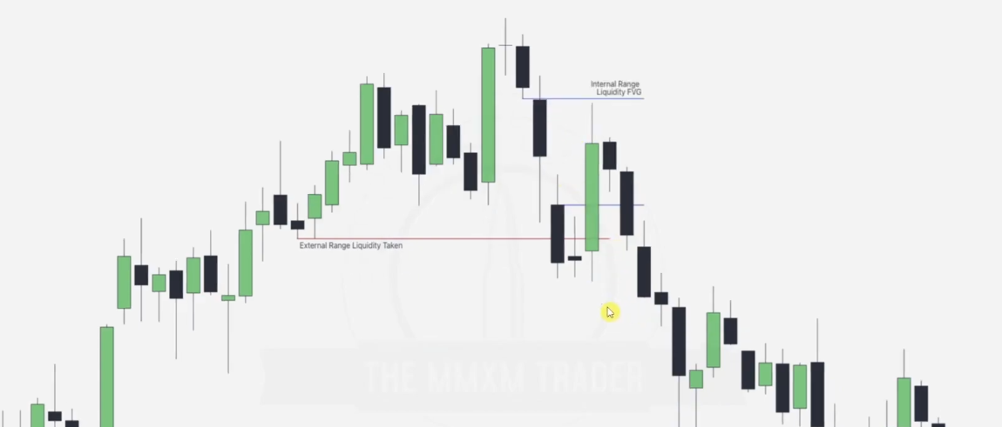

Note next swing low and draw ERL

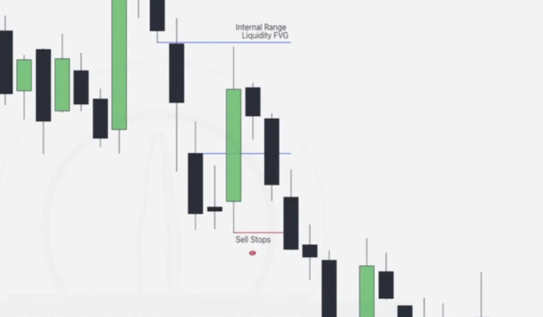

* Wait for it to be taken out and target next FVG.
* Looking for next FVG??? Now this is the next issue we were looking at, we have ERL cleared but a continued flow which is bearish.. **using the idea from the previous example where we wait for any change in candle structure before we go for any FVG clearance since we have failed we have failed to see a BPR or volume imbalance**..as seen with the last FVG downwards, hence we wait for a bullish candle.. turn to target any FVG after the ERL.Focus on where the cursor is

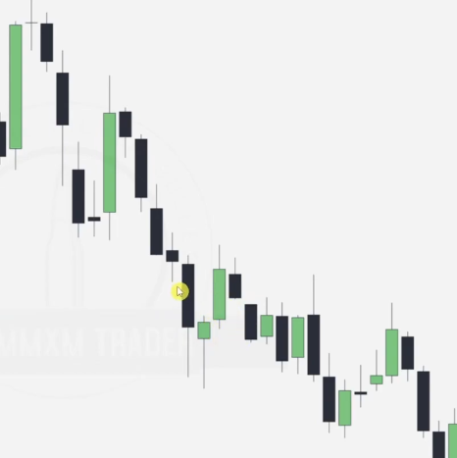

**IDEA HERE IS THAT AFTER THE LOW SWING IS ATKEN WE WAIT FOR ANY SIGN OF UPWARD MOVEMENT AND AIM for NEAREST FVG(LABELLED WITH THE CURSOR)**

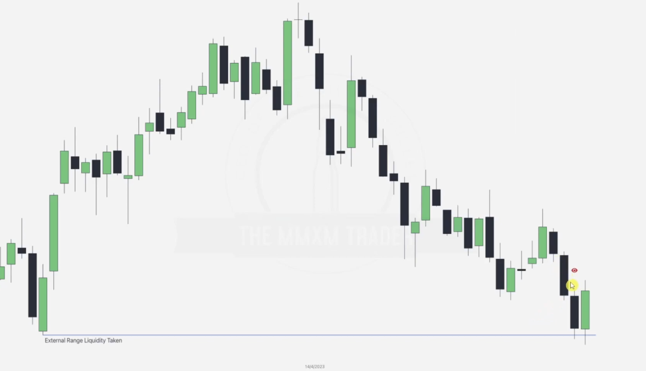

We monitor some serious consolidation after .. no IRLs marked here before price takes down an old ERL and looks forward to the highlighted FVG

**IRL VS ERL: EXAMPLE THREE**

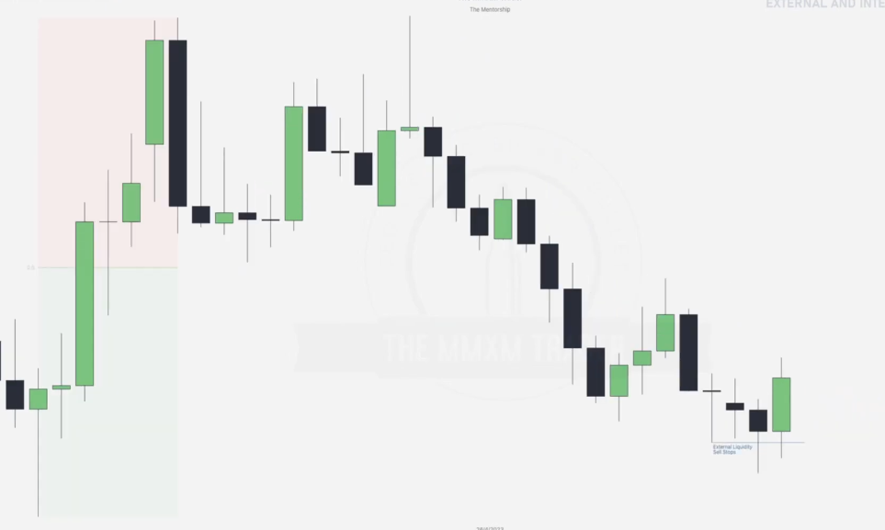

Draw ERL

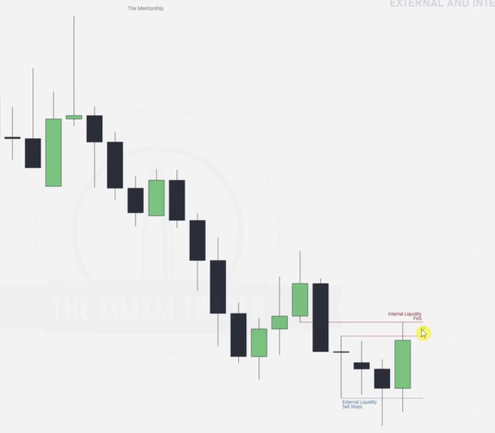

Draw IRL and..

Going to intra-day hourly

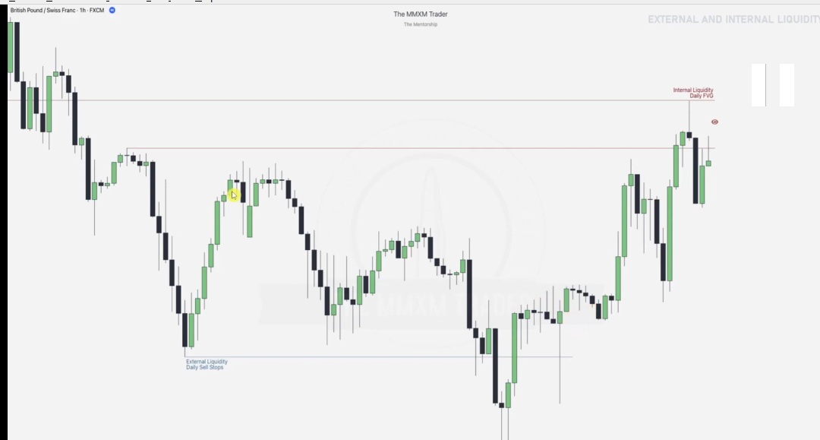

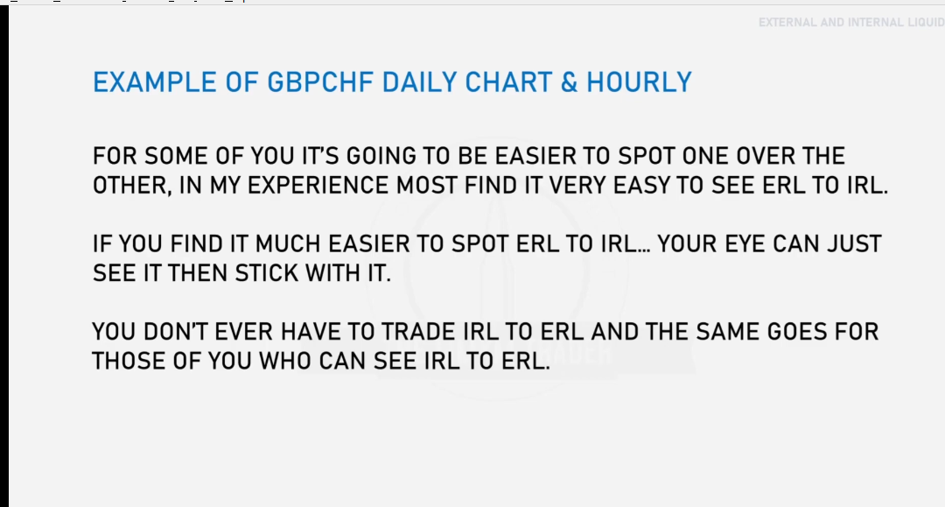

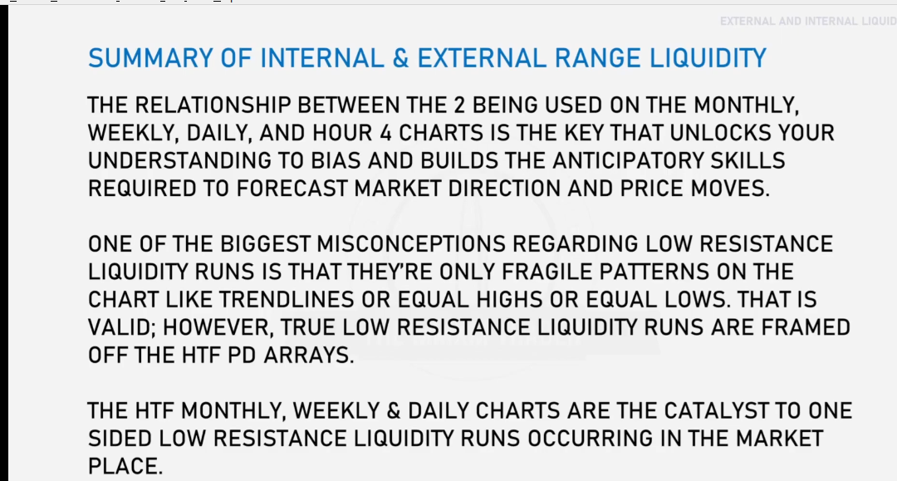

### ****ORDER PAIRING – HTF TURTLE SOUPS & LIQUIDITY ENGINEERING****

#### ****Understanding Liquidity Requirements****

To trade effectively, it’s crucial to understand the **liquidity requirements** that smart money (e.g., institutions) needs for their orders. This includes:

1. **Where they enter the market**
2. **How they exit their positions**

This foundational knowledge helps you trust the market's delivery to specific price levels and recognize **why and where the price is reaching those levels**.

#### ****Common Trader Challenge**:** You anticipate that price will move to a certain level. You exit your trade early, assuming a retracement is the start of a reversal. Eventually, the price hits your predicted level—after you've already exited.This scenario reflects **a lack of trust** in how the market delivers liquidity to its desired destinations.

#### ****The Role of Liquidity Engineering****

Market makers (e.g., institutions or algorithms) **engineer liquidity** to pair their orders effectively. This involves:

* Using retracements and corrections to induce traders into thinking price is reversing.
* Grabbing liquidity (e.g., stop-loss levels) before continuing toward the desired level.

#### ****Key Takeaway****

The urge to exit a trade prematurely during a retracement stems from:

* Misunderstanding the **delivery process** of liquidity.
* Underestimating how market makers engineer liquidity for their **order pairing**.

Trusting the market's delivery process and understanding liquidity engineering will help you stay disciplined and avoid unnecessary exits.

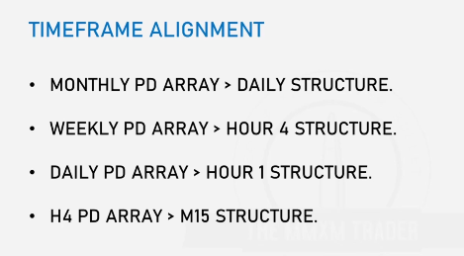

### ****Where Is Smart Money Involved?****

#### ****Time-frame:****Smart money (institutional traders) predominantly operates on **higher time-frames**, including: Monthly, Weekly and Daily. Their orders are too large to effectively execute on smaller time-frames due to insufficient liquidity.

**Price Action:**

* **Bullish Context:**  
  Smart money positions themselves **below swing lows** (seeking liquidity to buy at a discount).
* **Bearish Context:**  
  Smart money positions themselves **above swing highs** (seeking liquidity to sell at a premium).

**Trading Implication: If you’re not trading off higher timeframe levels, you’re gambling.** Lower timeframes often lack the structure and liquidity needed to align with smart money movements.

### ****Does This Mean Order Pairing Can Only Be Done on Monthly, Weekly, and Daily Charts?****

**Not entirely, but higher timeframes provide more reliability:** They contain larger pools of liquidity due to the volume of participants at these levels. They show clearer structural trends and key levels that smart money uses for execution.

**Can Order Pairing Work on Lower Timeframes?:** Yes, but it’s more risky because smaller timeframes can be influenced by short-term volatility, lack significant liquidity, and are often “noisy.”To safely execute order pairing on lower timeframes, align it with the direction and structure identified on the higher timeframe.

**ORDER PAIRING:EXAMPLE ONE**

Given this monthly structure

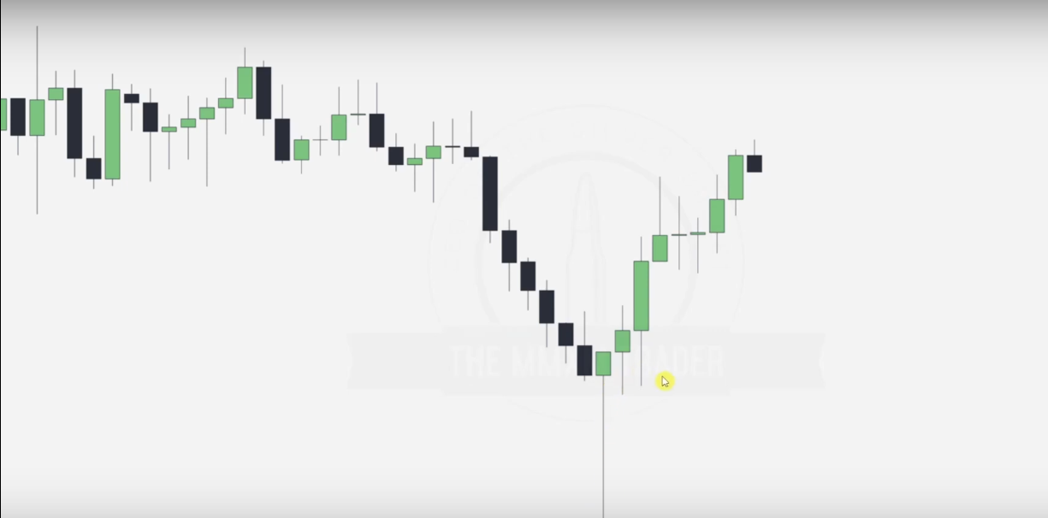

Draw a IRL to ERL movement from the bullish movement side

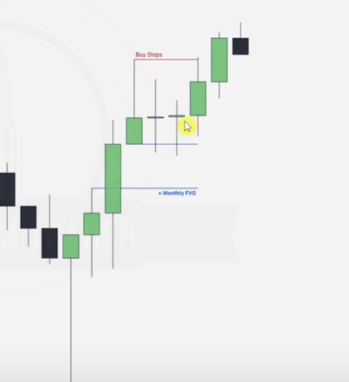

Going into the daily

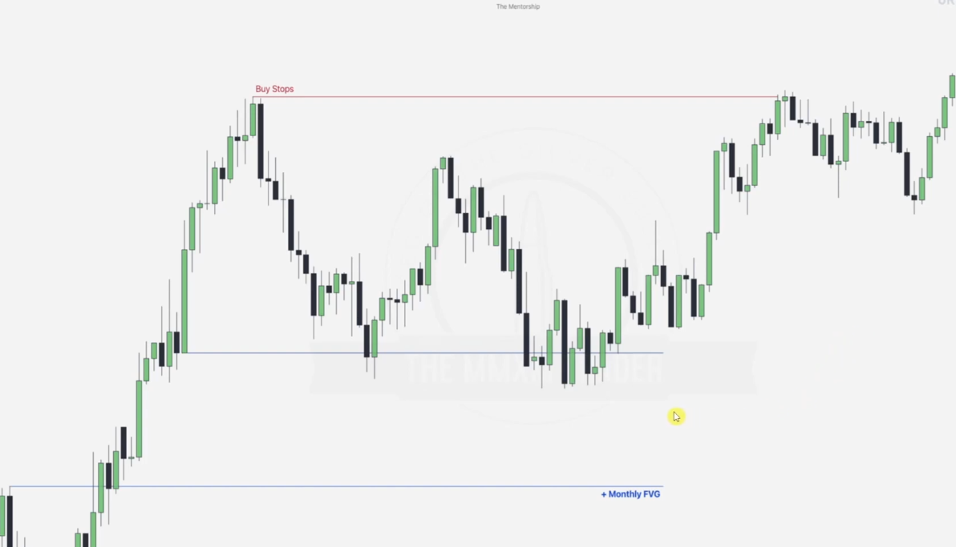

Kindly note that the eye denotes the point where we expect our sell stop(SSL where buyers are trying to catch but the bank has them)

And this is illustrated as below.. we note two accumulation zones though..

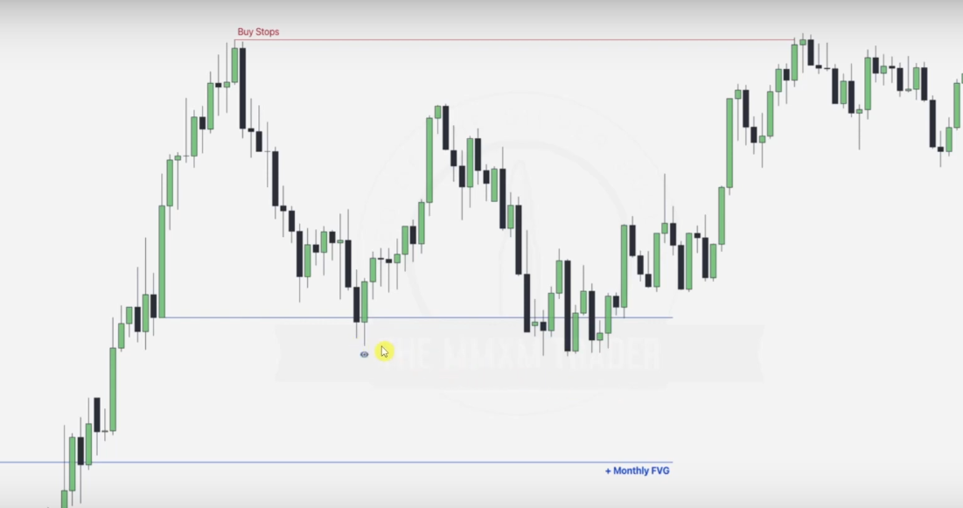

Sell stop illustrated and the market accumulations marked red

We can use the first accumulation.. retracement to mark our new sell stop..

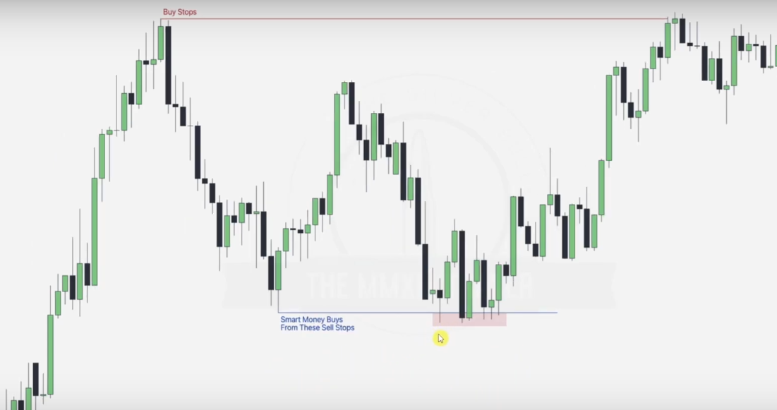

Smart money then sells at the red points ERLS, REMEMBER WE MOVED FROM A FVG TOO AT THE MANIPULATION to the willing buyers. Confluence here too good... FVG and Sell stop.. Since this is an IRL in HTF.. next is an ERL.. we start by marking some obvious ones in the 1 hr chart

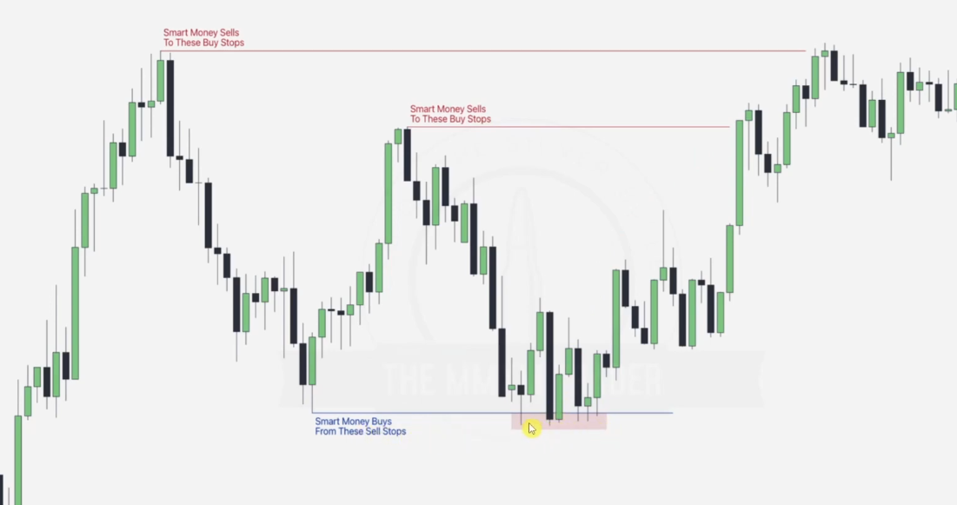

**NOTE: Engineering liquidity is done via retracements and failure swings**

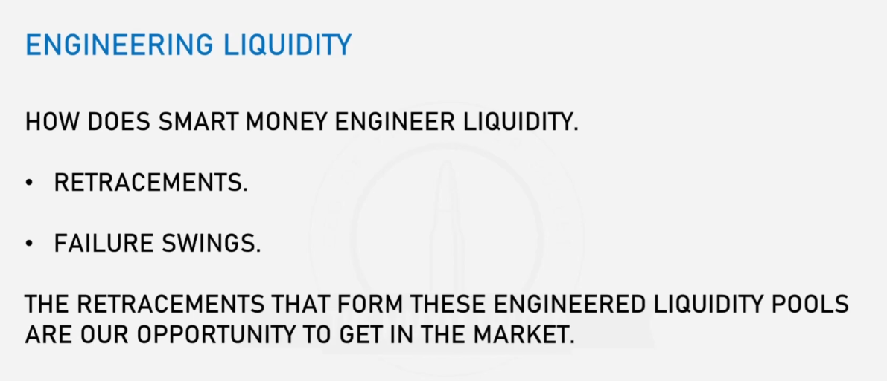

Illustrating failure swings(low resistance) in the prev daily chart

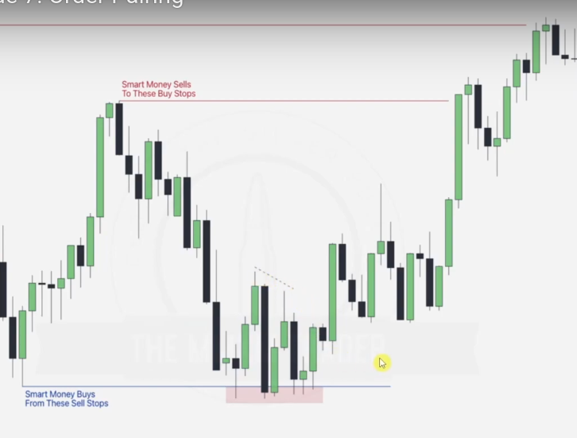

Using the ideas of ERL vs IRL

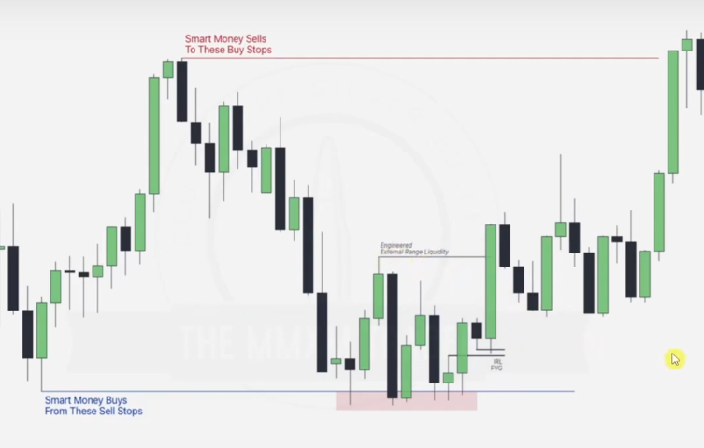

In the accumulation zone..order pairing we note that intra-day SSL is tapped into 3 times in a consolidating manner.. until a real break from the order pairing is done.. illustrated in table below

|  |  |
| --- | --- |
|  | SSL.. ERL tapped into after bearish movement forming first FVG..IRL  New break after order pairing forms the second FVG... filling the first bearish FVG |
|  | Second FVG is taken by the bearish block looking to tap into the SSL again.. This also forms a bearish order block in the process... after tapping the SSL.. this bearish FVG is broken... WHAT NEXT.. buy stop or SSL again? |
|  | Next journey was to the SSL in which another bearish FVG is formed.. we at the SSL now |
|  | The prev bearish FVG is taken over and a new break in structure is formed after the order pairing... from this point note that the price now goes bullish.. to the new buy stop even though it retraces to tap into the newly formed FVG.. after SSL. |

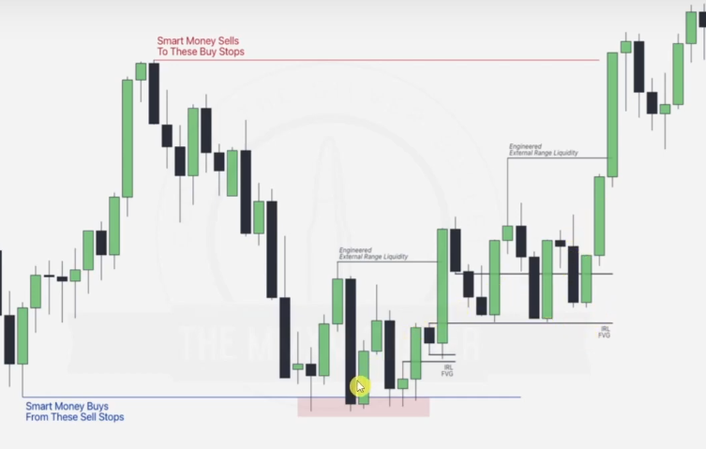

New Buy stop.. ERL is spotted as next aim since we bullish now.. in the process of taking this ERL.. FVG formed.. which is tapped into and there is some serious consolidation afterwards.. forming another high and this goes on and off

**ORDER PAIRING: EXAMPLE TWO**

Given weekly

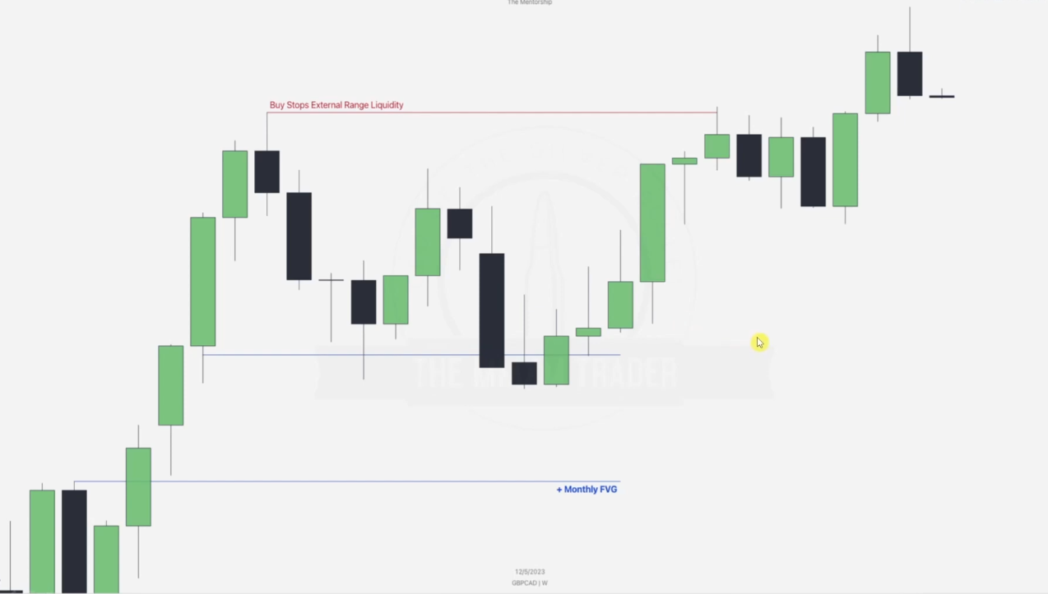

Going to daily

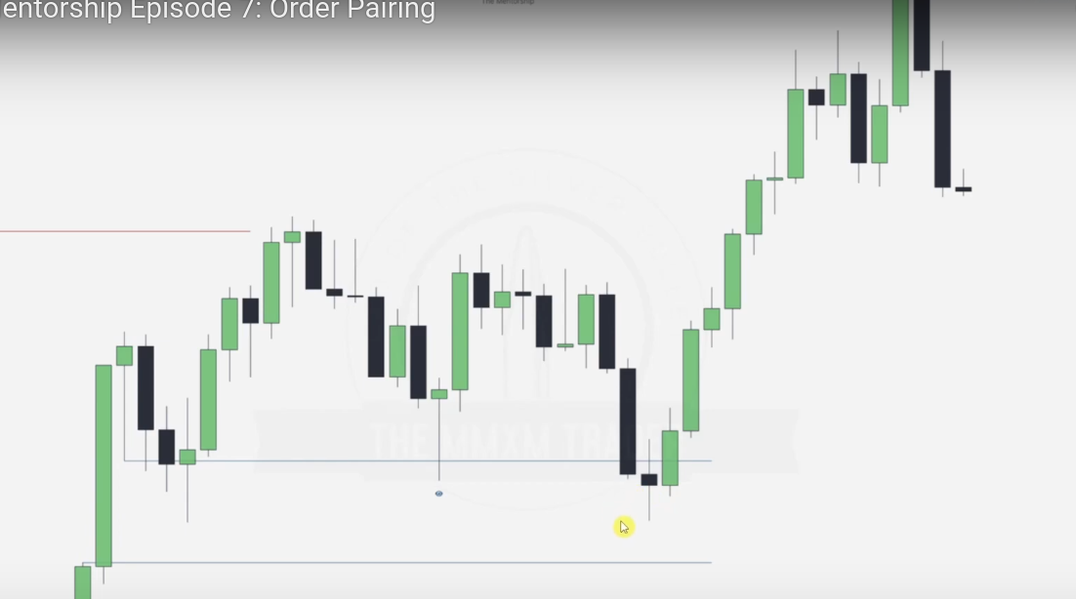

Next step is noting the sell stop for order pairing.. job of the FVG.. weekly was to note where support will be provided upwards.. hence we note the new sell stop and the buy stops upwards as below. Also include the Failure swings...

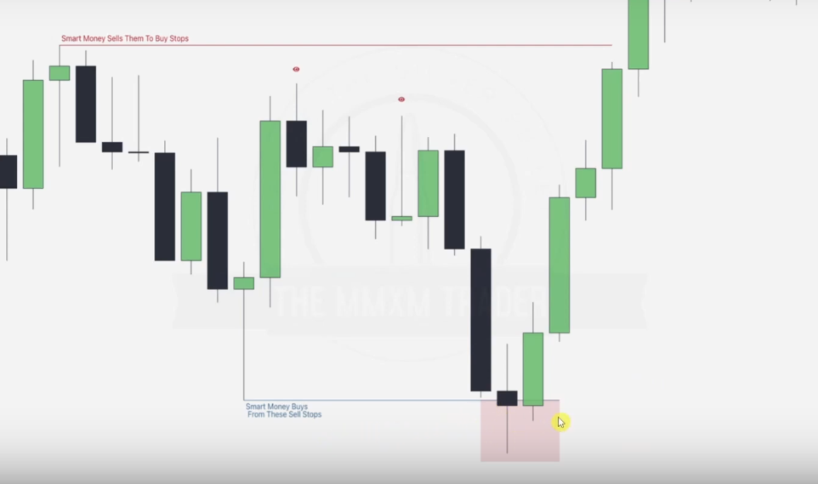

Going to hourly 1 hr

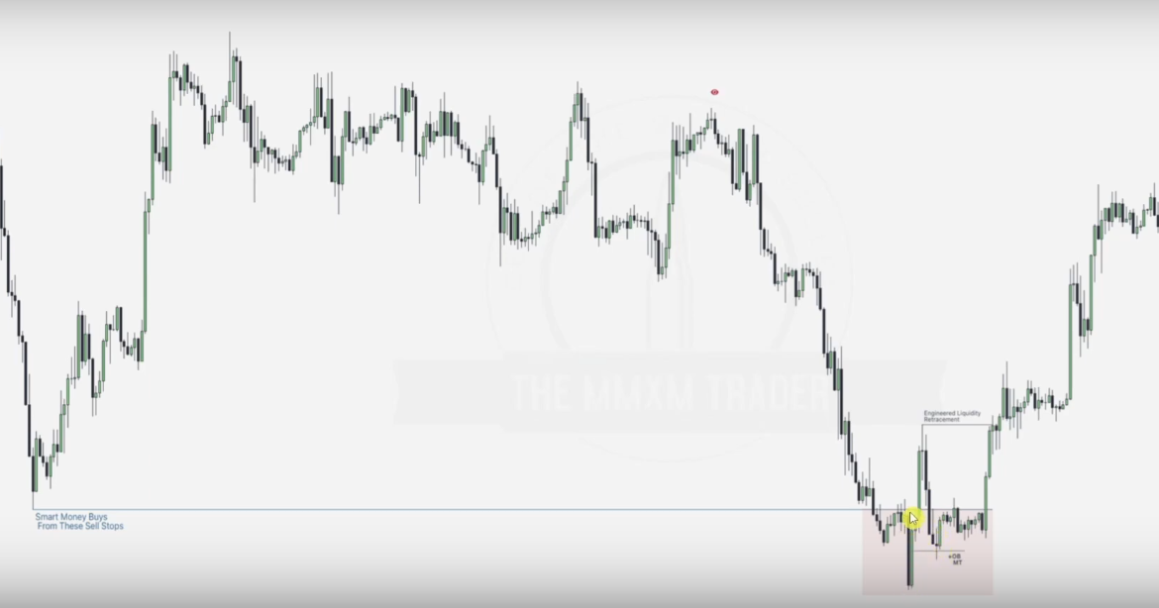

We note that there is a bullish order block that pushes price up during manipulation, the reversal after that push will cause most of the traders to sell-- falling to trap

After taking out the initial failure swings, we note a consolidation, NB: THERE IS NO REVERSAL AFTER A CONOLIDATION hence we aim for the more of the failure swings drawn in the daily chart.

Initial Failure swings were drawn in the consolidation(engineering zone as shown)

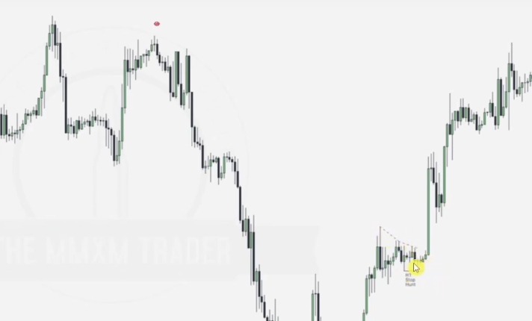

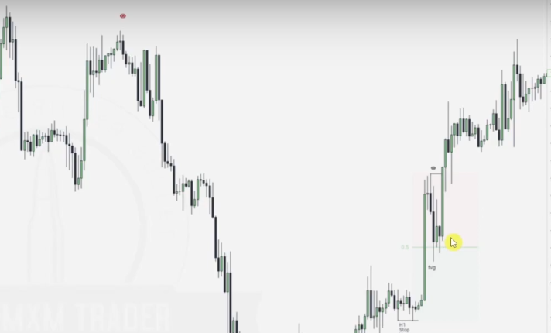

We draw our prem_disc chart, note that the high of that prem_disc is trying to create an equal high with an opposite candle swing other side. Price taked out Failre swing ERLs and taps back into the FVG in discount range.. this is the perfect point for longing

**ORDER BLOCKS**

**WHAT MAKES THEM HIGH PROBABILITY**

1. **Form at key level**

* Bullish order-blocks(**last bearish (down-close) candle** **before** a significant upward move or market shift occurs) with a short term liquidity pool above it
* Bearish order-blocks(**last bullish (up-close) candle** **before** a significant downward move or market shift occurs) with a short term liquidity pool below it

### ****Liquidity Pool and Stop Purges:****Order blocks push price into a liquidity pool, causing a ****purge on stops****, leading to:

* **Bearish Order Blocks:** An **up-closed candle** that drives price into **buy stops(stop buying , sells overtaking).**
* **Bullish Order Blocks:**A **down-closed candle** that drives price into **sell stops(stop selling , buys overtaking).**

### ****Market Program Influence:****

* **Bullish Order Blocks:** Occur in a **buy program** to support price moving higher toward a **draw on liquidity above** the market price.
* **Bearish Order Blocks:** Occur in a **sell program** to support price moving lower toward a **draw on liquidity below** the market price.

**WHAT CHARACTERISTICS DO HIGH-PROBABILITY ORDER BLOCKS HAVE?**

### **Bullish Market Conditions: Down-closed candles** will act as **roadblocks** when Price moves **down into them**, providing support and pushing price higher.

### **Bearish Market Conditions: Up-closed candles** will act as **roadblocks** when Price moves **up into them**, providing resistance and pushing price lower.

**NB: It has to hit a key level to be a high probability order block**

EXAMPLE ONE

WEEKLY CHART

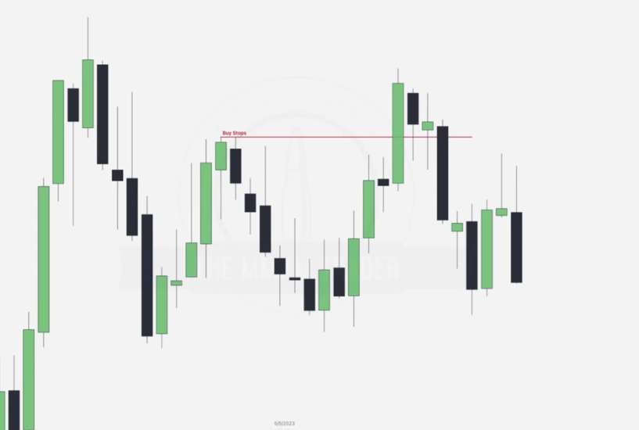

Here now we need to apply the concepts of ERL vs IRL , Failure swings and Order pairing

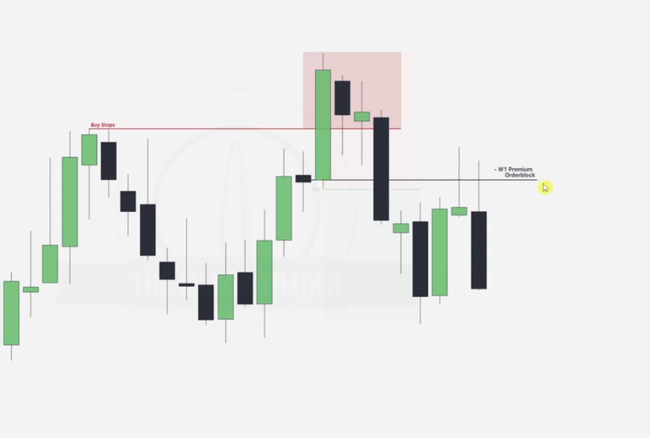

We note that after noting the order pairing , ERL has been taken down hence next journey is the Order block which is labelled it is an IRL.

After this we go to a 4hr chart

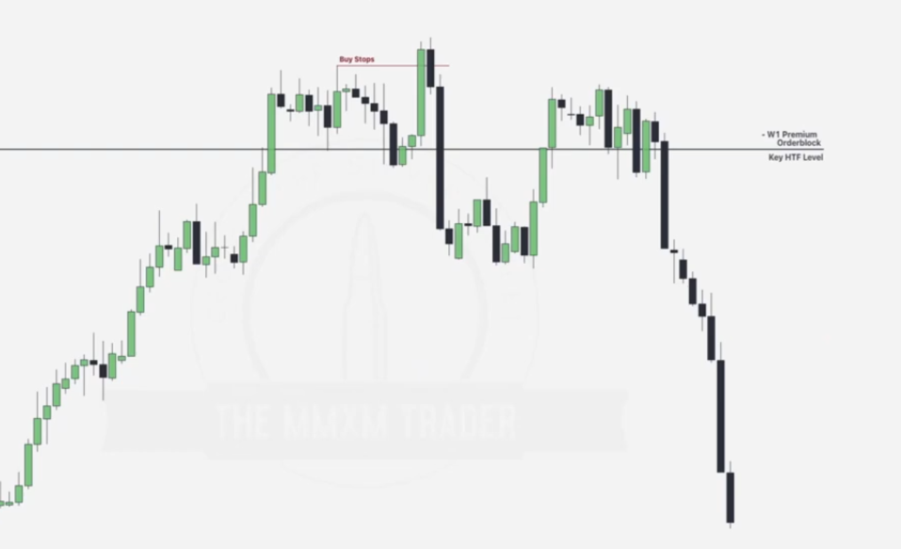

PLAN: NOTE A HIGH PROB ORDER BLOCK

Draw the failure swings

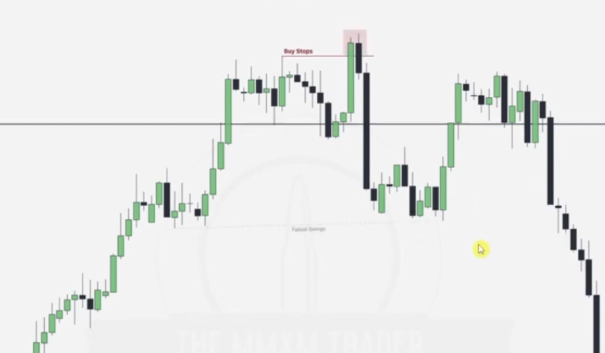

Up close candle (order block) in bearish order flow now acts as resistance. NOTED

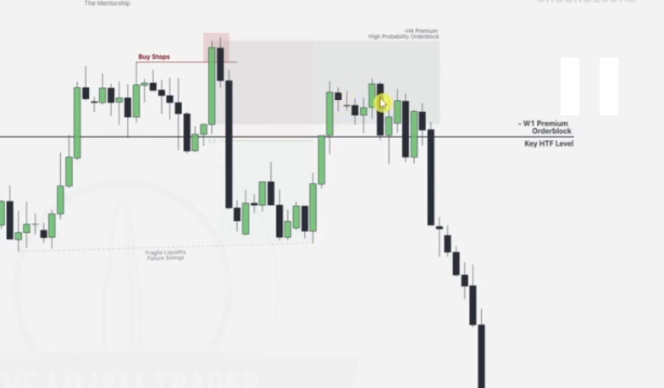

EXAMPLE 2

GIven a monthly chart.

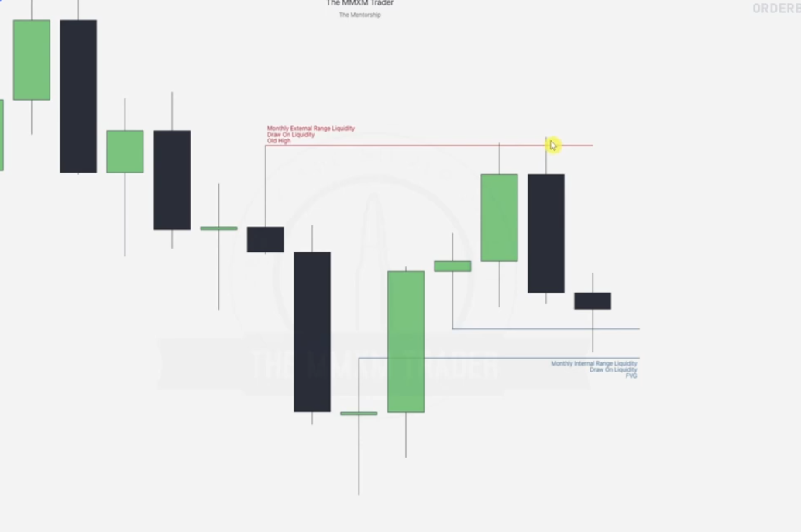

We do the normal (OHLC, Failure swings, Swing high swing low, order pairing)

Here we basically used ERL Vs IRL only

Going to daily

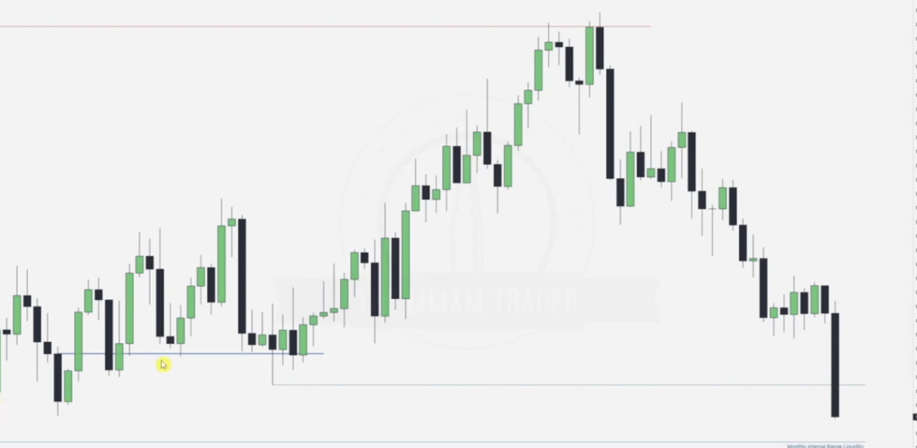

We note that this down close candle provides support and it is of HIGH PROB because it occurs within the range of the Monthly FVG

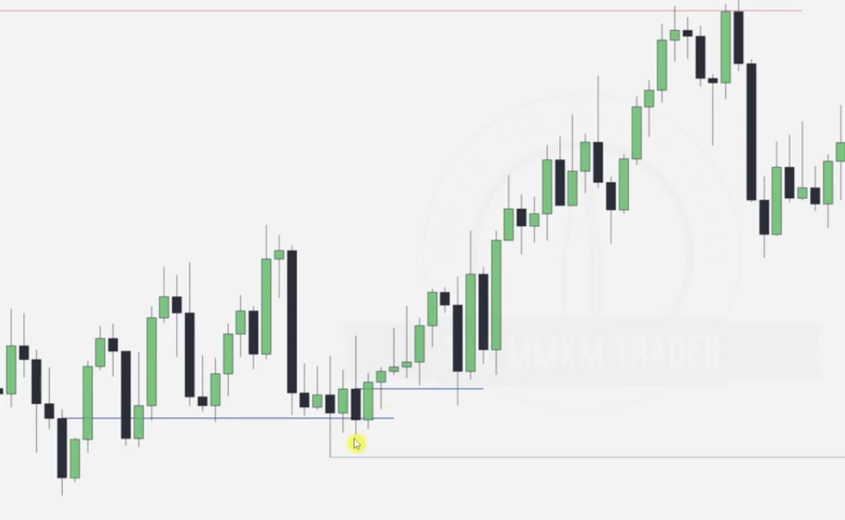

Next one forms at key level of the previous order block

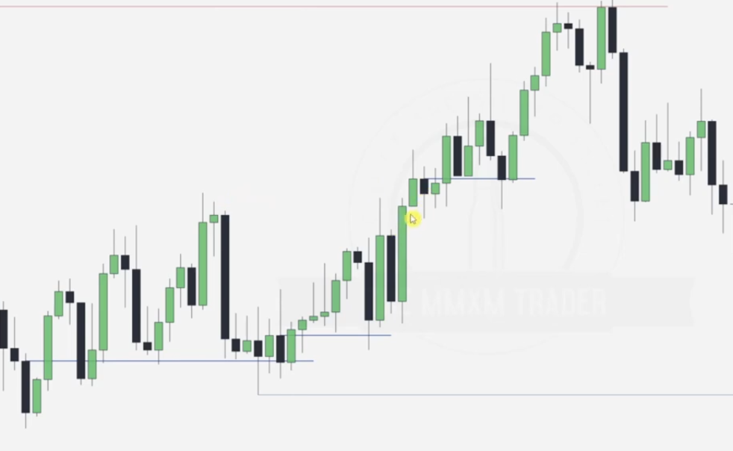

Next one hits the imbalance as shown above

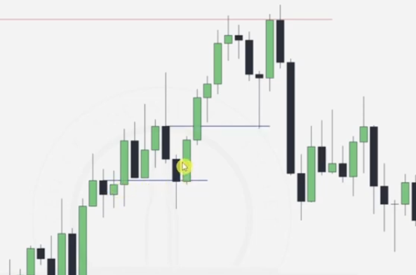

Next order block labeling seems to be wrong, BUT all in all after taking out the order blocks at key levels IRLs we note that there is a high run tot the ERLS.

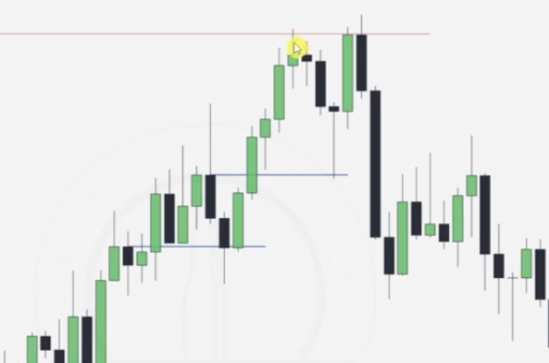

We note that there is a raid here but it is shortlived, this points out that there is a potential second raid

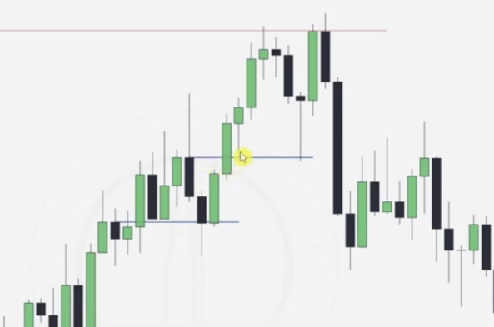

Price taps into and orderblock + FVG IRL combination after the shortlived raid



Hence next step is an ERL which is the top red buy stops.

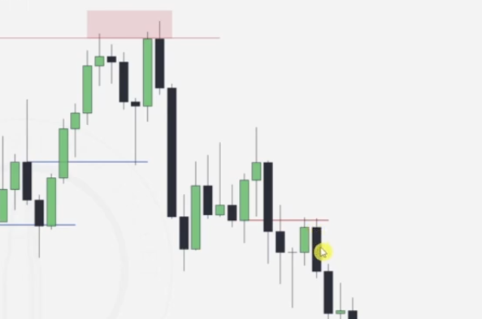

Note that the order pairing causes the reversal, after that a break occurs.. FVG.. and now we are in Bearish order flow.

Note that the first upclose candle providing downward resistance is at key level of an FVG and a recent order block.

WE note down the Bearish order blocks now at the KEY LEVELS

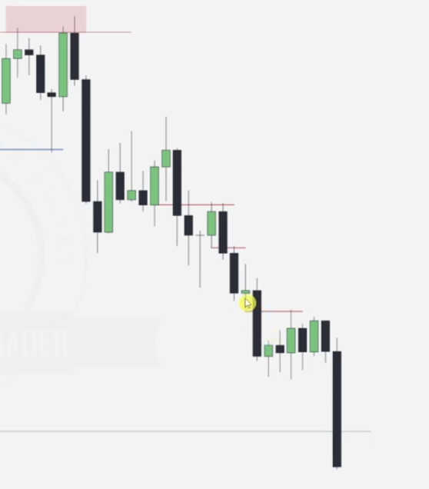

NOTE AN ORDER BLOCK PAIRED UP WITH AN FVG IS NOTED HENCE HIGHER PROBABILITY

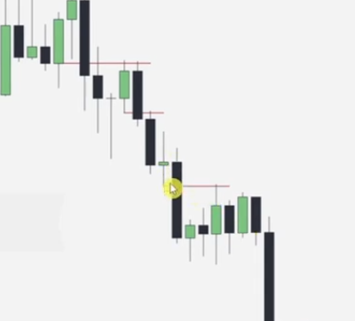

NOTE THAT ALL THESE ORDER BLOCKS HAVE BEEN TAPPED INTO

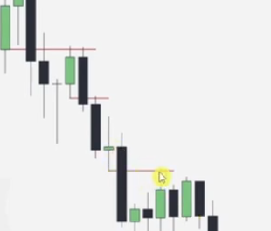

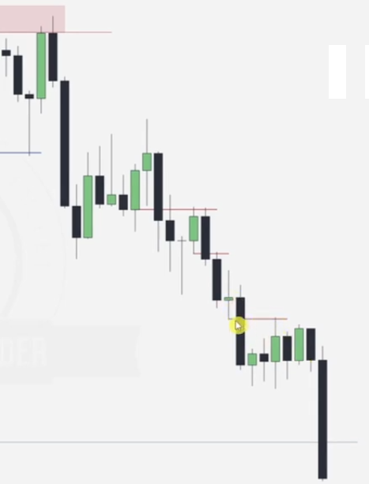

**INDUCED ORDER BLOCKS**

**EXAMPLE 1**

**Provided a 15m chart**

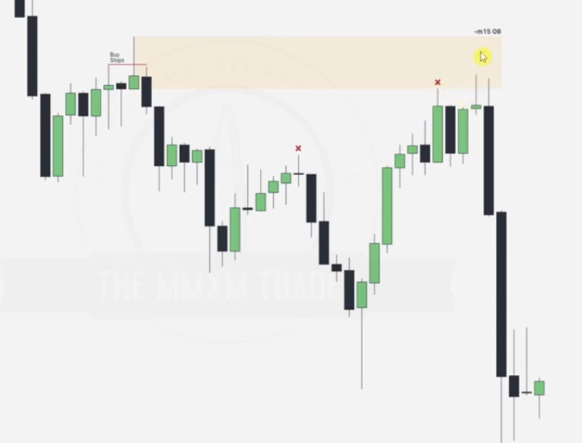

Order block labelled is a bullish reversal(rejection candle), it is a high probability order block bcoz it raided the buy stop and has tapped in to a prev bearish FVG.

The marked x reds show the buy stops(swing highs) which have been taken over , each taken over leads to inducement for more bullish bias until it reaches a point where by it has to take over the the high probability order block, this order block will provide resistance leading to a reversal to bearish as shown.

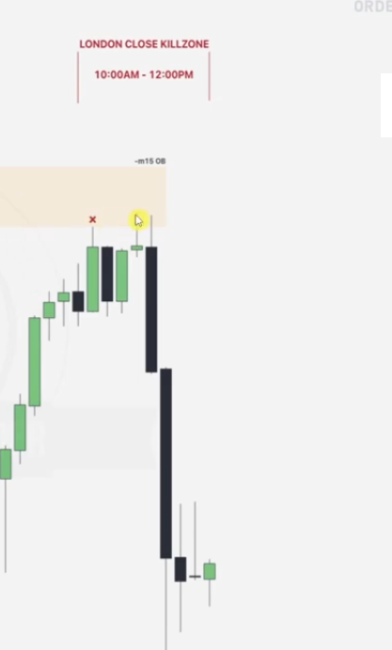

Time/ sessions are very important when trying to implement the action of your order blocks, in this case it is better to aim our anticipated reversal for NY/ london/ london close sessions.

EXAMPLE THREE -- INDUCEMENT ORDER BLOCK 2(BULLISH)

Given hourly chart

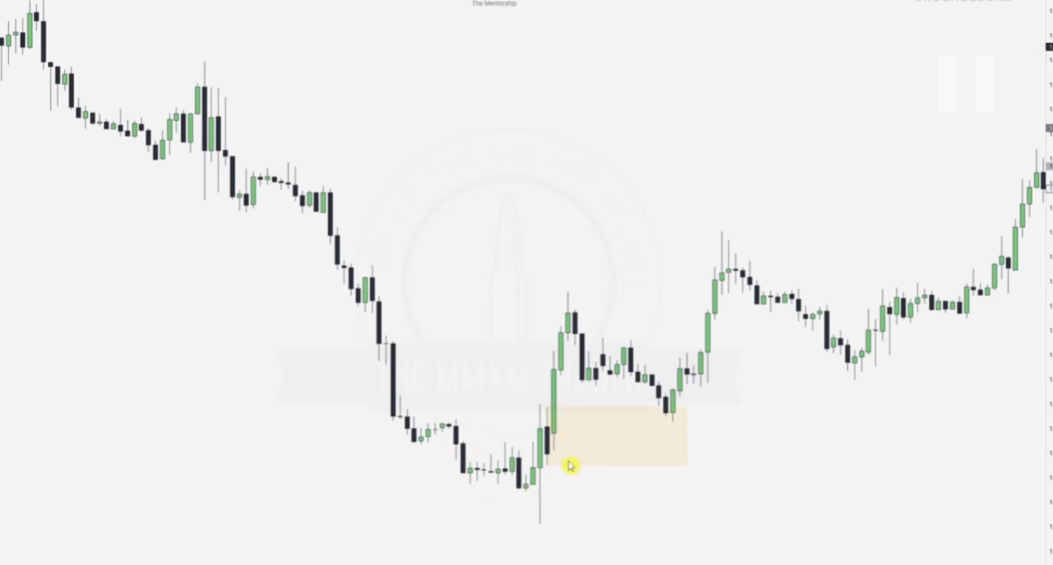

WHY IS THE PROVIDED ORDER BLOCK HIGH PROB

When we look at sells stops below it we notice some order pairing done, meaning price is going to be pushed up from here.

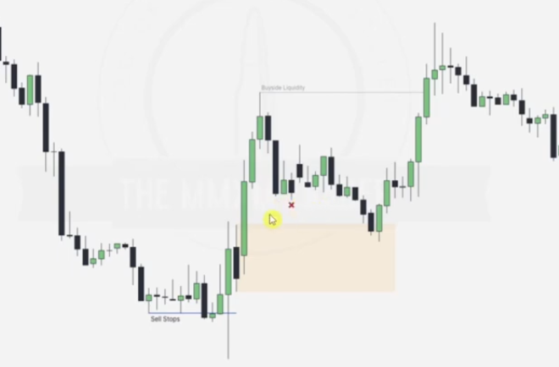

The reason we call this induced is because a low will be formed just before tapping the order block as part of engineering liquidity(M)[Low resistance liquidity] before it is raided and the order block acts as a support, order pairing then occurs in the process.

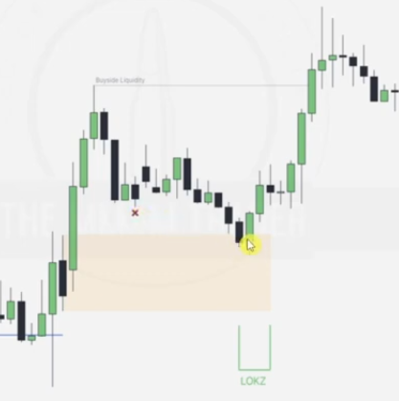

Meanwhile lets not forget about the time zone for which our anticipated reversal wil happen, note that here it happened in the london kill zone.

**BREAKER BLOCKS**

**Definition**:  
A breaker block is a price zone formed when a previously respected support or resistance level is violated, and the price retraces to retest it. It's often associated with institutional order flow, where large traders manipulate price to clear liquidity before moving in their intended direction.

EXAMPLE 4

Given weekly chart

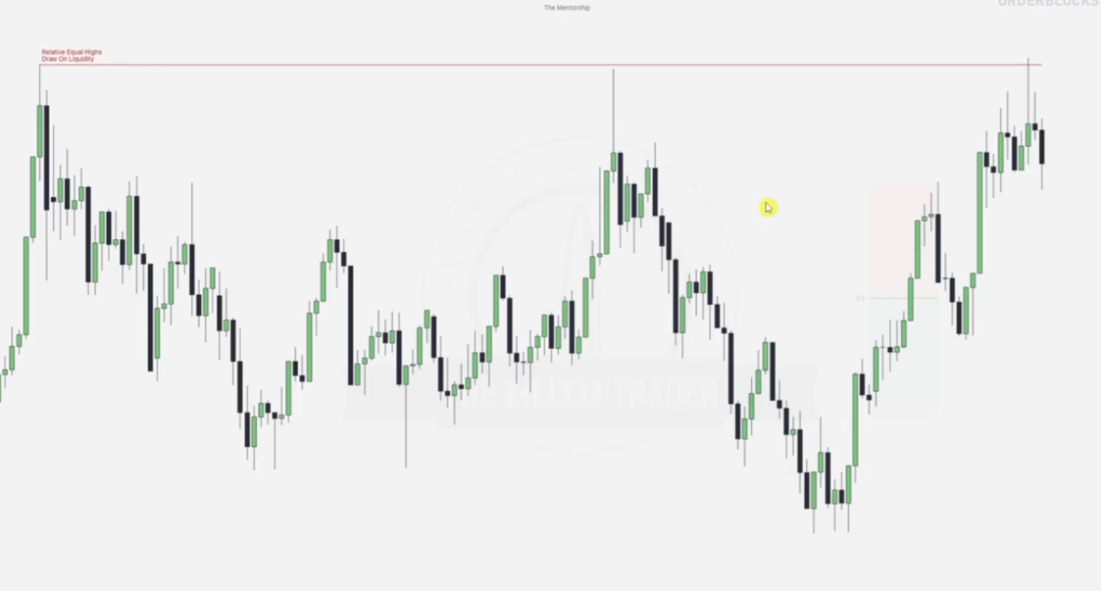

**Drawing of the breaker block based on order pairing**

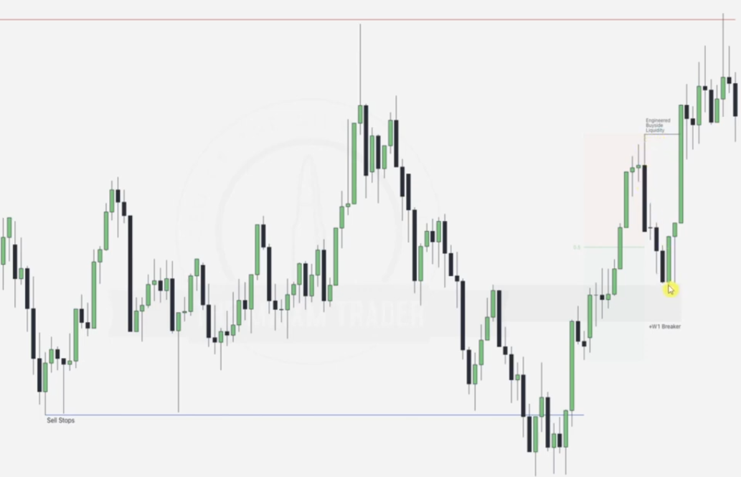

Going to the 4hr chart

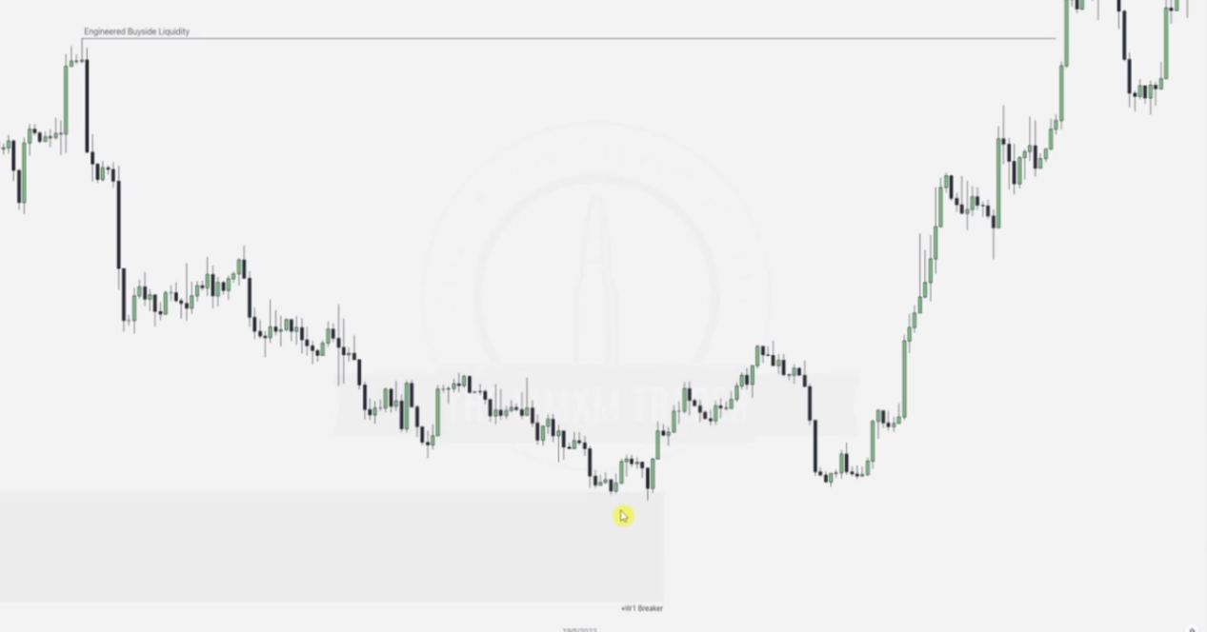

WHERE WILL THE HIGH PROBABILITY ORDER BLOCK BE?

Note that it occurs at seel stops where order pairing is taking place and it is within a weekly breaker block retest.. this is a very high prob order block.

Draw the Failure swings and the engineered buyside liquidity which eventually leads to another order pairing when trying to tap into our high prob order block

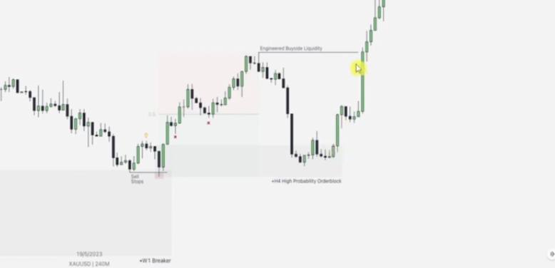

Next is drawing more high probability order blocks. NOTE THAT AFTER THE BUYSIDE LIQUIDOTY FORMED BY DRAWING OUR EQUAL HIGHS IN THE FIRST DIAG ARE TAKEN , DO NOT CHOOSE ORDER BLOCKS ANYMORE

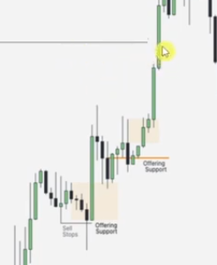

First case here is a high prob order block formed at a high resistance failure swing(taking the W model), which is retested to form a new high prob order block in the upper part

EXAMPLE LAST 1HR TO 5 MIN

Given hourly chart

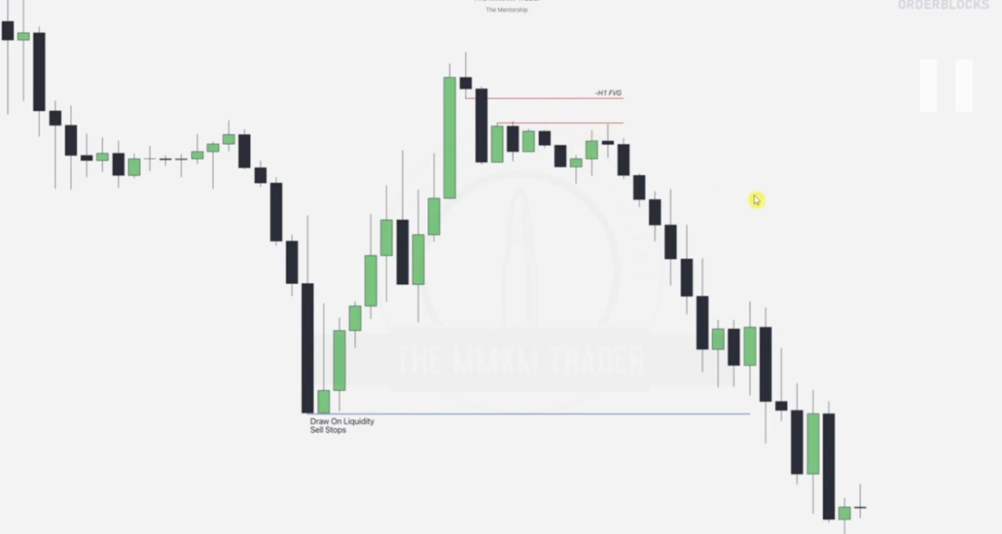

Examine the Failure swing ERLs being taken out , draw the FVG and note the sell stops.

Going to 5 minute

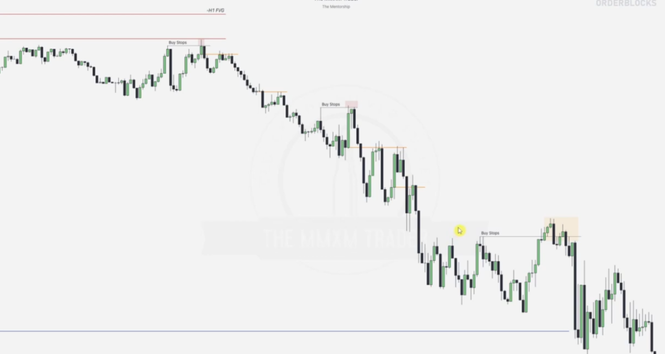

NOtice that when we are out of the sells stops , stop drawing high prob order block

FINISH VIDEO FOR MORE

IPDA MARKET CYCLES

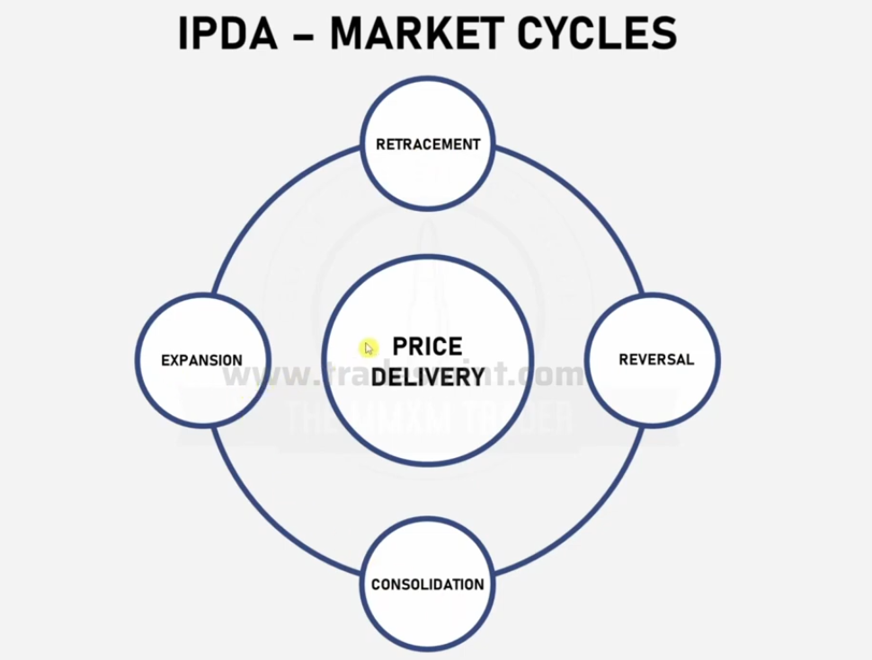

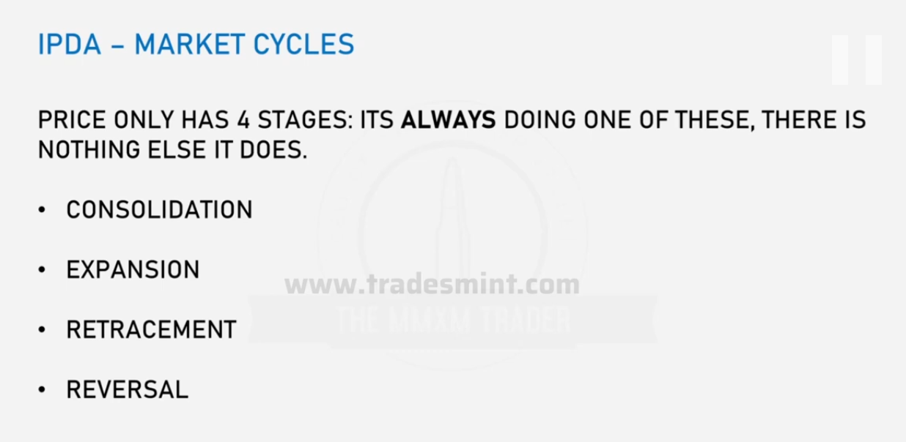

**Consolidation.** This is a period where the price moves within a narrow range, neither trending strongly upward nor downward. It often represents market indecision or a pause before the next significant move. Traders often refer to this as "sideways movement" or "chop."

**Expansion**: This stage occurs when the price breaks out of the consolidation range and starts trending strongly in one direction, either upward (bullish) or downward (bearish). Expansion is characterized by increased market volatility and larger price moves.

**Retracement**:A retracement is a temporary reversal in the overall trend. For example, in an upward trend, the price may pull back (decline) before resuming its upward movement. It’s often seen as a correction or profit-taking phase and usually does not signify a full trend reversal.

**Reversal**:This marks a complete change in the market's direction. For example, a bullish trend transitions into a bearish trend, or vice versa. Reversals are often confirmed by breaking significant support or resistance levels and are typically longer-lasting than retracements.

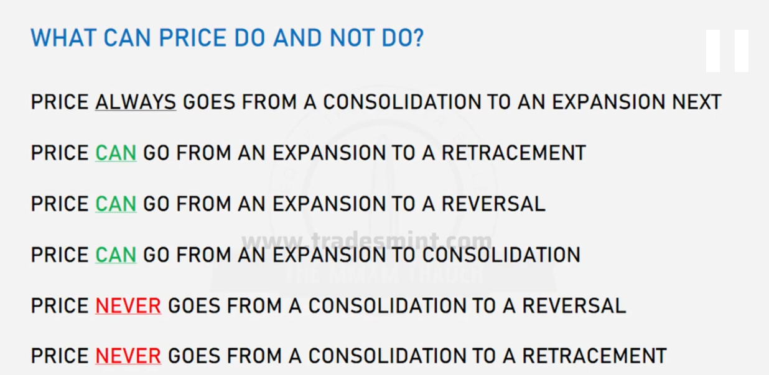

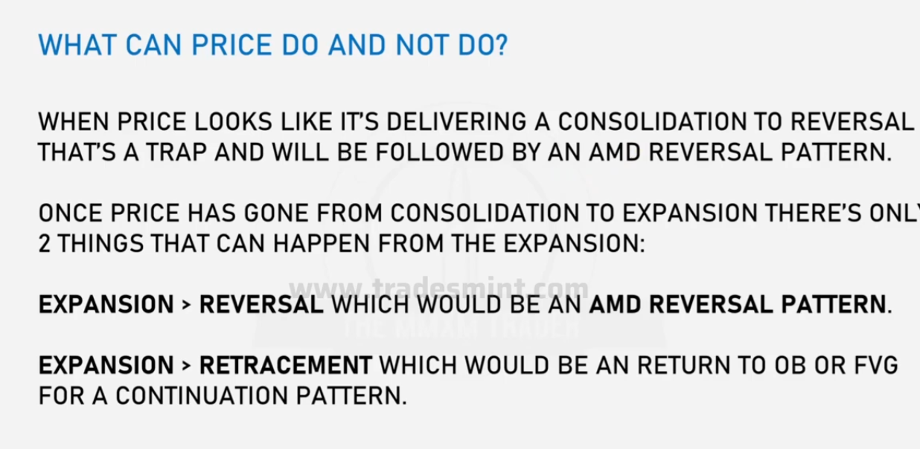

When in a bullish market and there is consolidation, AMD(Accumulation Manipulation and Distribution), signs of a reversal indicate M.. Manipulation with the initial consolidation being the Accumulation , hence expect the price to continue in the bullish direction.. D.. Distribution after the M.. Manipulation.

2 things happening:

EXPANSION > REVERSAL -- Expansion was part of the Manipulation , now reversal takes us back to the original bias.. Distribution.

EXPANSION> RETRACEMENT -- Trying to reachout to an IRL(FVG/OB) after ERL

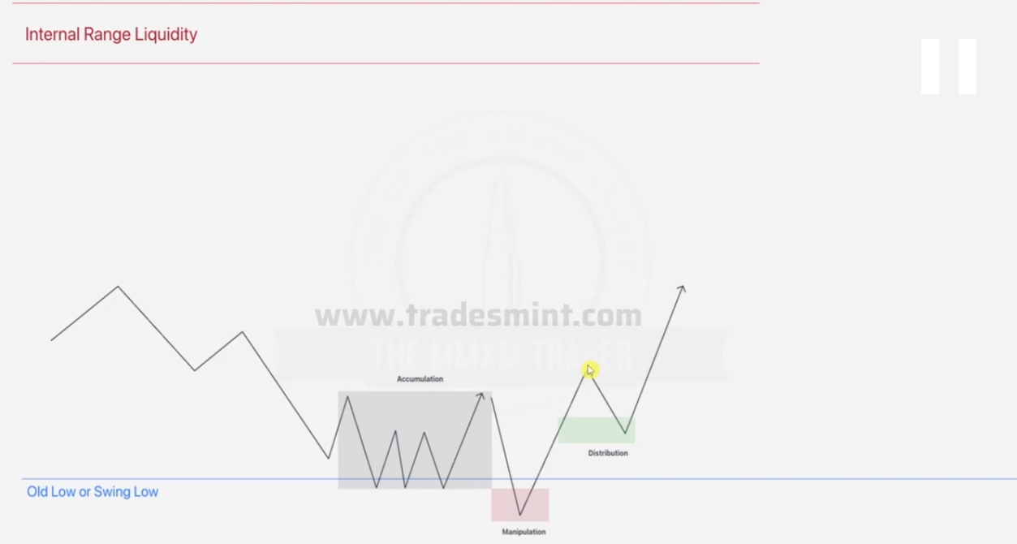

Notice the FVG formed during the DISTRIBUTION PHASE for which it will come back for during the ERL--IRL relationship. Kind reminder, this going back is part of the retracement.

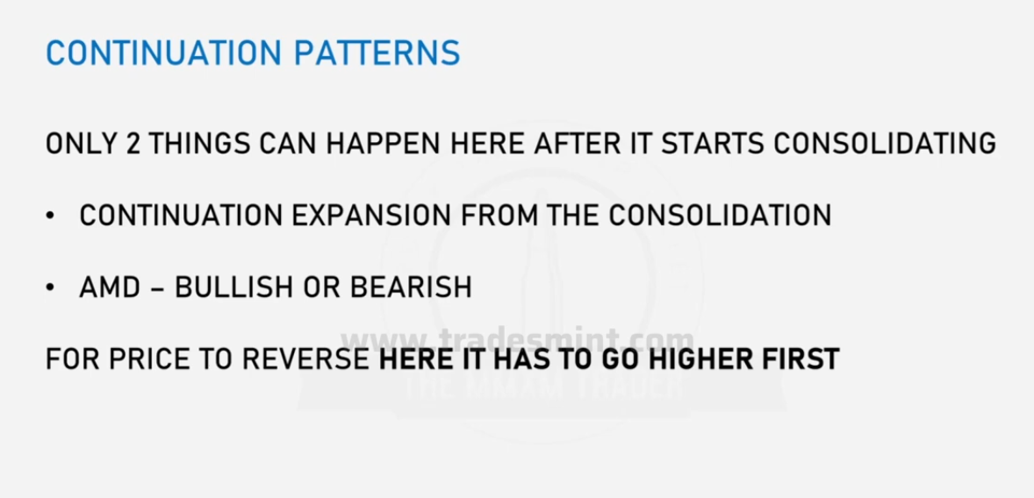

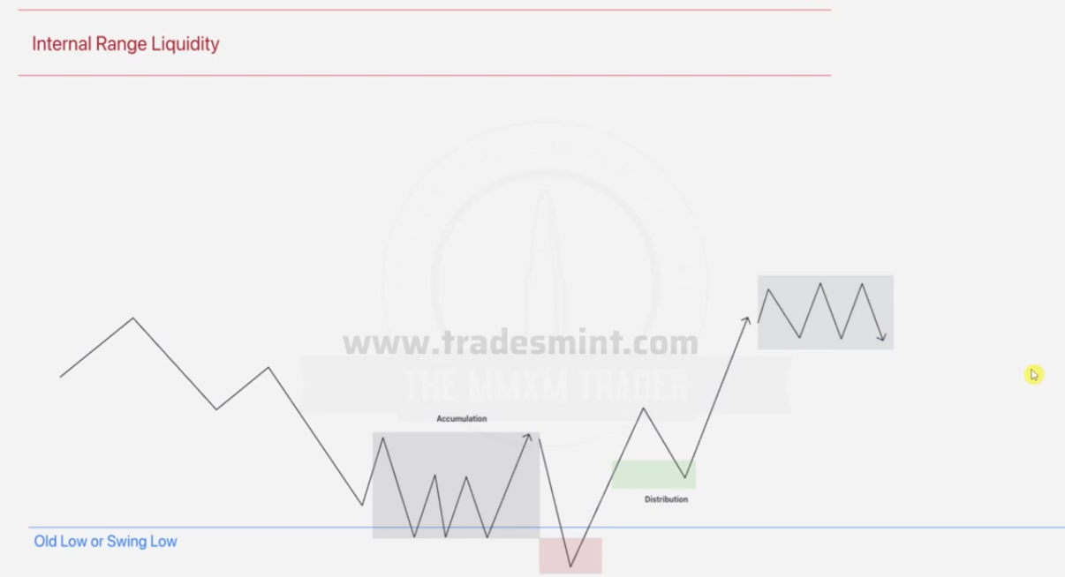

Now in this scenario, we note that the manipulation was part of order pairing(hence price might never aim for down ever again since the old low has been taken) and we have just tapped into an FVG before formation of the new consolidation range,

BUT Remember, we cant move directly from consolidation to reversal so expect expansion downwards, which will be a manipulation , before the upward movement to the IRL in red. HENCE THE RESULT AS BELOW

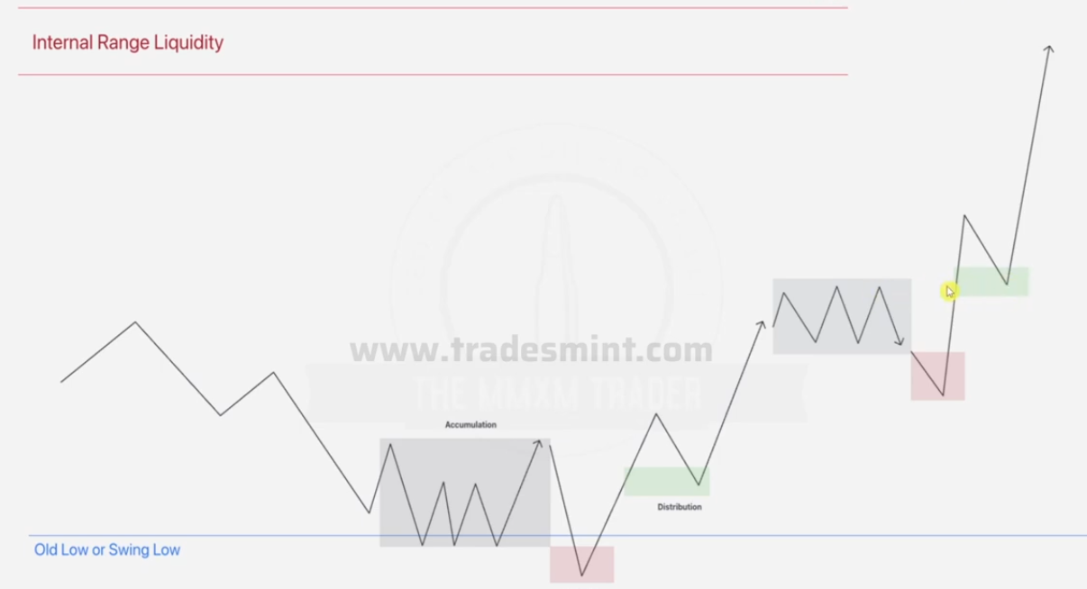

REMEBER SINCE WE ARE NOT 100% sure, this can also happen

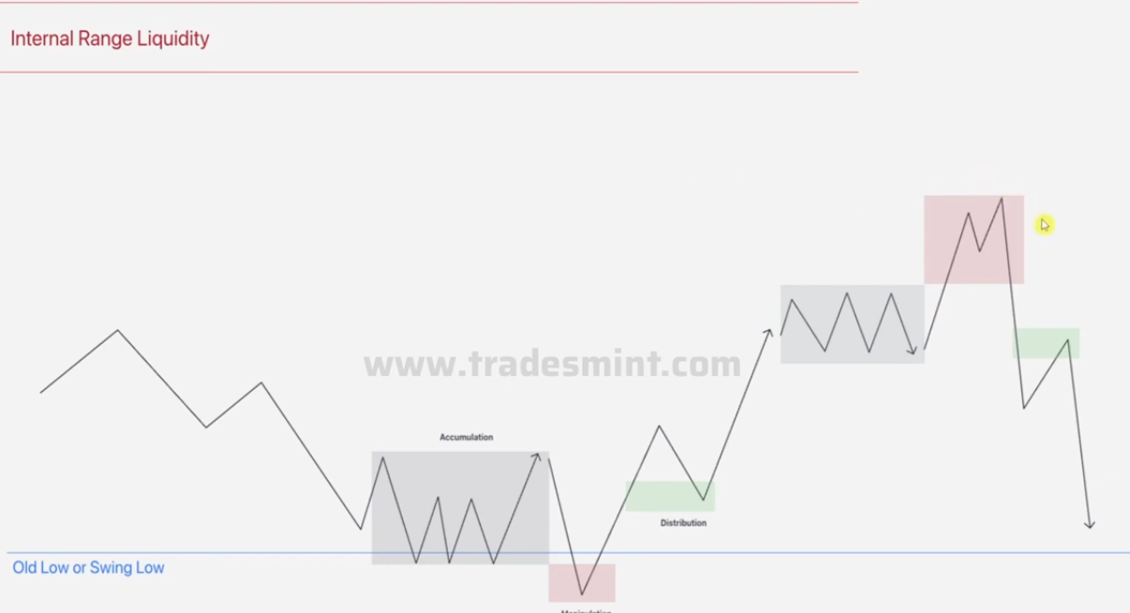

EXAMPLE ONE

Given daily chart

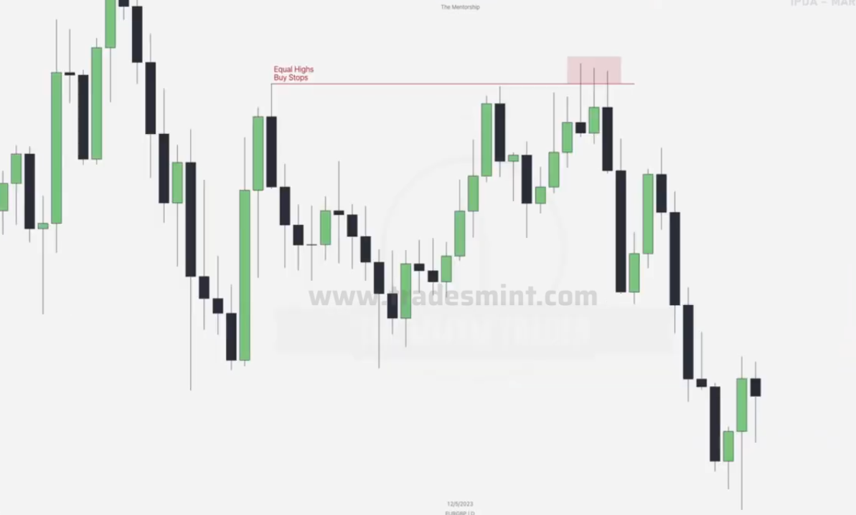

Think about ERL Vs IRL , Order pairing, Failure swings, FVGs , order blocks and draw the Liquidity points as below

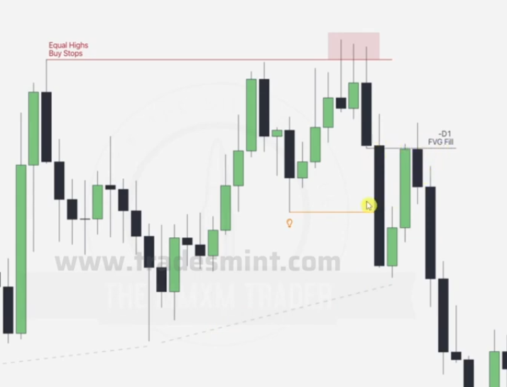

Drawn a failure swing as an ERL, FVG formed while taking it and note that this FVG is fully taken after. Then we draw one last sell stop

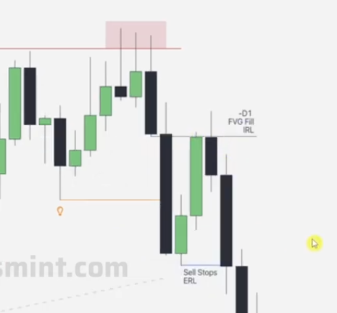

Going to a 1hr chart

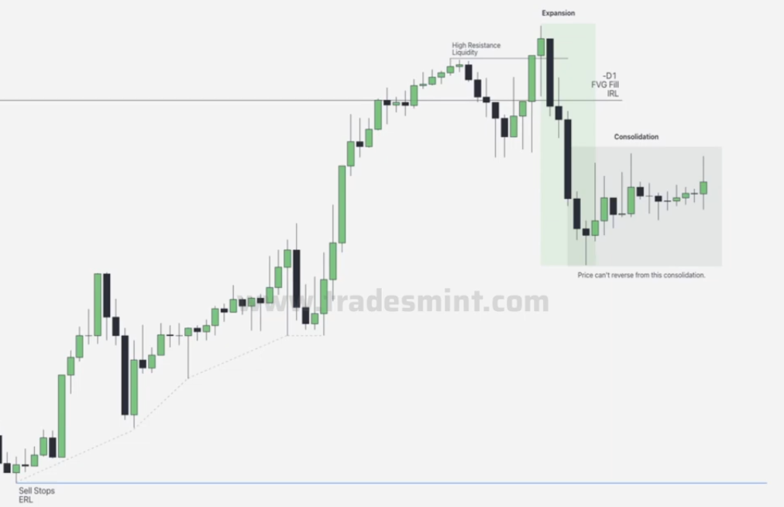

We see a high resistance liquidity leading to order pairing and there is as expansion which runs through the key level of Daily FVG , then we go straight into consolidation. Now from this point remember since we cannot go straight to reversal from consolidation, AND we are aiming for the ERL which is the SELL STOPS down, we anticipate an expansion acting as a manipulation upwards, then the true distribution downwards towards the sell stops.

TWO SCENARIOS OCCUR

Either

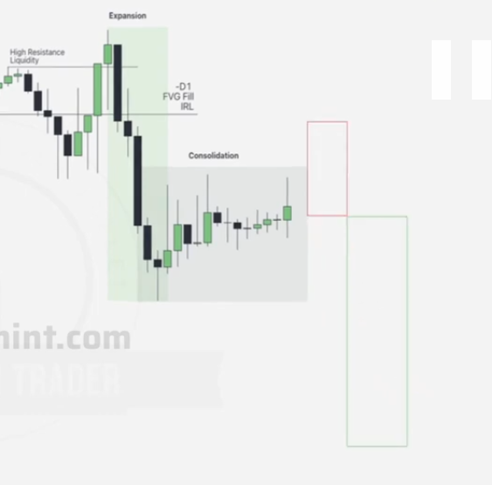

OR

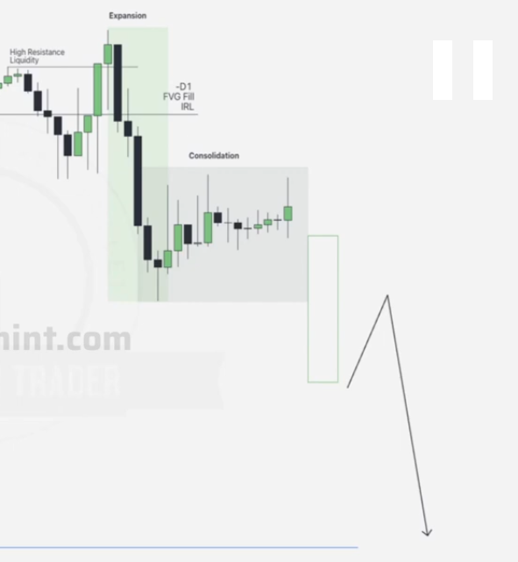

REMEMBER

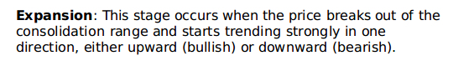

We then do the ERL vs IRL until we reach the sell stops

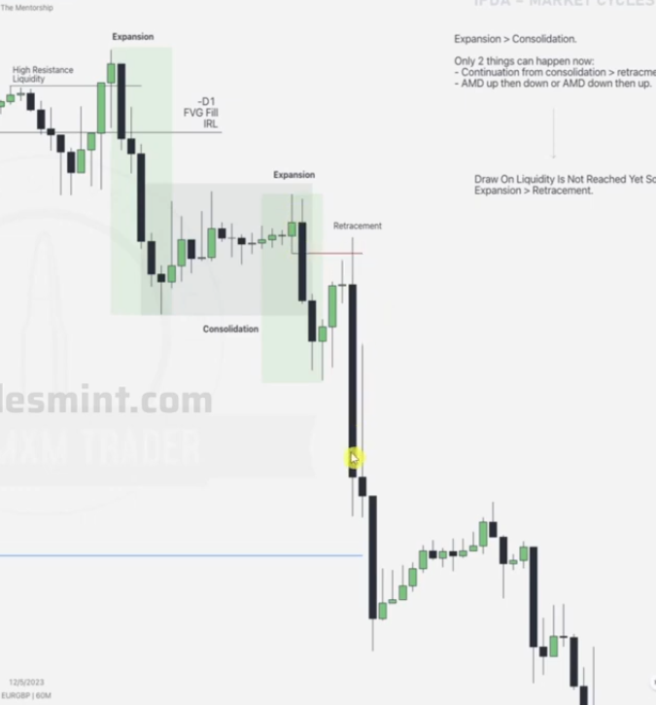

DO THE LAST EXAMPLE

**BREAKAWAY GAPS AND BPR (Balanced Price Ranges)**

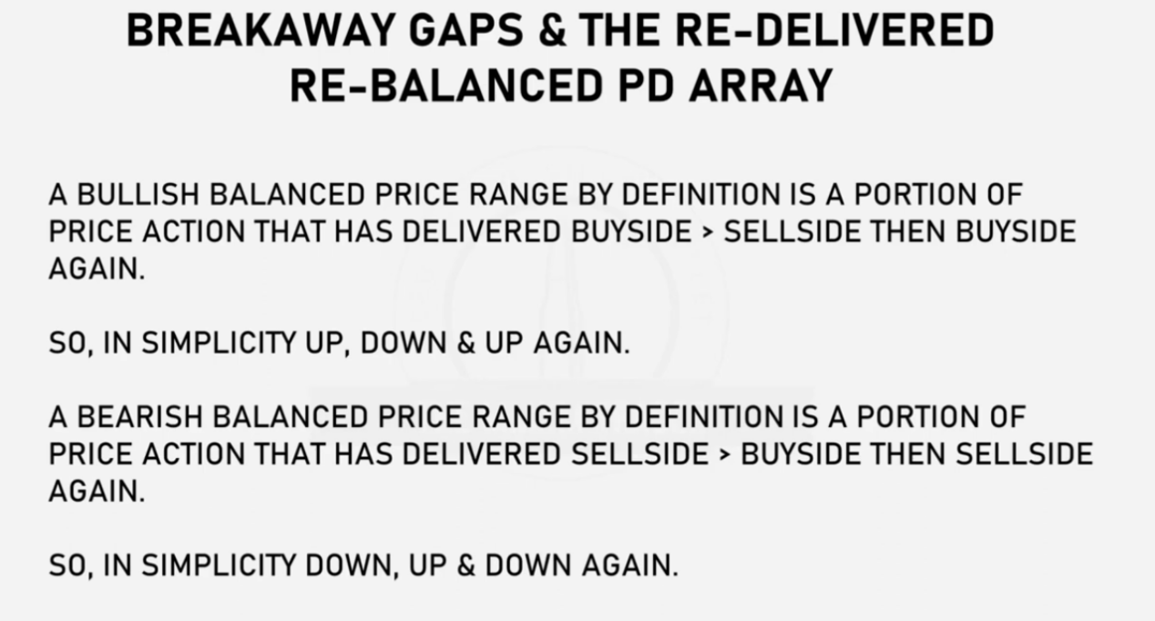

**BULLISH BALANCED PRICE RANGE**

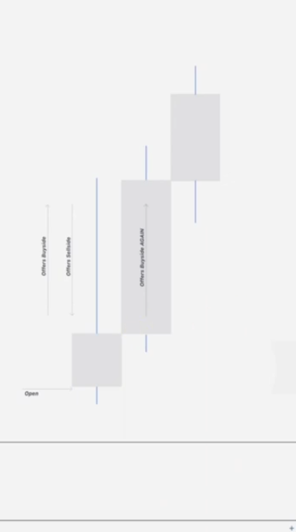

Provided a bearish reversal candle(first), buyside is offered, then after sell side is offered, after that on next candle which is bullish candle.. buyside offered completes the HENCE THIS PIECE OF PRICE ACTION IS FULLY BALANCED... for the next candle incase it tries to tap into the balanced price range, the FVG itself can remain open

BEARISH BALANCED PRICE RANGE

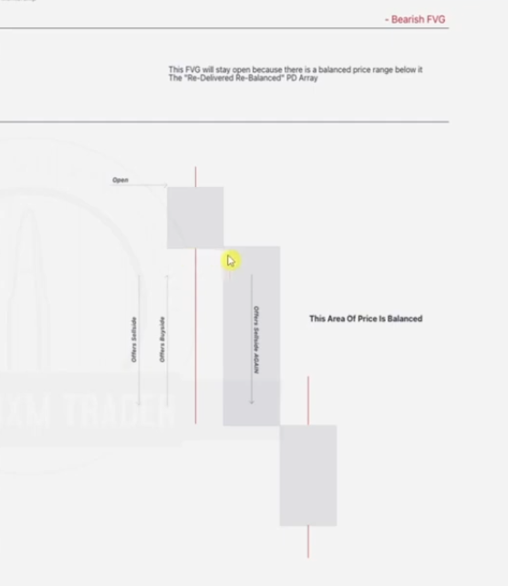

We can also draw lines to illustrate the areas of rejection by the newly formed balanced price ranges. Draw a line btn the close of the bullish/bearish reversal and the wick of the candle trying to tap into the Balanced Area.

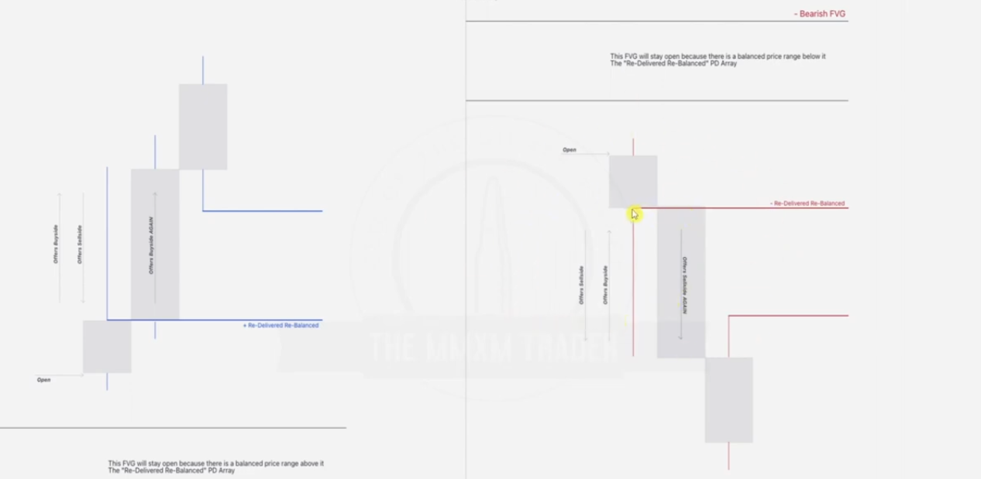

EXAMPLE 1

Given the 4hr chart

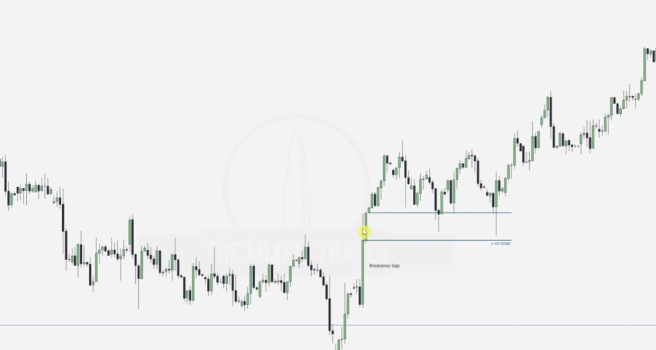

In the highlighted area, price goes up(buyside), then goes down to close(sellside)..we are working on the wick of the candle, then we see the next candle causing a buyside.. HENCE a full balanced area, note that is now forms support making all the candles trying to tap into it to go back up. THIS IS A NEW PD ARRAY

Compare and contrast

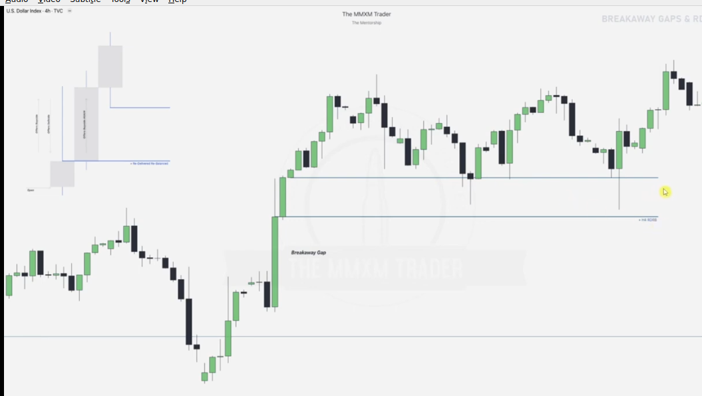

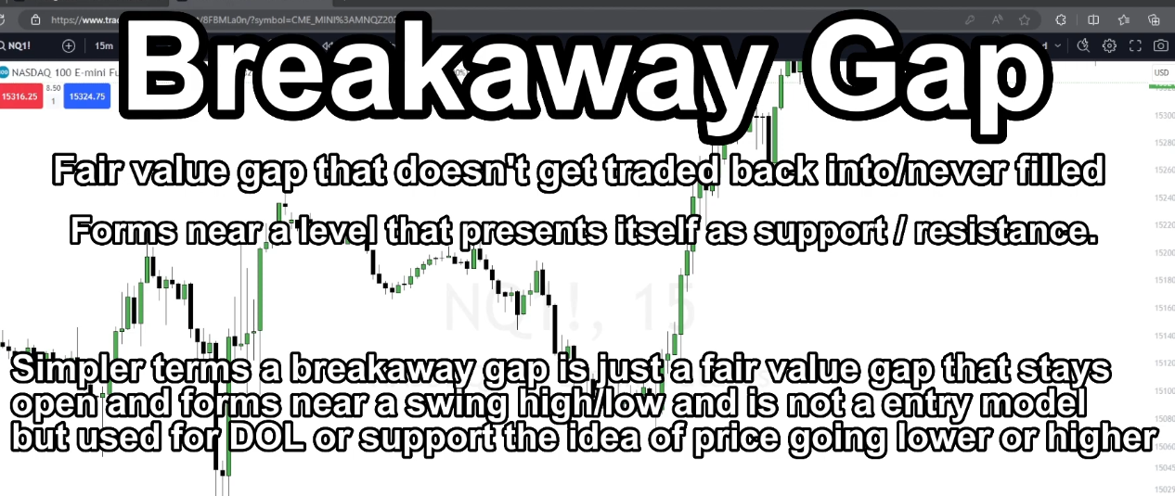

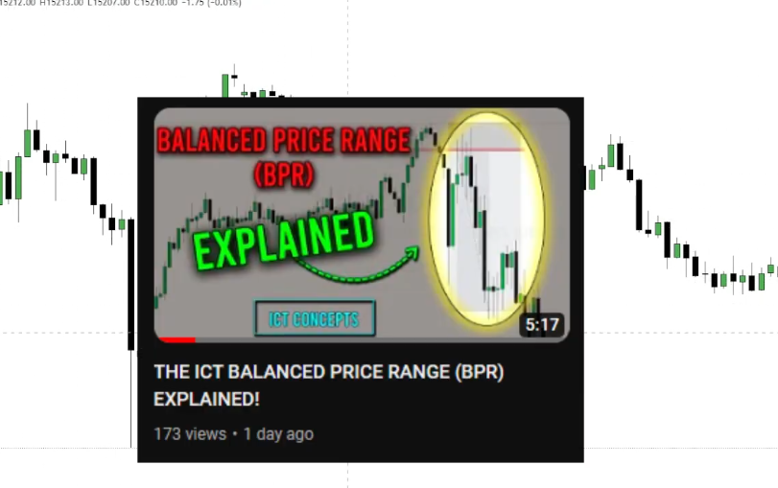

Breakaway gaps usually occur when there is a more significant resistance below(bearish order flow) EG A BPR as in next example providing resistance for lower candles ...EG

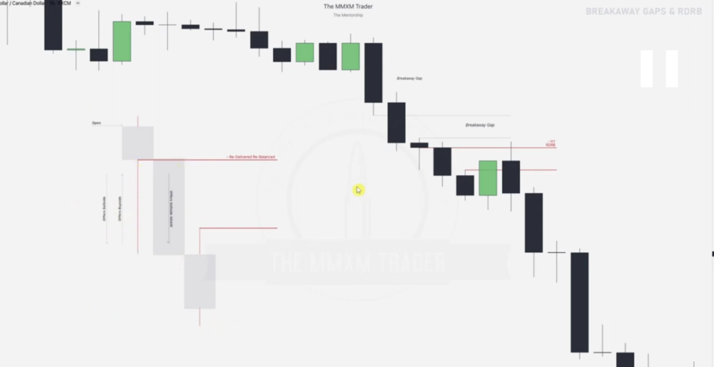

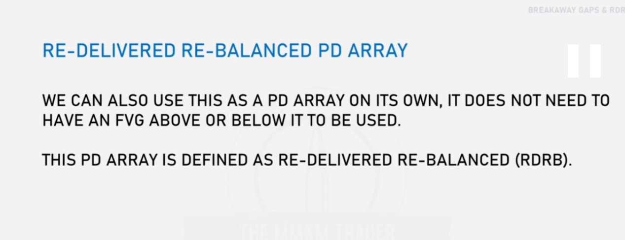

EXAMPLE ONE

Given a 4 hr chart

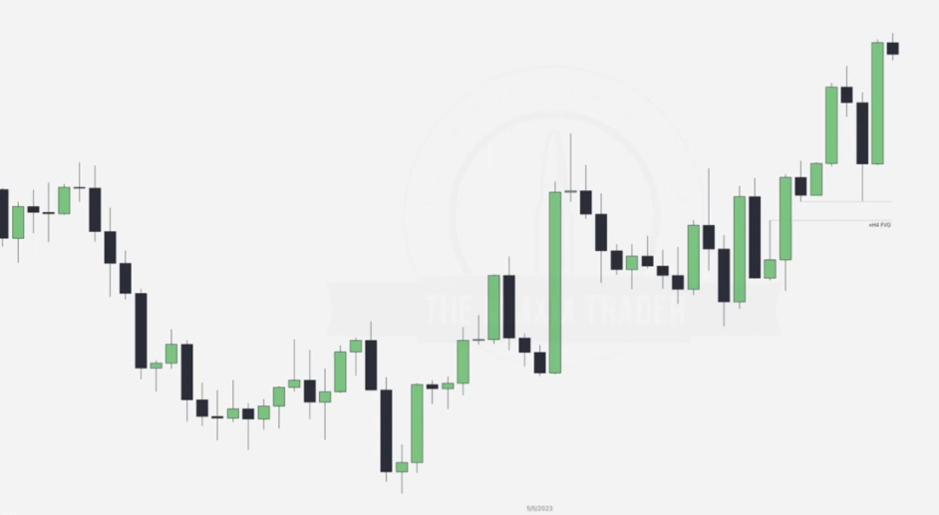

Please note where the BPR will form

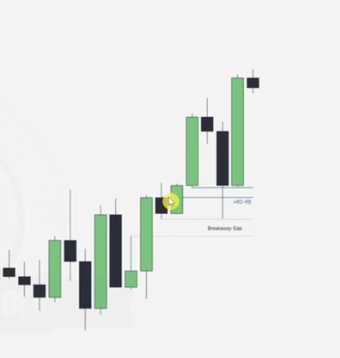

In this case this will be a discount array, showing that we are going into premium range, this also indicates that the FVG will not be tapped at this point(until a break happens i think)

Going to the 1 hr chart

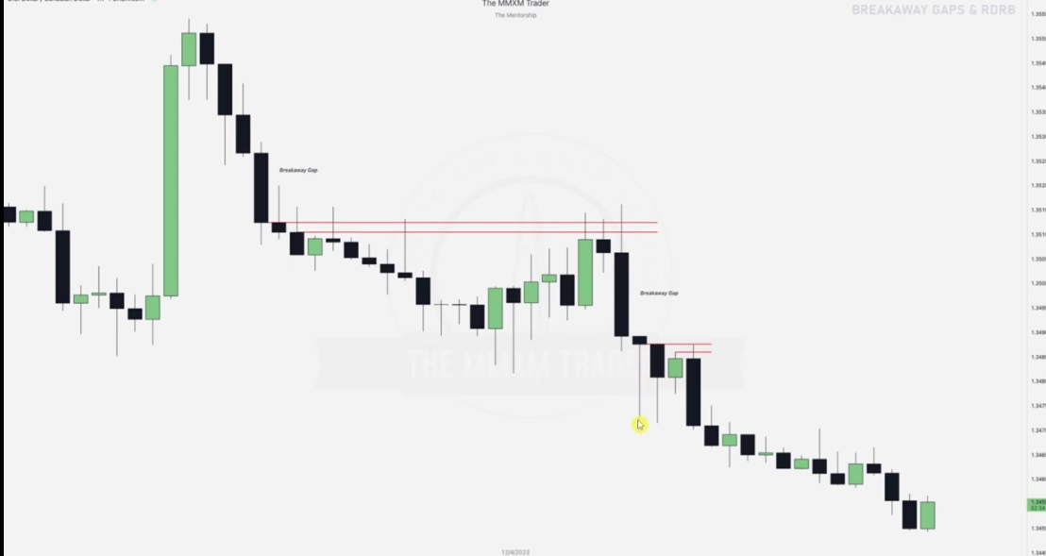

BPRS formed act a the resistance making it for the prices not to reach the FVGs labelled as breakaway gaps.

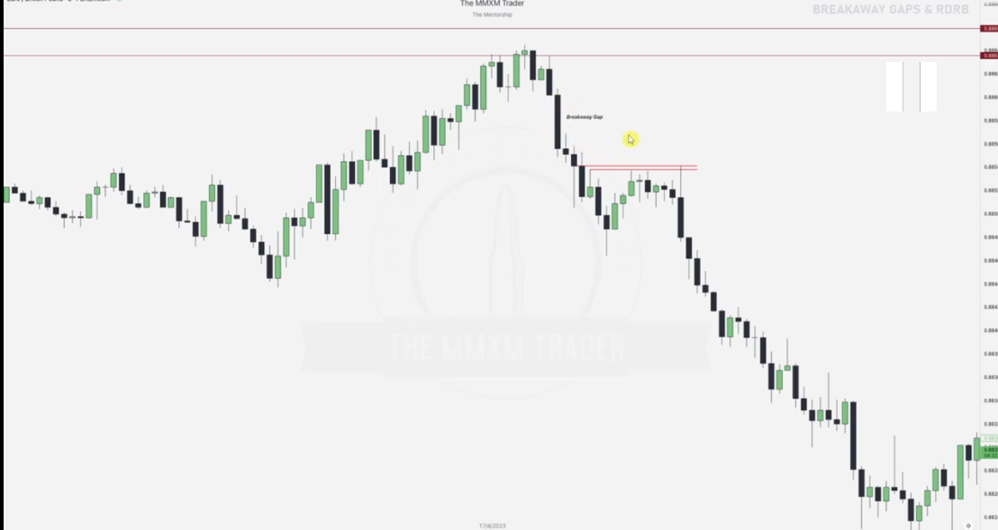

WONDERING WHY THE FVG HAS NOT BEEN TOUCHED???

EXAMPLE 5

Given a 1 day chart

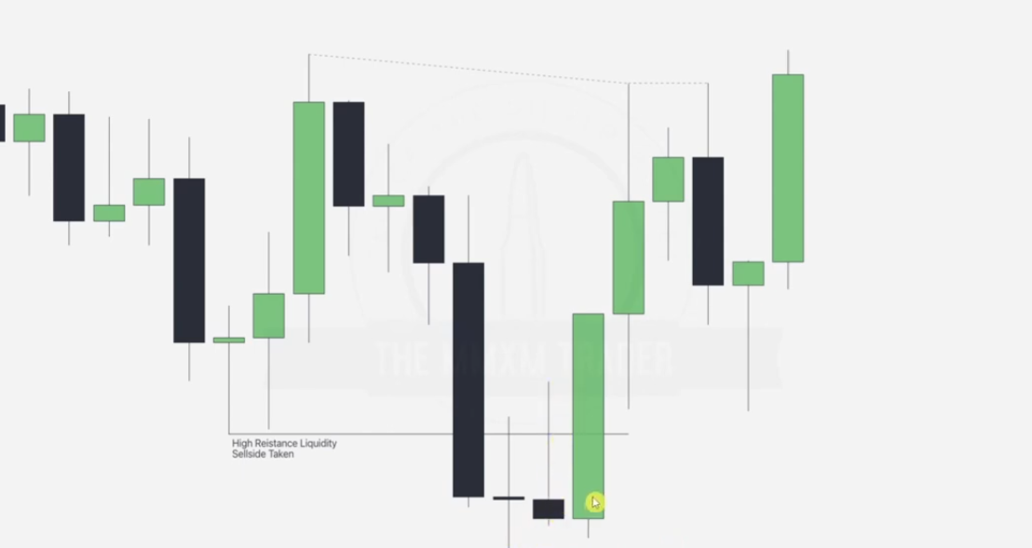

Draw ERLS , failure swings and note the BPR as noted in the cursor

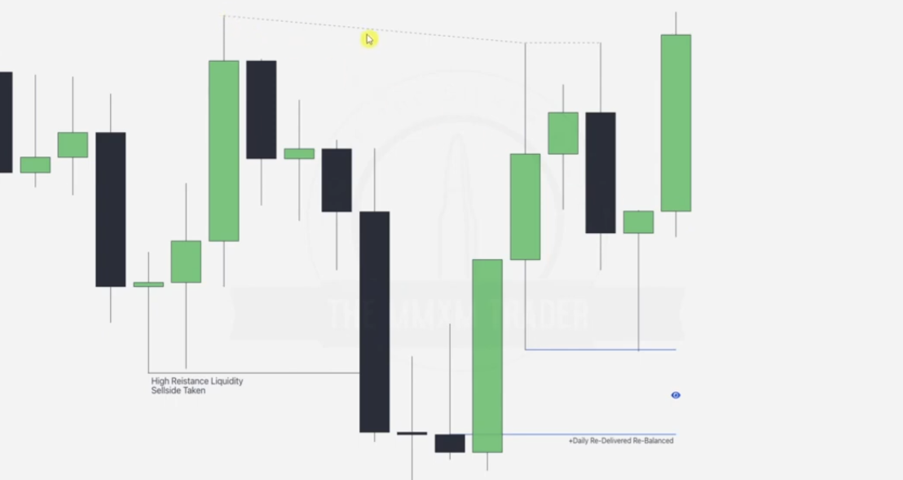

Given the 1 hr chart, ask yourself why we are not trading into the FVGs provided

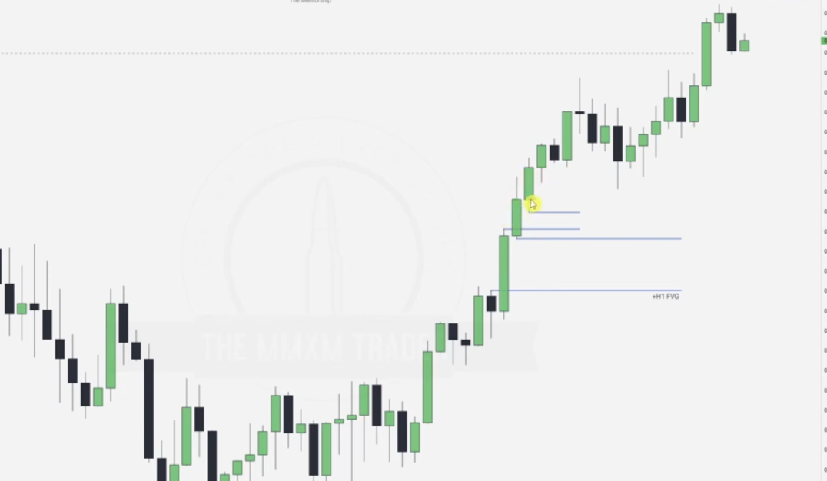

This is because we notice a up/down/up BPR as below hence new breakaway gaps

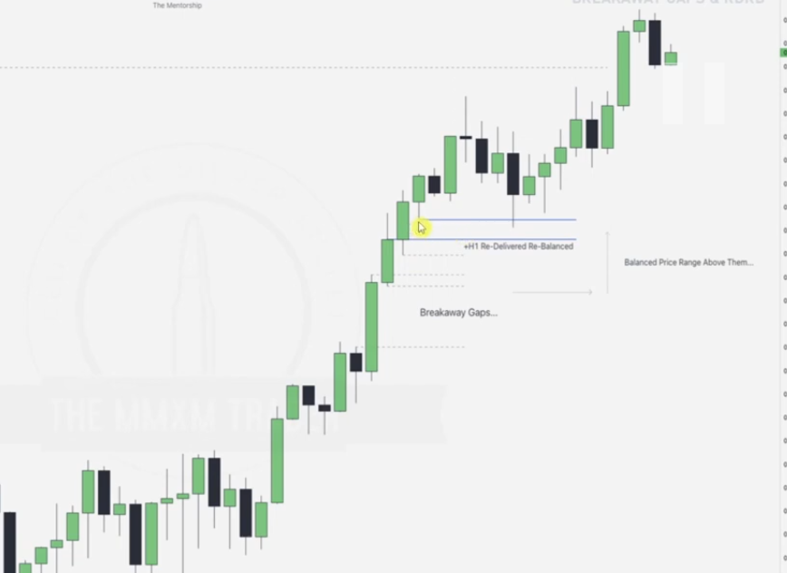

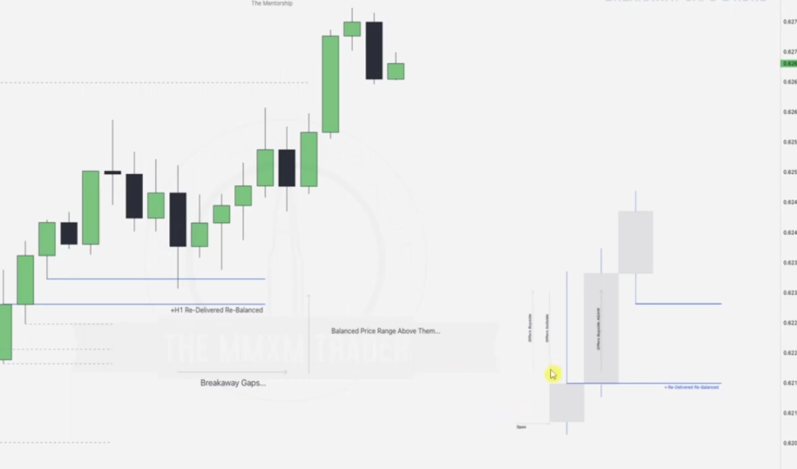

EXAMPLE

BPR LABELLED ON A MONTHLY

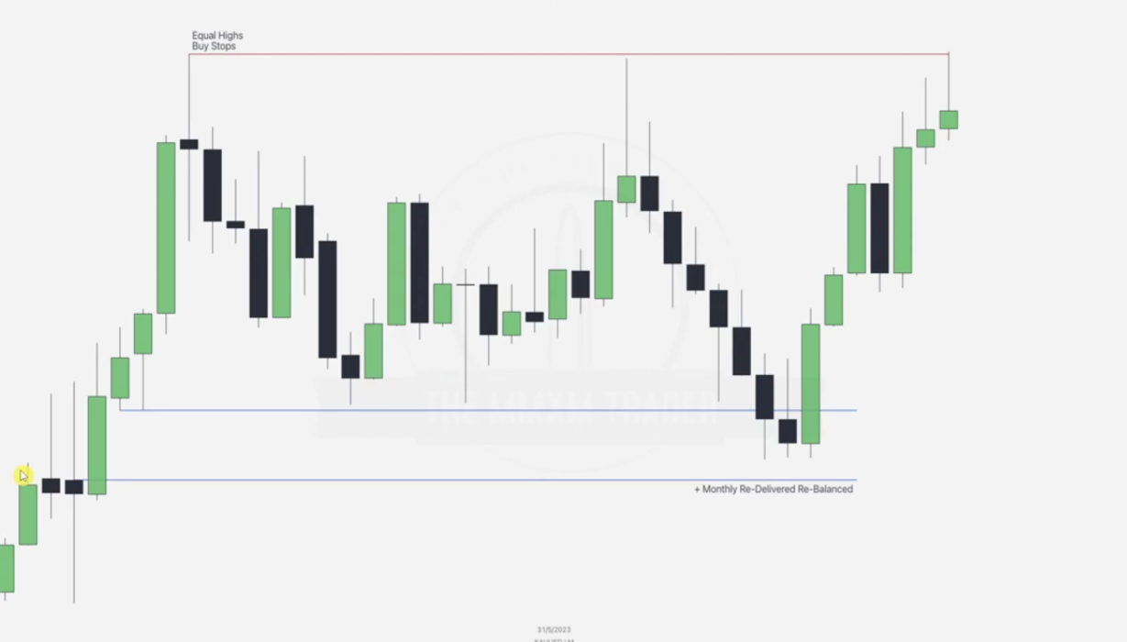

We also notice order pairing and ERL vs IRL hunting, Failure swings etc

EQUAL HIGHS EYES

EXAMPLE

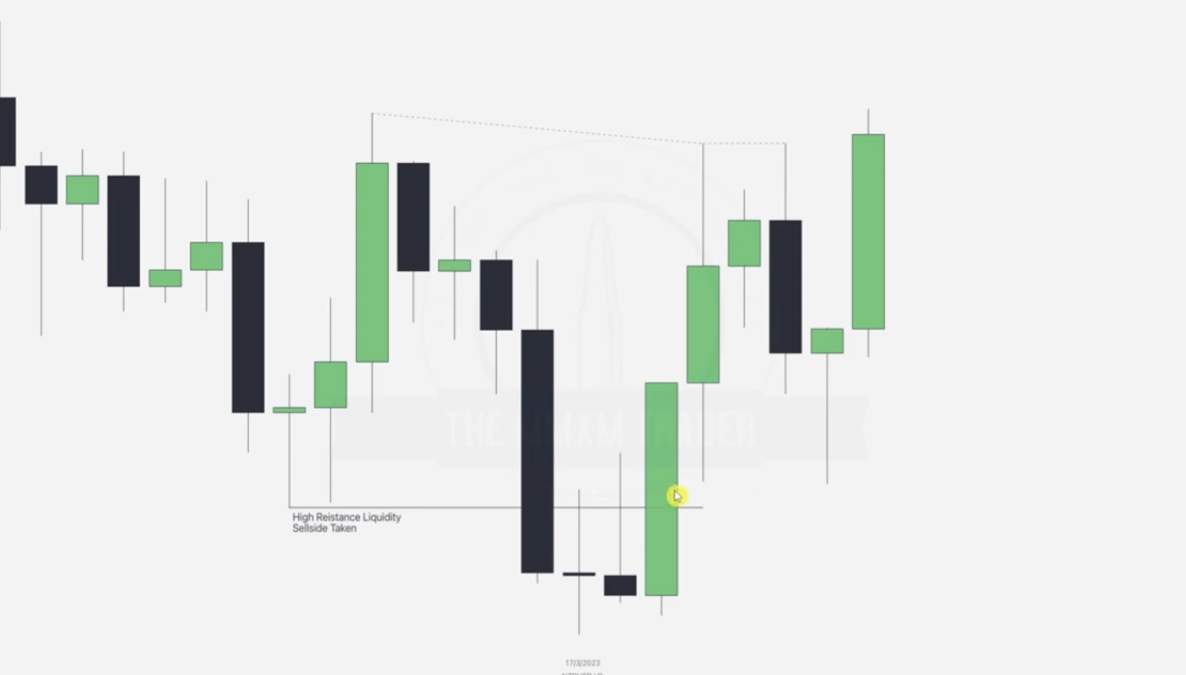

NOTE WHERE BPR WILL BE FORMED

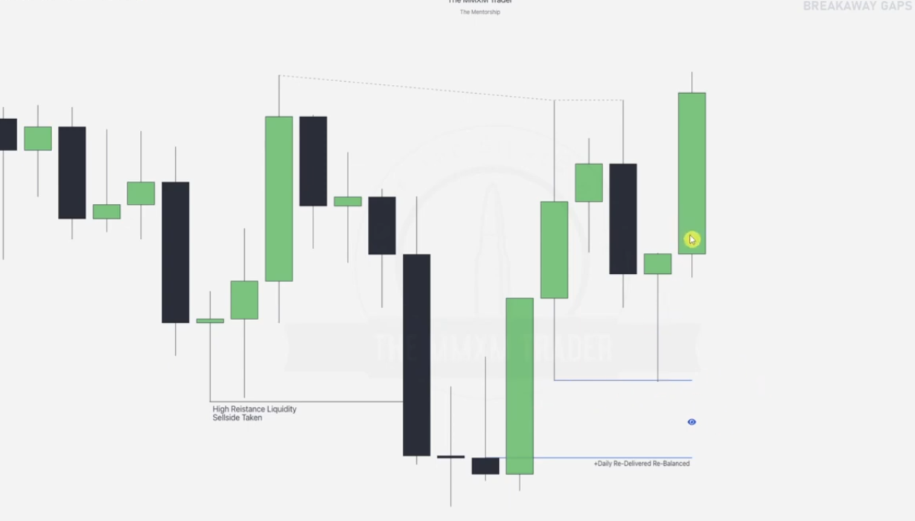

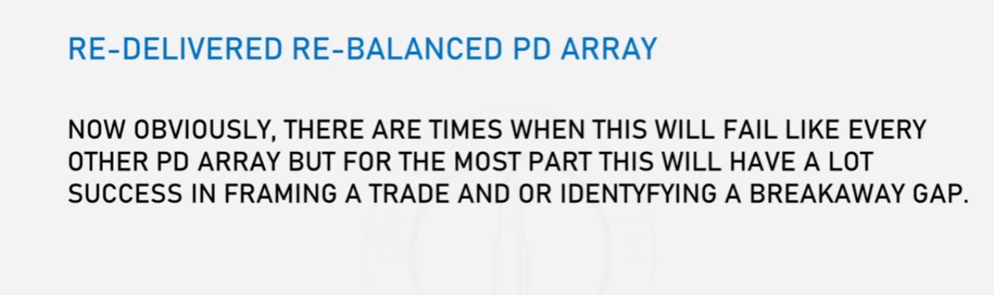

**DXY CONSOLIDATIONS**

**DXY consolidation** refers to a period when the **U.S. Dollar Index (DXY)** is trading within a defined range, without showing a clear upward or downward trend. The **DXY**, which measures the strength of the U.S. dollar against a basket of major currencies (EUR, JPY, GBP, CAD, SEK, CHF), can enter consolidation phases due to various market conditions.

### ****Key Characteristics of DXY Consolidation:****

**Sideways Movement**

* 1. The price fluctuates between support and resistance levels without a strong breakout in either direction.
  2. Traders often see this as a period of indecision in the market.

**Reduced Volatility**

* 1. Price movements tend to be smaller, and momentum slows down.
  2. Lower trading volumes may accompany consolidation periods.

**Range Bound Behavior**

* 1. The index moves within a well-defined range, often between horizontal support and resistance levels.
  2. Indicators such as Bollinger Bands, RSI, or Moving Averages may show flattening trends.

**Market Uncertainty**

* 1. Consolidation can occur before major economic events, such as **Federal Reserve interest rate decisions**, inflation reports, or geopolitical developments.
  2. Traders often wait for a catalyst to drive the dollar in a definitive direction.

### ****Causes of DXY Consolidation:****

**Lack of Major Economic Data**

When there are no significant macroeconomic releases, the dollar may consolidate.

**Uncertainty About Federal Reserve Policy**

Traders may pause before key FOMC meetings or rate announcements.

**Balance of Global Currencies**

If major currencies in the index (e.g., the euro or yen) are also consolidating, DXY may follow suit.

**Risk Sentiment in Markets** If global markets are uncertain or mixed, the dollar index can enter consolidation.

### ****How to Trade DXY Consolidation:****

**Identify Support and Resistance Zones:** Mark key horizontal levels where the index is bouncing between.

**Range Trading Strategies** Buy at support and sell at resistance within the range.. Use indicators like RSI (overbought/oversold levels) to time entries.

**Look for Breakout Signals.** Watch for a breakout above resistance or below support to anticipate the next trend. Volume spikes, fundamental news, or technical patterns can confirm breakouts.

**Use Other Indicators**

Bollinger Bands: Narrowing bands may signal an impending breakout.

MACD/RSI: Divergences may indicate momentum shifts before consolidation ends.

### ****Exotics and Futures in Forex and Their Relation to DXY Consolidation****

#### ****1. Exotics****

**Exotic currency pairs** refer to forex pairs that consist of a **major currency (like USD, EUR, or GBP)** paired with a **less liquid or emerging market currency**, such as:

* **Examples of exotic pairs:**
  + USD/TRY (U.S. Dollar/Turkish Lira)
  + EUR/ZAR (Euro/South African Rand)
  + GBP/MXN (British Pound/Mexican Peso)

**Characteristics of Exotics:**

* **Lower liquidity:** Exotics are less traded compared to major pairs like EUR/USD.
* **Higher volatility:** They tend to have larger price swings due to economic instability or lower trading volumes.
* **Wider spreads:** Because they are less liquid, transaction costs (spreads) are generally higher.
* **Susceptible to external factors:** These pairs are highly influenced by political events, economic instability, and commodity price fluctuations.

**Relation to DXY Consolidation:**

* When **DXY consolidates**, exotic currencies can experience:
  + **Reduced volatility:** Traders may wait for a clear direction in USD before making decisions on exotic pairs.
  + **Range-bound behavior:** Exotic pairs tied to USD often mirror the indecision seen in DXY.
  + **Capital flow shifts:** During consolidation, investors might move funds from exotic currencies to safer assets until a clearer trend emerges.

#### ****2. Futures****

**Forex futures** are standardized contracts that represent an agreement to buy or sell a currency at a predetermined price and date in the future. These contracts are traded on exchanges like the **CME (Chicago Mercantile Exchange).**

**Characteristics of Forex Futures:**

* **Standardized contracts:** Fixed contract sizes and expiration dates.
* **Traded on exchanges:** Unlike the spot forex market, futures are traded on centralized exchanges.
* **Used for hedging and speculation:** Businesses use them to hedge currency risk, while traders speculate on future price movements.
* **Leverage:** Futures allow traders to control large positions with a smaller margin.

**Relation to DXY Consolidation:**

* **Hedging Activity:** When DXY consolidates, institutional traders may hedge their positions with USD futures to protect against potential volatility.
* **Futures Volume Decline:** During DXY consolidation, futures trading volume may decrease as traders avoid taking positions in uncertain market conditions.
* **Breakout Potential:** Consolidation in the DXY index can lead to increased positioning in futures as traders anticipate a breakout in the dollar's value.

### ****How Exotics and Futures Respond to DXY Consolidation****

**Exotics Response:**

* + If DXY is consolidating, exotic pairs may trade in narrow ranges, as emerging market currencies typically react to USD strength or weakness.
  + A breakout in DXY can lead to sharp moves in exotic pairs due to their higher volatility and sensitivity to USD movements.

**Futures Response:**

* + During consolidation, futures contracts often show lower volume and volatility.
  + Traders may look for breakout patterns in the DXY before entering long or short positions on USD futures.

**Key Takeaways:**

* **Exotics tend to be more volatile and can react strongly to DXY breakouts.**
* **Futures reflect trader sentiment on the U.S. dollar and can provide clues about potential DXY breakouts.**
* **During DXY consolidation, both exotic pairs and futures may exhibit lower volatility and reduced trading activity, awaiting a clear directional bias.**

By monitoring both exotic currency pairs and USD futures alongside DXY, traders can gain insights into potential market moves and positioning strategies.

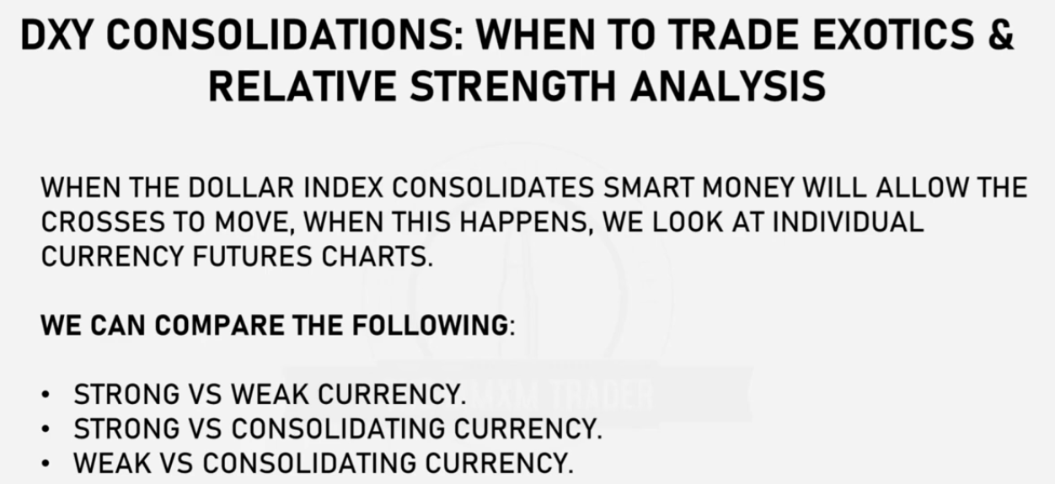

### ****Key Concepts Explained:****

**DXY Consolidation & Smart Money Movement**

When the **DXY consolidates**, it means the U.S. dollar is not trending strongly in either direction and is moving sideways within a range.

During this period, **"smart money" (institutional investors)** may shift their focus to **non-USD currency pairs**, such as exotic or cross pairs (e.g., EUR/GBP, AUD/NZD). The rationale is that with the dollar moving sideways, other currencies will have more freedom to move based on their own fundamentals.

**Analyzing Currency Strength Through Futures Charts**

Traders should analyze individual currency futures charts (e.g., EUR futures, GBP futures) to determine which currencies are currently strong or weak relative to others.This allows traders to identify better trading opportunities outside of USD pairs.

In this context, **strong** refers to a currency showing **bullish momentum**, meaning it is appreciating in value relative to other currencies. Conversely, **weak** refers to a currency exhibiting **bearish momentum**, meaning it is depreciating in value.

### ****Relative Strength Comparison Methods:****

The text suggests three key comparisons when trading during DXY consolidation:

**Strong vs. Weak Currency:**

Identify a currency that is showing strong bullish momentum and compare it against a weak currency (e.g., buying EUR/JPY if EUR is strong and JPY is weak). This pairing increases the probability of trending movement, even while DXY is consolidating.

**Strong vs. Consolidating Currency:**

Look for a currency that is trending strongly and compare it against one that is currently range-bound or consolidating. Example: If GBP is showing strength and AUD is consolidating, GBP/AUD could present a bullish opportunity.

**Weak vs. Consolidating Currency:**

Pair a weak currency against a consolidating one, taking advantage of the weakness in the weaker currency. Example: If JPY is weak and CAD is consolidating, JPY/CAD could trend higher.

### ****Trading Implications:****

**Focus on Cross Pairs:** During DXY consolidation, it's wise to shift focus to crosses and exotic pairs rather than major USD pairs, which may show little movement.

**Capitalizing on Strength Differentials:** By comparing relative strength, traders can identify high-probability trades outside of the U.S. dollar's influence.

**Waiting for DXY Breakout:** Traders can capitalize on these opportunities while waiting for the dollar to break out of consolidation for future USD-based trades.

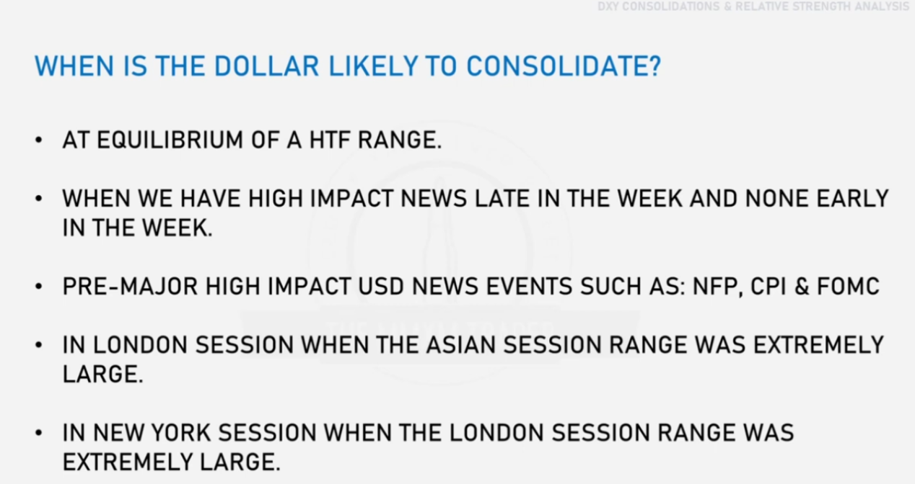

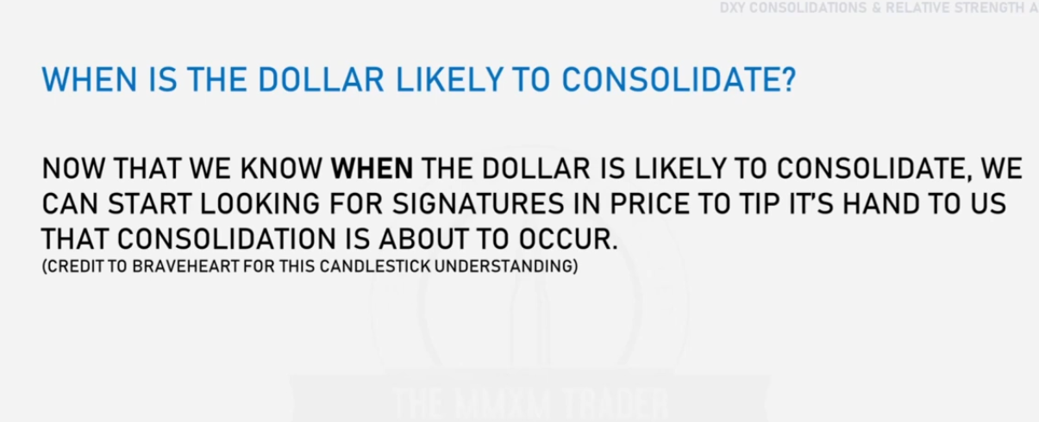

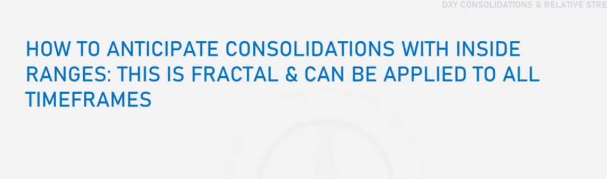

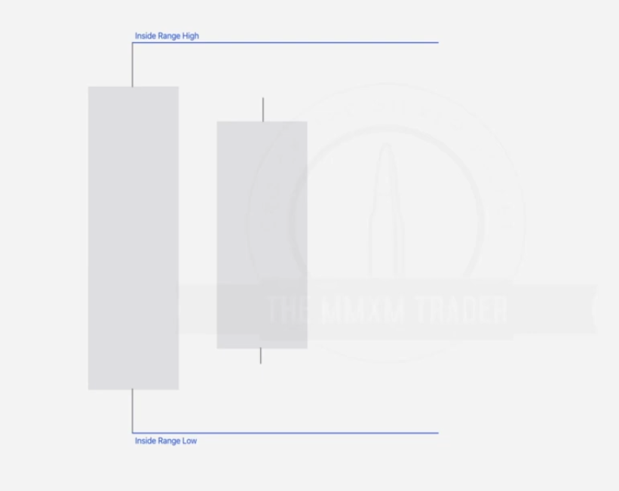When you have an inside candle(unable to take prev highs or lows), and the next candle also fails to take the inside range low or high as expected, we anticipate a consolidation.

EXAMPLE ONE

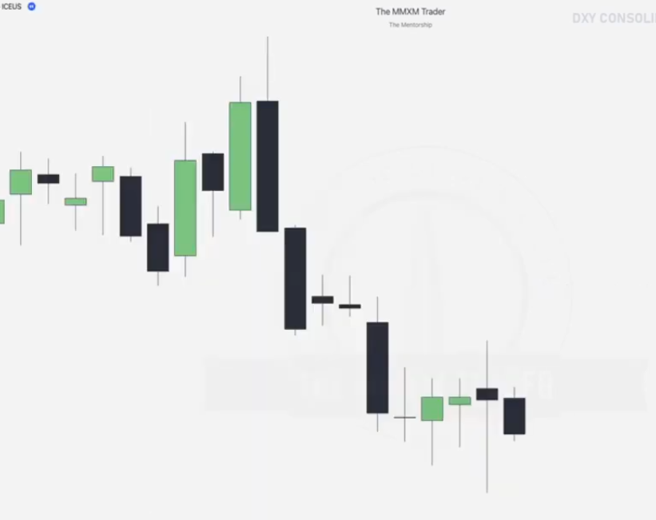

Given a daily chart

Note the inside bar formation and draw the internal range high/low

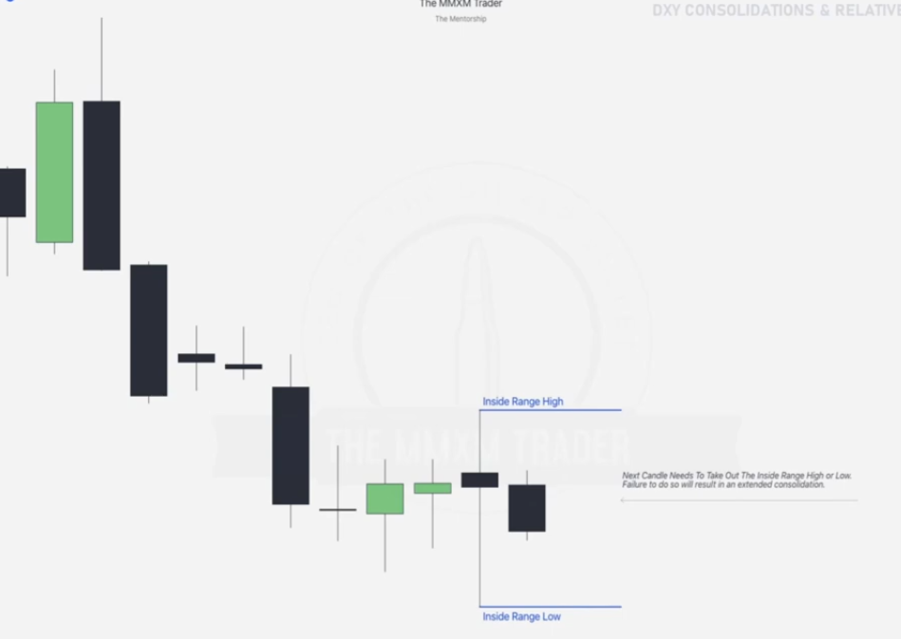

If third candle fails to take over the ranges, this will lead to extended consolidation and now **we look at exotics**.

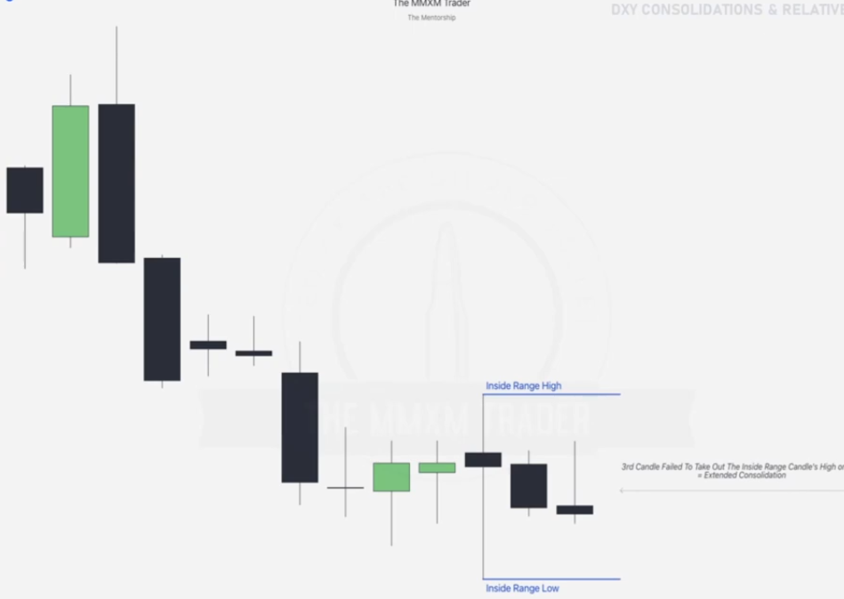Third candle fails, NOW WE LOOK FOR EXOTIC PAIRS

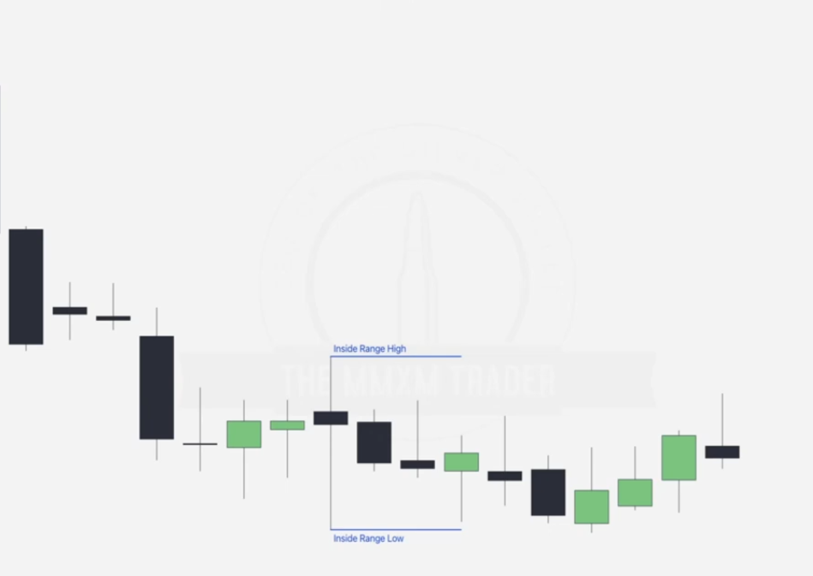

EXAMPLE TWO

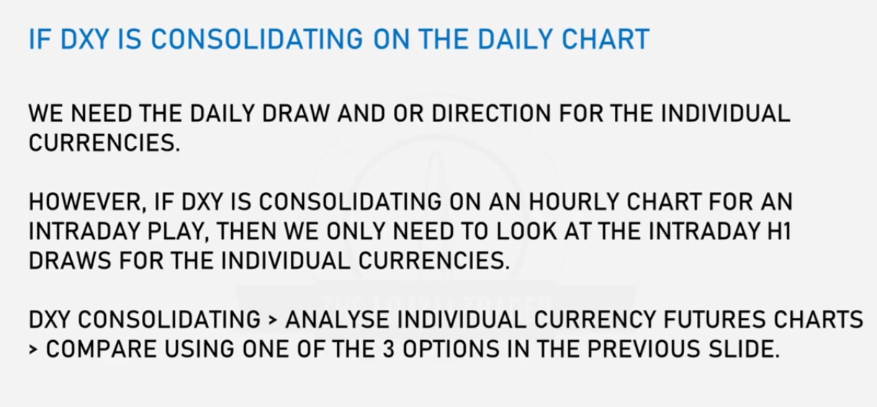

EXAMPLE 2

Given a daily chart is this a CAD/EUR Canadian Euro chart

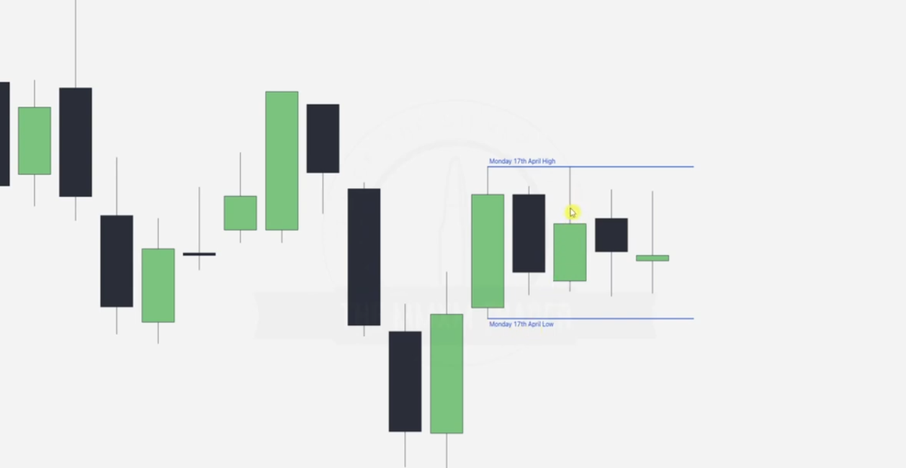

One hour chart, one big consolidation

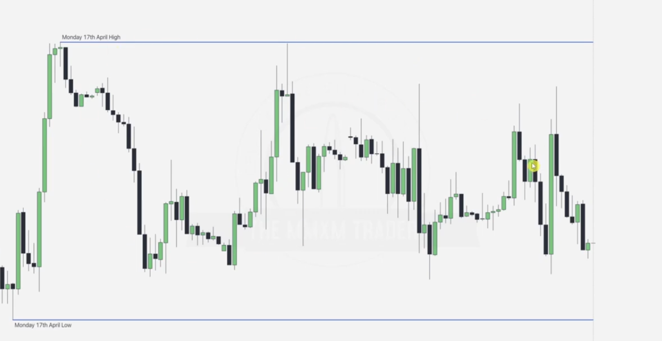

Now going to canadian futures chart(going individual)

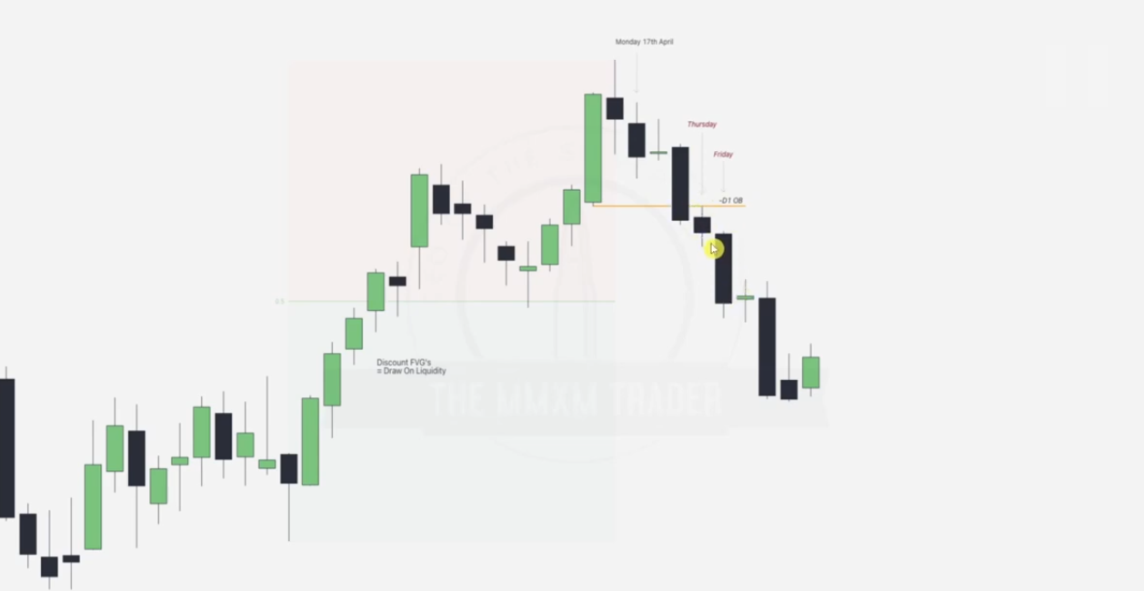

We mark april 17th-- date when the inside range highs/ lows were drawn.

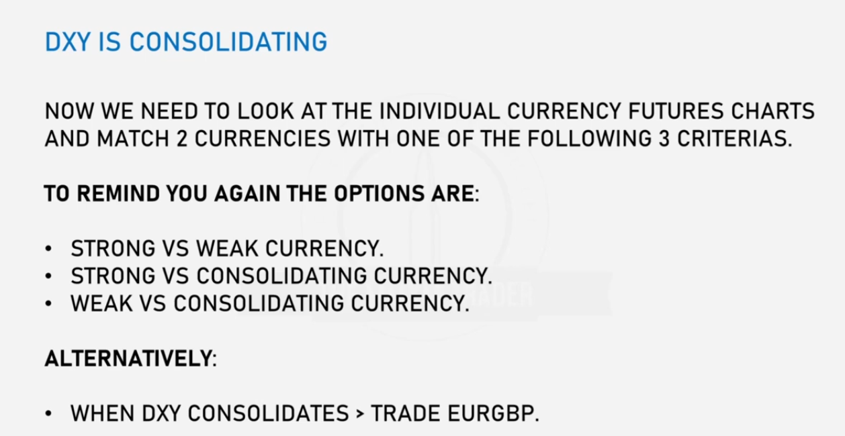

EUROGBP moves when DXY is consolidating

Going to canadian USD futures Daily

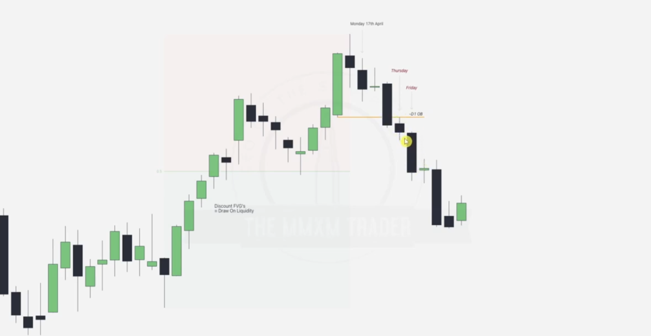

Note prem_disc, draw the bearish order block and note that price is going down to discount, also the date for the inside range high/ low is indicated. We are focusing on Thursday and Friday which are respecting the order block

Going to the intraday

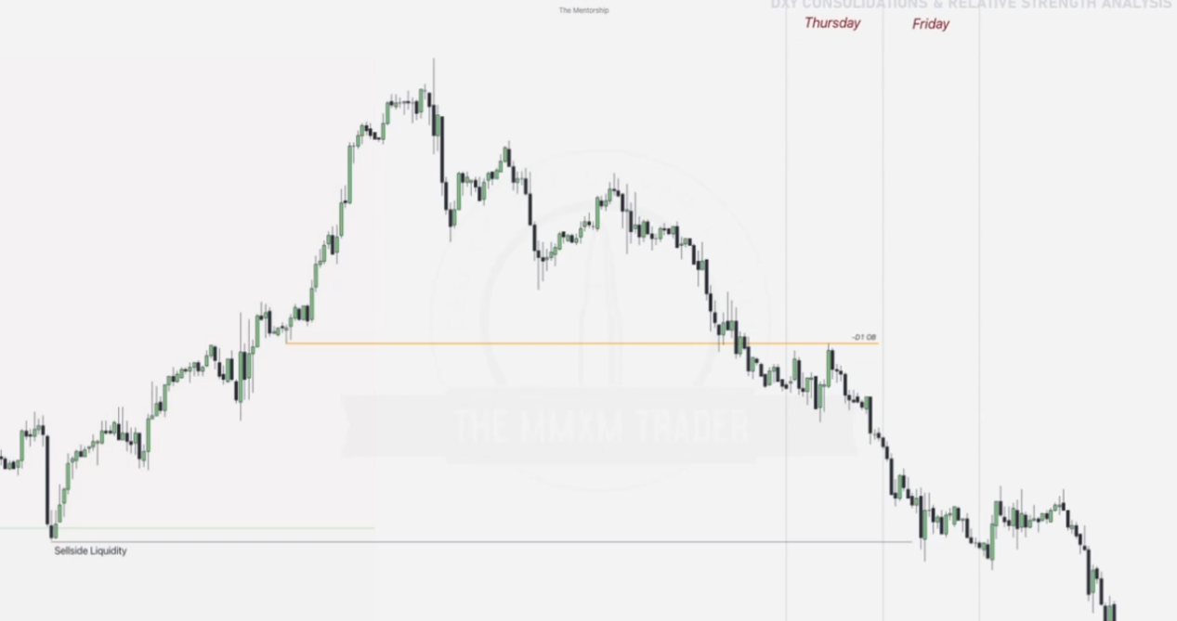

After Wednesday the inside bar is still held hence we expect good movement for the exotics during Thursday and Friday.

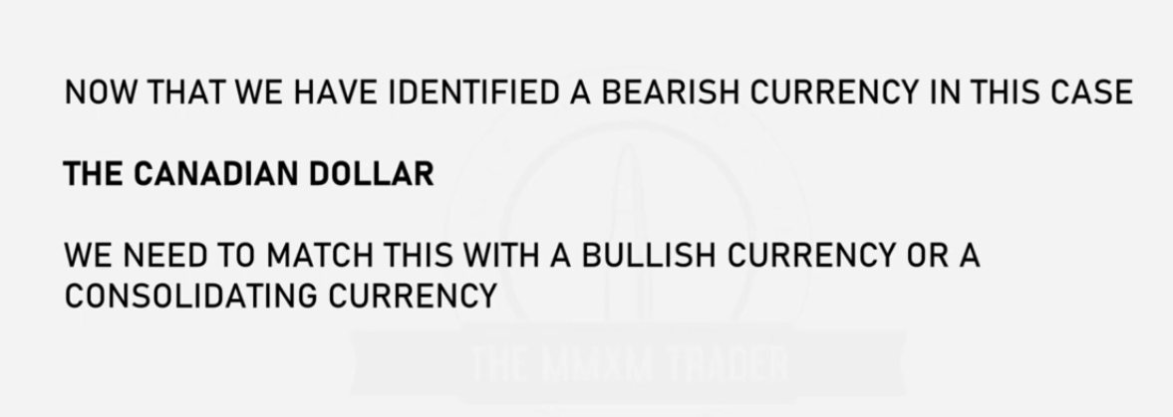

Hence we check a EURO futures chart next in same date range(thursday and friday)

Given daily chart

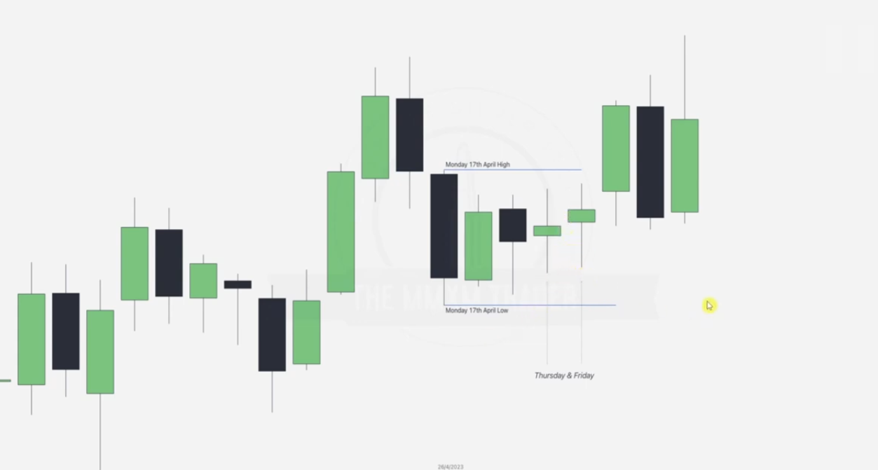

Going to the intraday we note that EURO is consolidating compared to canadian which is bearish

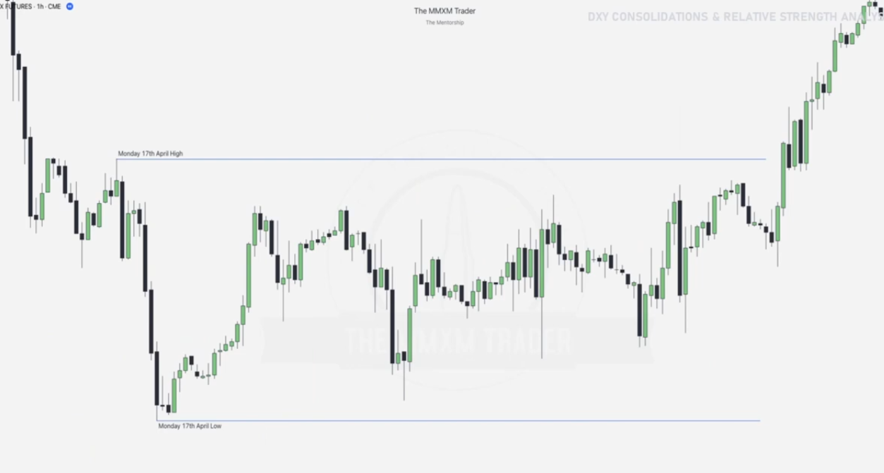

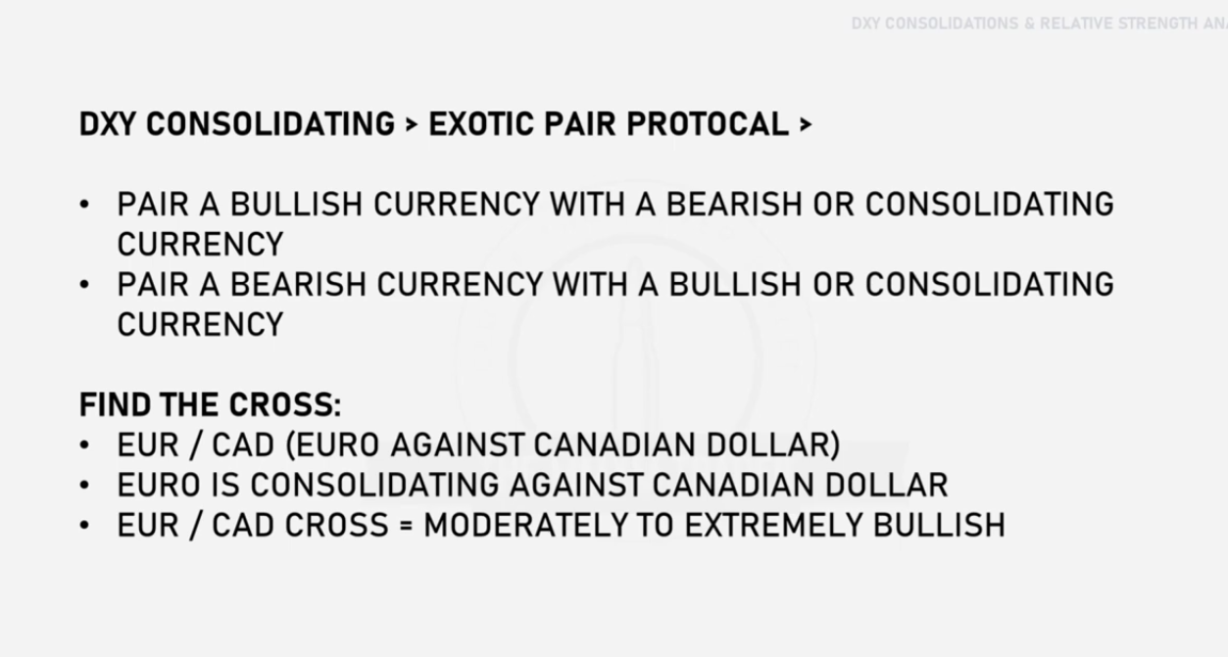

Hence we now use the exotic pair EUR/CAD

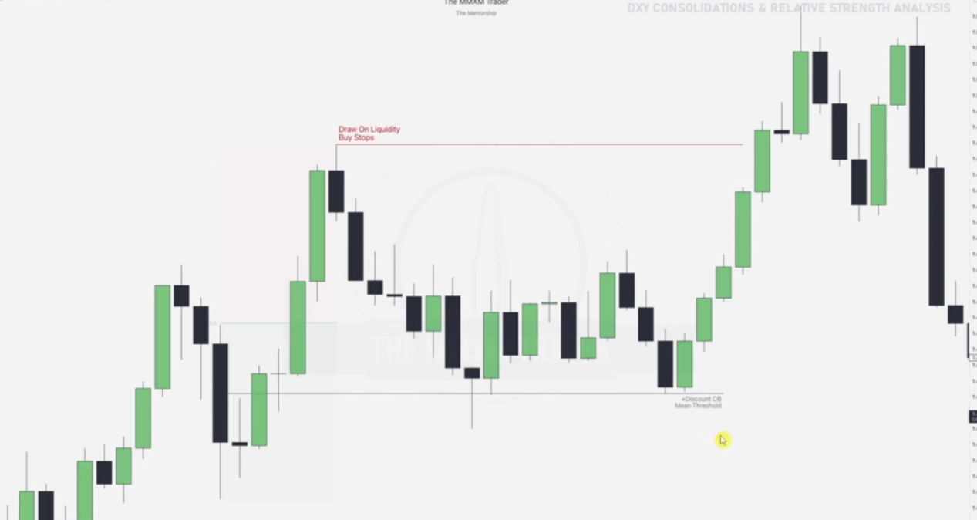

We draw our prem_disc note the order block and line out its MEAN then notice that price is in discount.

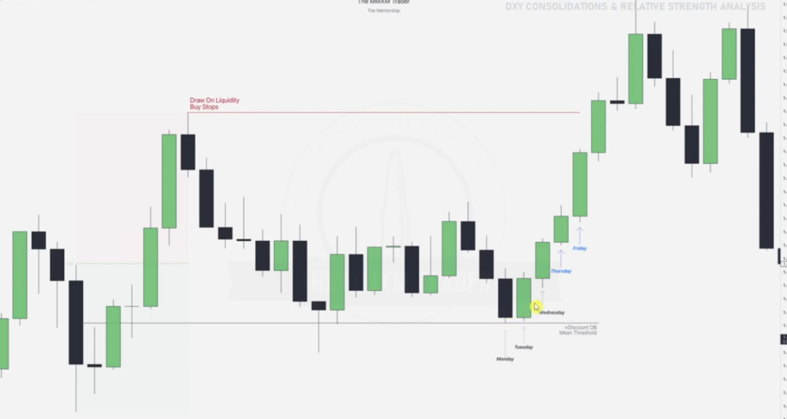

Now that the DXY consolidation happens from Wednesday , Thursday Friday, we head there and we see that there is a bullish force, also note that there is a swing low that occurs at a key level-- discount ORDER BLOCK labelled before. FOCUS ON THE 4TH AND 5TH candle as before in tutorial.

Going to the intraday 1 hr chart

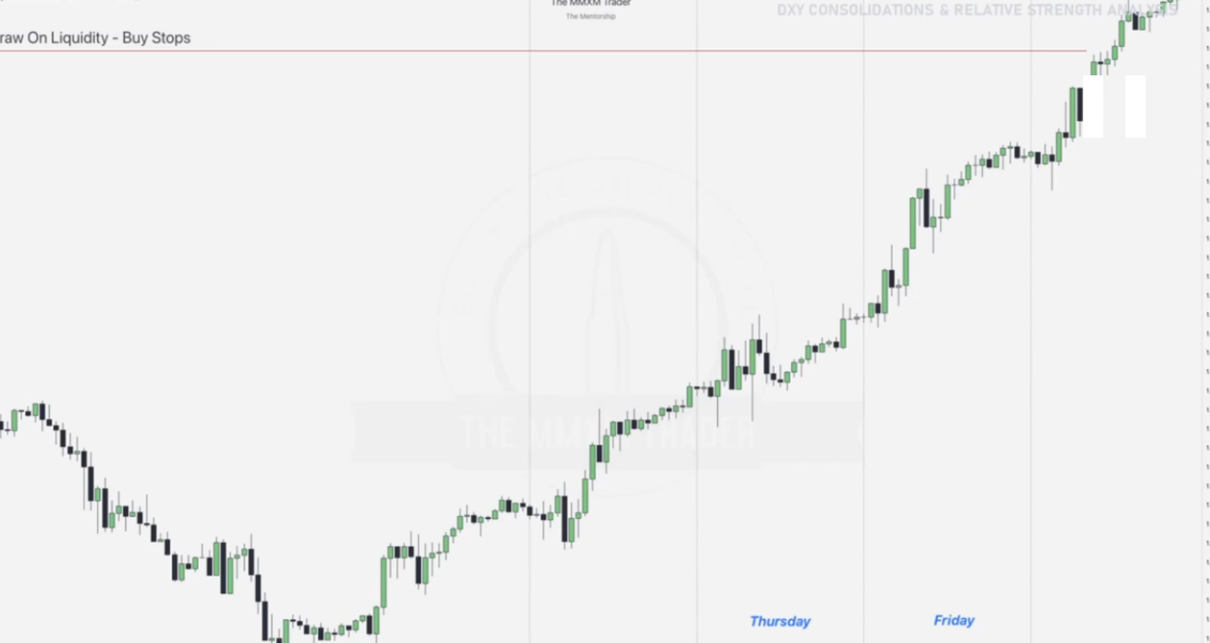

We will focus on Thursday and Friday

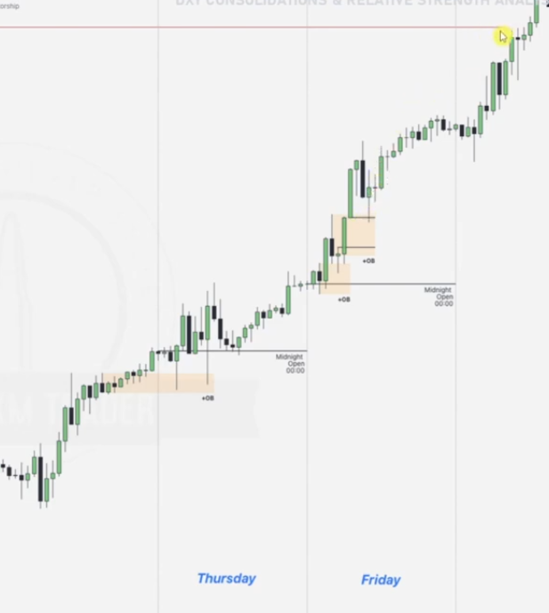

Taking into the OHLC and OLHC we draw our midnight open and notice that the candles are going bullish, we then draw our order blocks as aligned. EVENTUALLY WE GO AND REACH THE RED DRAW ON LIQUIDITY

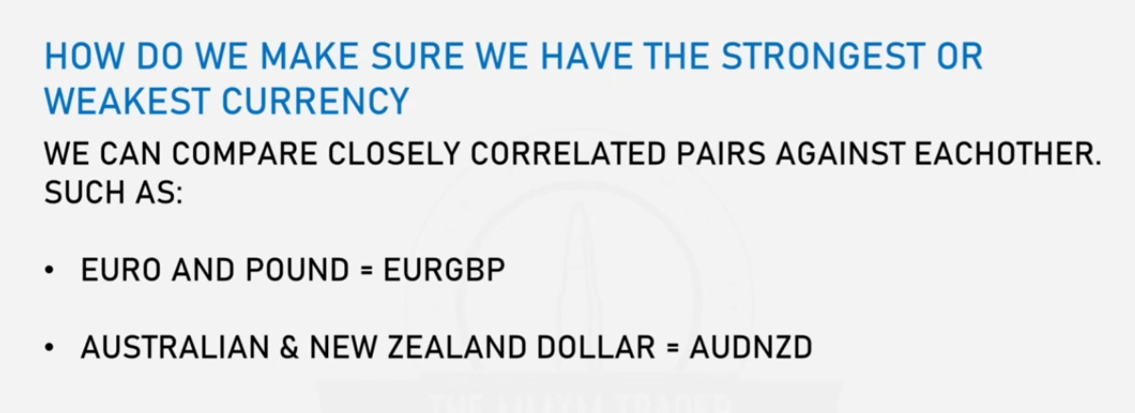

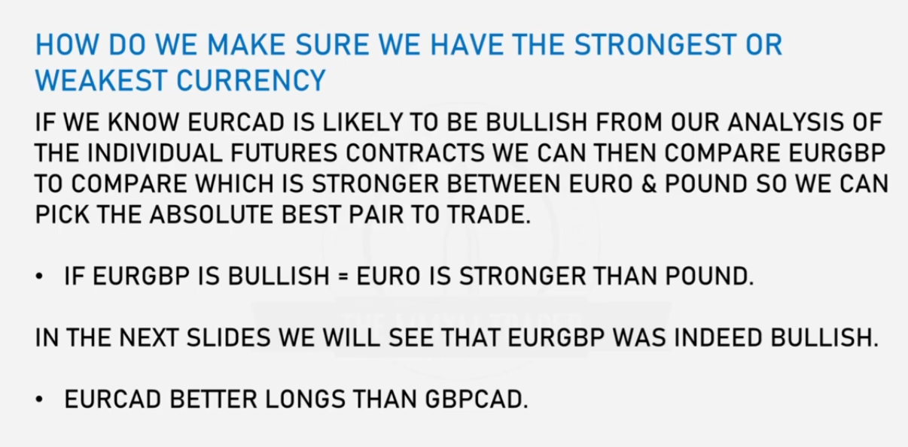

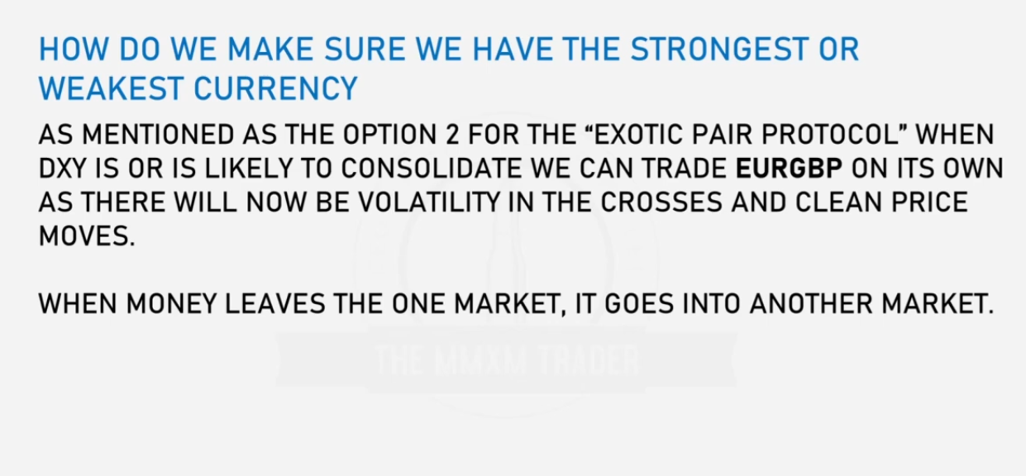

Going into the EURGBP EURO /POUND